***HOW Are We Building an***

***INCLUSIVE Community?***

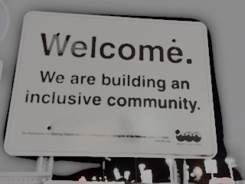**Want to be part of making the Mid Ohio Valley the best it can be?**

Be part of the *What’s Next MOV* conversation and hear from various sectors about the ways we are providing a welcoming environment for EVERYONE:

Individuals, Families, Community Groups, and Businesses

***Light refreshments will be served***

**WHEN:** **Martin Luther King, Jr. Holiday, Monday, Jan 16, 6:00 – 8:00 PM**

**WHERE**: **Judge Black Annex, 318 Market Street, Parkersburg, WV**

**WHY:** **To make a positive difference in our community**

**HOW:** **Making our voices known in dynamic conversation with follow-up**

**For more information contact: [jeanambrose8@gmail.com](mailto:jeanambrose8@gmail.com), 304.679.3970**