**Reports for Green Sanctuary Meeting of September 15, 2024**

**George Banziger**

Save Ohio Parks

No recent news

Next meeting – September 20 at noon via Zoom

Watch for “nominations” for fracking sites coming out of Oil & Gas Land Management Commission and please respond with comments.

Citizens Climate Lobby

Trying to set up a candidates’ forum involving the two candidates for OH 06 congressional seat. Due to lack of response from Rulli, the event is now a town hall with Kripchak on September 23 (in-person & via Zoom).

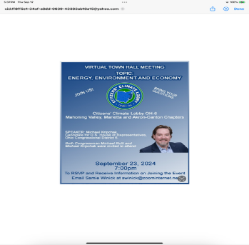

Similar event in Marietta?

ReImagine Appalachia

-Upcoming webinars:

September 26, 3 p.m. – Grow it in Appalachia

October 10, 3 p.m. – Alternatives to single-use plastics

October 16, 3 p.m. – Repurposing shuttered coal plants

October 24, 3 p.m. – Creating green building supply chains

Injection Wells

I just finished reading Justin Nobel’s book, *Petroleum 238.* He makes the strong case for there being high levels of radiation (radium 226 and 228) in fracking waste. Drivers of “brine trucks” and others who deal with fracking waste in this region have no protective gear against radioactivity. Trucks carrying brine waste are not marked as containing hazardous/radioactive material. Fracking waste can leach into aquifers.

Is this something to raise as a “challenging reality” in our Climate Justice Revival sessions?

Pollinator Plot on Fort Street

I saw this grant opportunity. We might apply under the category, Community Grant, and use these funds to hire a part-time coordinator of the project:

<https://appalachianohio.org/grow/pillarsofprosperity/environmentalstewardship-2/>

We can apply in Q4 (October 1- December 1) with a decision date of December 30.