

Sunday, August 25, 2 PM ET via Zoom - Brett Christophers

The Price is Wrong: Why Capitalism Won’t Save the Planet

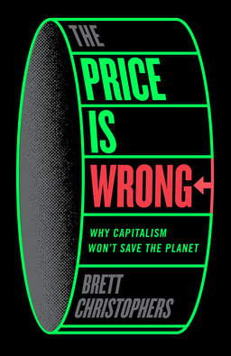

“Standard theories of the causes of climate breakdown will not survive this book. Readers will be all the wiser.”
--Andreas Malm, author of How to Blow Up a Pipeline

Why the market will never solve the climate crisis.

What if our understanding of capitalism and climate is back to front? What if the problem is not that transitioning to renewables is too expensive, but that saving the planet is not sufficiently profitable?

This is Brett Christopher’s claim. The global economy is moving too slowly toward sustainability because the return on green investment is too low.

Today’s consensus is that the key to curbing climate change is to produce green electricity and electrify everything possible. The main economic barrier in that project has seemingly been removed. But while prices of solar power have tumbled, the golden era of renewables has yet to materialize.

Brett Christophers is a political economist and economic geographer, and the author of Our Lives in Their Portfolios, Rentier Capitalism and The New Enclosure, which won the Isaac and Tamara Deutscher Memorial Prize. Brett Christophers is based at Uppsala University in Sweden.

REGISTER: Brett Christophers

OR



