2023-2024 Green Sanctuary Annual Report

It’s been another busy year for FUUSM’s Green Sanctuary Committee. Co-chairs are Dawn Hewitt, Debra Miller, and Jim Grecni, and active members include Adeline Bailey, Mike Bailey, Shari Ballantyne, George Banziger, Vic Elam, Chris Jacobs, Kelcey Jacobs, Mark Krivchenia, Maggie Meyer, Ginnie McNeil, Maggie Meyer, Rebecca Phillips, and Cindy Taylor. New “regulars” to our group include Jonathan Brier, Greg Foster, Charquequa Frye, Susan Henderson, Lace Lynch, and Ann Sparks (who lives in Athens!) Sadly, in 2023 we lost Dave Ballantyne, who gets a whole lot of credit for the solar panels on the roof of our sanctuary, and who was a longtime and active member of this team. Throughout the year we met in person and simultaneously via Zoom, and we plan to continue that to accommodate those who live distant from Marietta. We are grateful for the dozens of others who are on the GSC’s email list who help us out when we need it and support our activities and events.

During Earth Month (April) 2023

* We led the April 16, 2023, service, with Ginnie McNeil and Rileigh Trembly providing the reflection, titled “East Palestine: Pray, Reflect, and Put Faith into ACTION!”
* We staffed a booth during Marietta’s Earth Day, sharing our space with Citizen’s Climate Lobby, MOVCA, Faith Communities Together (FaCT Ohio), and the Fourth Street Pollinator Habitat (which we initiated a few years ago). We distributed native wildflower seeds and lots of information. We also offered voter registration under our large tent.
* Afterward, several GSC members helped the Ohio River Islands National Wildlife Refuge staff and other volunteers to plant a few hundred trees on Buckley Island.
* In conjunction with Interfaith Power and Light (of which we are a member), we screened Current Revolution, a film about the transition to renewable power sources.

That second bullet point is noteworthy: many of our members are actively involved with other environmental organizations and activities, and sometimes boundaries are blurred. For example, George Banziger doesn’t take off his FUUSM Green Sanctuary Committee badge when he chairs the local chapter of Citizen’s Climate Lobby, or attends ReImagine Appalachia workshops, or participates in Save Ohio Parks protests, or talks to local officials about the threats of injection wells, or serves on the advisory board for the Center for Clean Energy and Climate, or writes “Climate Corner” editorials in the Parkersburg News-Sentinel, or works to establish a native plant corridor in Devola, etc. And George is just one example (an exemplary example) of our Green Sanctuary Committee members. Several GSC members regularly contribute essays to the “Climate Corner,” A lot of GSC members are involved with numerous organizations working hard on issues important to our committee, and there is strength in numbers. We are grateful to have representation in many overlapping green circles.

Ginnie McNeil has been active with Faith Communities Working Together, and at her prompting, FUUSM’s Board of Trustees approved a proposal that FUUSM would serve as the Southeastern Ohio Anchor Congregation for FaCT, with Ginnie serving as liaison. Notably, FaCT provides a Distinguished Speaker series via Zoom that many GSC members have attended—and benefitted from. Note: One is coming up on May 17 at 7 p.m. Visit factsustain.org to find out about the presentation by Justin Nobel, author of Petroleum-238

The threat of fracking waste—brine—is increasingly a problem the GSC is working on. Washington County disposes of more brine injection wells than any other county in Ohio, and more than the entire state of Pennsylvania and West Verginia—because those states are more protective of their subterranean environment—including aquifers—than Ohio is. Brine is threatening drinking water sources in Washington County and elsewhere, and FUUSM’s Green Sanctuary Committee is paying attention, speaking out, raising awareness, and otherwise working to protect human health and the environment, for today and the future.

The Fort Street Pollinator plot has gone from a Green Sanctuary project funded by a DuPont Clear Into the Future Grant, to a community project with involvement from Harmar neighbors, the Girl Scout troop that meets in our social hall every Tuesday, other community and gardening organizations, and with ongoing support from the City of Marietta. We tabled Harmar Days to draw attention to the Fort St. Pollinator Habitat, sharing information about the benefits of native plants, promoting Homegrown National Parks, and handing out native plant seed packets. Kudos to Rebecca Phillips for leading the effort on this visible, tangible effort to control erosion while providing for birds and bees and native plants and trees.

The Solar-powered Charging Bench, also funded by the DuPont CITF grant is in full operation, including with maintained information panels that include FUUSM events and other community events. On Nov. 4, 2023, we dedicated our solar-charging bench. Two city officials, Steve Wetz and Geoff Schenkel, attended to represent the city’s involvement and endorsement. On April 1, we updated it for April and May events, and within a few days, it was underwater. We will soon learn if the battery, light fixtures, wiring, or other components were damaged, as we clean out muck from its interior and exterior.

Thanks to Claire Mullen, the Green Sanctuary Committee now has a logo!!

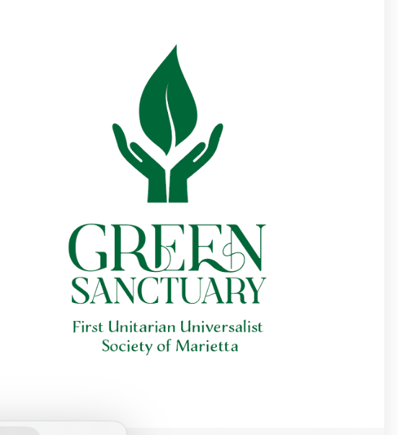

In addition to the risk and threats of injection wells, in 2023, we learned of Ohio House Bill 507, which permits and encourages oil and gas leasing under public lands. Several GSC members have been attending meetings, writing letters, and contacting legislators, and continue to peacefully protest such disrespectful, short-sighted, profiteering on the public commons. Two of our members attended and protested nominations of state parks for fracking at a state Oil & Gas Land Management Commission meeting. Protestors crowded the room, but the commissioners seem oblivious to citizen objections to this exploitation of public lands, and even though many endorsements of this plan were fake, falsified, fictitious. Several members of the GSC contacted state officials to express their opposition to fracking on, near, or under public lands. Anne Sparks has been active with Save Ohio Parks, and has kept us up to date on their activities—which we support and endorse.

We continue to learn about and honor indigenous people. Toward that goal, several of us attended a fund-raising cook-off, hosted by the Nahyssan Tribe in Cutler, of which FUUSM friends Ami Rush and Jocelyn Jones are members. On Indigenous Peoples’ Day in October, the GSC held an educational presentation adjacent to our sanctuary on Putnam and Third streets featuring posters and art intended to honor the ancients who walked upon this land long ago, and those who still do. Ami presented the Nipmuk prayer in both the original language and in English, and Marietta resident and Menominee tribe member Drew Waepew-Awaehsaeh (pronounced WAH-POO-AH-WAH-SAH) shared his moving story.

Although his work isn’t officially a Green Sanctuary Committee project, we have supported, encouraged, and sometimes helped Mark Krivchenia with ecological restoration at Broughton Nature Park and at the Ohio River Islands National Wildlife Refuge.

Last summer, the GSC voted to recommend to the FUUSM Board of Trustees our support for the UU Youth’s proposal, that the UUA divest of its fossil fuel investments, to be presented at the General Assembly.

Many of us participated in various events sponsored by Mid-Ohio Valley Climate Action, including “Plastic-Free July.” During that month, Dr. Randi Pokladnik presented a talk in the FUUSM social hall, titled “Plastics in Our Bodies and the Environment.” Many of us also watched and discussed a film titled Atomic Hope: Inside the Pro-Nuclear Movement, hosted by MOVCA.

In September we held a Sustainable Supper (formerly known as a Just Dinner), and 19 of us enjoyed a conscientiously prepared meal and enjoyable discussions on mindful eating.

On Make A Difference Day, Oct. 28., Roger Kalter organized an effort to plant 46 trees along the River Trail. Several other GSC members assisted.

Six teams of two GSC members continue to sweep litter and natural debris (especially sweet gum balls) from the River Trail twice each month, for two months each year. We’ve had some turnover and are grateful to Beth Lepore, Stephanie (Squish) Rector, and Joey Thomas for filling those holes.

The GSC, especially Ginnie McNeill, has been working on developing a program to attract youth to participate in environmental initiatives, but we do not have anything to report at this time. We haven’t given up, though!

There’s more. But already this report is four pages long. It’s tempting to report on what’s ahead during Earth Month (April) 2024—and beyond. But we’ll save that for next year’s annual report.