**Margaret Keen gave Ohio unspoiled land 28 years ago, state now opening it to fracking**

**https://www.dispatch.com/story/opinion/columns/guest/2024/03/25/fracking-in-ohio-betraying-trust-of-those-who-gifted-cherished-land/73057370007/**

**Columbus Dispatch, March 25, 2024**

Briones Bedell

Guest Columnist

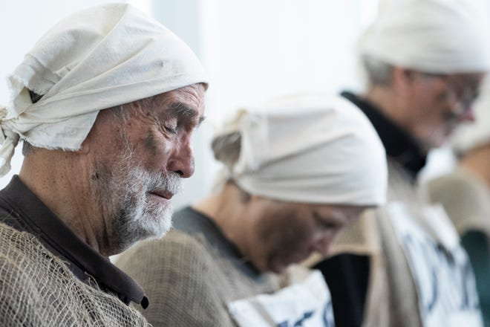

*Briones Bedell is a nonprofit fundraiser and communications professional residing in Columbus.*

Those managing our public lands have a priority problem and it is leading them to drill away trust and betraying natural treasures gifted to us by Ohioans like [Margaret Keen.](https://saveohioparks.org/2024/03/17/keen-wildlife-area-in-oil-and-gas-crosshairs/)

Last month, the Ohio Oil and Gas Land Management Commission approved leasing nominations for fracking in [three state parks and wildlife areas,](https://www.dispatch.com/story/opinion/columns/guest/2024/01/18/what-is-fracking-and-why-is-it-wrong-for-ohio-state-parks/71963551007/) spanning thousands of acres across our southeastern counties.

The fossil fuel corporations awarded the rights to drill —Texas-based Encino Energy and West Virginia-based [Infinity Natural Resources](https://www.dispatch.com/story/news/politics/2024/02/26/ohio-commission-picks-companies-to-frack-under-state-park-wildlife-areas/72688551007/) — are preparing to siphon profits out of Ohio and imperil our natural heritage.

Since the Commission [decided to open](https://www.dispatch.com/story/news/2023/11/15/ohio-oks-accepting-bids-for-fracking-under-state-park-wildlife-area/71577809007/) our already-limited public lands to the oil and gas industry, more and more requests to drill have been submitted.

**Trust being broken**

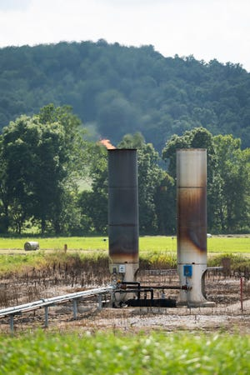

Take the example of the [84-acre Keen Wildlife Area](https://ohiodnr.gov/go-and-do/plan-a-visit/find-a-property/keen-wildlife-area). Established in 1996 with land from the estate of Margaret Keen, the preserve [is used for hiking](https://url.us.m.mimecastprotect.com/s/TU52CADXvPfEmnlqghX62rY?domain=dam.assets.ohio.gov), nature study, birdwatching, and hunting, giving Ohioans priceless opportunities to recreate in our natural spaces.

A private citizen entrusted this land to our state under the assumption that it would be preserved for the benefit of the ecosystem and the people who access it.

**It shouldn't happen again.**[One of worst methane gas leaks in US history happened in Ohio.](https://www.dispatch.com/story/opinion/columns/guest/2024/03/06/largest-methane-leak-in-us-history-belmont-county-ohio/72780052007/)

Only 28 years later, that commitment has been walked back by the opening of this preserve to [leasing nominations](https://url.us.m.mimecastprotect.com/s/waG1CBBXwLt8ZMR21cPeo0e?domain=cleveland.com) from the fracking industry.

**What is fracking?**

It has become clear that fracking is not just an environmental issue. It is also a moral one, and it is clear that this decision is a grave misuse of Ohio’s public lands.

Fracking is the process of extracting natural gas from under the ground, and emissions from this fossil fuel produce methane, a chemical [80 times more effective](https://www.edf.org/climate/methane-crucial-opportunity-climate-fight#:~:text=Methane%20is%20a%20potent%20greenhouse,warming%20in%20the%20near%20term.) at trapping heat in the atmosphere than carbon dioxide.

The fracking process can [contaminate drinking water and soil](https://www.scientificamerican.com/article/fracking-can-contaminate-drinking-water/), exposing communities to toxins [linked to cancers](https://e360.yale.edu/features/fracking-gas-chemicals-health-pennsylvania), endocrine disorders, asthma, and complications in pregnancy. It threatens our [air quality](https://url.us.m.mimecastprotect.com/s/sehVCL91K8fQomw8Acyxw0d?domain=biologicaldiversity.org). The heavy, loud, and ugly machinery used in fracking operations will disturb wildlife and decrease the natural beauty of our landscapes.

**Officials must understand the danger**

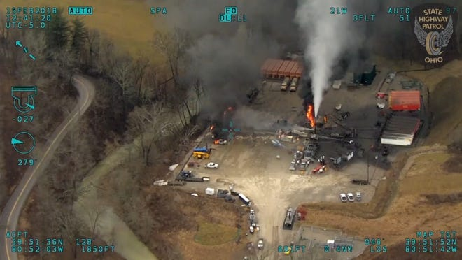

 Our decision-makers now rank the interests of out-of-state fossil fuel corporations above Ohioans’ rights to unspoiled natural spaces.

**Gun violence erodes American freedom.**[After Easton shooting, is no place safe? | Opinion](https://www.dispatch.com/story/opinion/columns/guest/2023/08/31/easton-town-center-shooting-rashawyn-carter-jr-no-place-is-safe-from-gun-violence-columbus-ohio/70721363007/)

The request to frack in the 18,0011-acre [Egypt Valley Wildlife Area](https://ohiodnr.gov/go-and-do/plan-a-visit/find-a-property/egypt-valley-wildlife-area) in Belmont County is as disappointing as what is planned for Keen.

Conservationist groups — including the Conservation Fund, Ducks Unlimited, the National Wild Turkey Federation, and the Ruffed Grouse Society — banded together to create this preserve.

A park composed of land [recovering from extensive surface coal-mining](https://url.us.m.mimecastprotect.com/s/ngP0CG6XB5iAy0OXmFLpNaq?domain=dispatch.com/), the recent proposition to begin fracking on this preserve adds insult to injury. It hampers decades of efforts to restore critical habitat, reintroduce native plant and [animal populations](https://url.us.m.mimecastprotect.com/s/a4NkCERXz9SpAg0XmtL5KwM?domain=ohiodnr.gov), and provide recreational space.



We protect public lands for practical reasons, like [carbon sequestration](https://www.fs.usda.gov/research/treesearch/33137), habitat restoration, and tourism.

But the intangible things that nature preserves provide us — respite from the troubles of everyday life, connection with the world around us, appreciation of our natural heritage — are just as valuable.

Fracking on our public lands is a bad deal for people and the planet alike. It’s time our decision-makers understand this.

*Briones Bedell is a nonprofit fundraiser and communications professional residing in Columbus.*