

Hello, Friends of MOVCA,
I am reaching out to let you know about a powerful event we are hosting on Thursday, February 22, 2024, from 7:00 - 9:30 pm. We will be featuring a virtual screening of Atomic Hope - Inside the Pro-Nuclear Movement, followed by conversation where we will discuss the film and hear what others think about the use of nuclear energy.

Disclaimer: Screening this film is not an endorsement of nuclear energy. Through films and open discussions, Mid-Ohio Valley Climate Action seeks to educate ourselves and others about the pros and cons of nuclear power and other non-carbon energy sources.

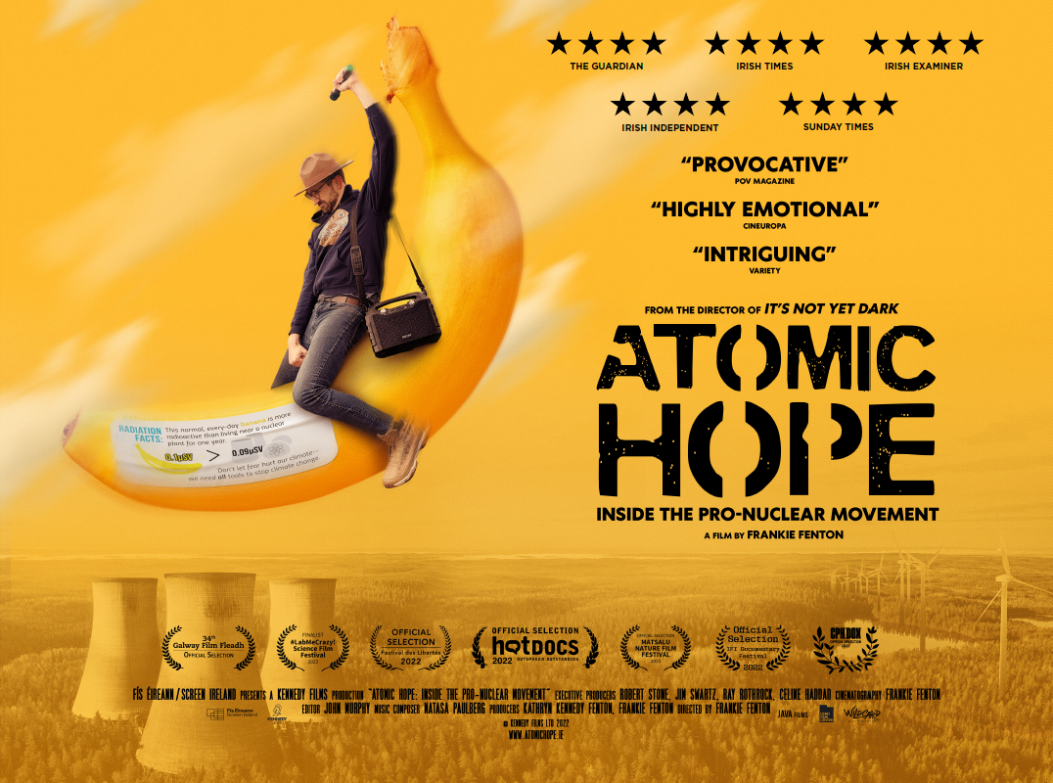
Atomic Hope – Inside the Pro-Nuclear Movement is an observational Irish feature documentary which follows a tiny group of “pro-nuclear” activists. They believe we now need to urgently re-address our feelings on nuclear power if we are to have any hope of decarbonizing our energy systems before the effects of catastrophic climate change wreak havoc.

But for better or worse? A sordid history of nuclear meltdowns, radiation fears and nuclear waste are just some of the very serious issues traditional environmentalists have with this contentious technology. However, in the face of this pushback and conflict, these activists argue that, “science and data is all we have”.

Reservations are required for this event. To reserve your access to the film and discussion, please visit this link:
https://us02web.zoom.us/meeting/register/tZ0od-uuqjkrG9TrVkDQhQTe24QuOhuurB6p

After registering, you will receive a confirmation email containing information about joining the meeting.

We hope to see you there!

Best,
Adeline Bailey, MOVCA program organizer

