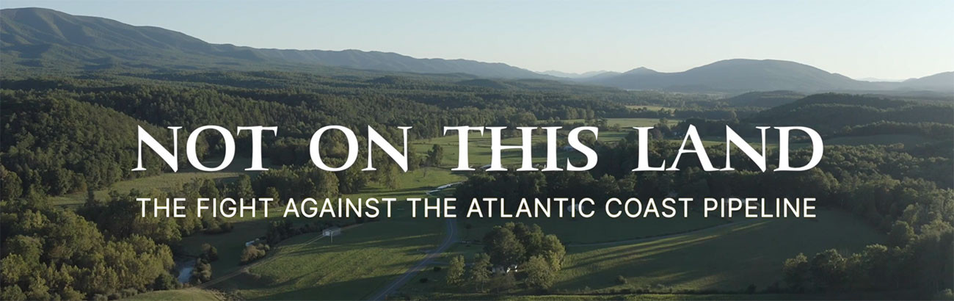
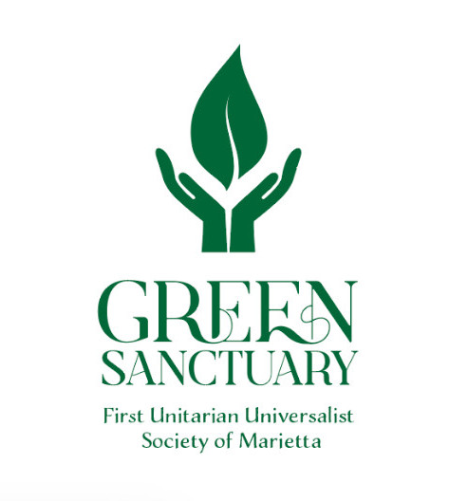

Upcoming Meetings and Events

Free screening open to the public:
Hosted by Mid-Ohio Valley Climate Action
7:00 pm, Thursday, November 16, 2023
FUUSM Social Hall

Green Sanctuary
Committee Meetings
Sunday, November 19, 2023, 12:30pm
Sunday, December 17, 2023, 12:30pm
FUUSM RE/Office Building

