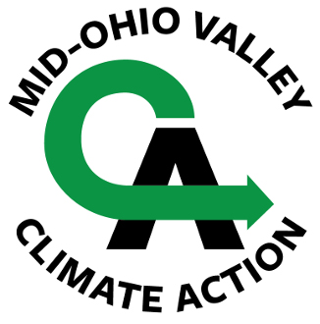

BREAK FREE FROM PLASTIC: PLASTIC FREE JULY

Join Our Team of Investigators . . .

Sometimes it seems impossible to avoid single-use plastic, no matter how hard we try to refuse, reduce, reuse, or recycle in our every day activities. We're all in this together, but because each person can't be everywhere at once, Mid-Ohio Valley Climate Action invites you to be an Investigator who will use a survey to help us find the stores, restaurants and businesses that are working with us to reduce - or better yet, eliminate - single-use plastics in their operations.

To make it more fun (we hope!), we're making it a competition by assigning point values to the survey questions we hope you'll work on. Then you'll record your results and send your report to MOVCA. (A report sheet is on the next page.)

You can report on more than one store or business. Just send a separate report for each place you survey. We want to cover as many businesses as possible: local, small businesses and markets, including farmers markets; fast food places and coffee shops as well as restaurants; grocery stores, drug stores - almost any place you dine or shop!

and Win a Prize!

All participants will receive awards, with our thanks! The top three point-earners will each receive a prize package featuring sustainable alternatives to single-use plastics.
Sign up to participate: leave your name and email address HERE

A few tips about conducting this survey:

Be respectful, not confrontational. Most businesses are doing the best they can to meet our needs for products delivered safely and conveniently; sometimes those two goals seem to be at odds with protecting the environment.

Be aware of the time needed to answer your questions. Make an appointment for another, more favorable time, if necessary.

Thank them for their responses. It's good to let them know we are all in this together.

Tell them you are conducting this survey for Mid-Ohio Valley Climate Action. We want to get to know them, too!

MOVCA greatly appreciates a grant from the Mountain Watershed Association Direct Support Fund in support of our anti-plastic campaign. The Direct Support Fund is made possible by The Heinz Endowments, The 11th Hour Project and The Plastic Solutions Fund and is a project of the Mt. Watershed Association. For more information or to apply please visit http://www.mtwatershed.com.

Break Free From Single-Use Plastics
Report Sheet - 2023

Name and location of the store or business you are investigating:

Date of investigation:

(Point value-5)
1. Check single-use plastics found: - straws - disposable cups - carry-out containers - cutlery - wraps/packaging - single-use shopping bags - water bottles
- other (please specify)

(Point value - 10)
2. Ask owner/manager if the business offers alternatives to any of the single-use plastics and record their response:

(Bonus point value - 15)
3. Call, email, google search, or write to the corporation or person responsible for store policies and ask them about alternatives. Say who you contacted and record their response:

(Bonus point value - 15)
4. If you have a favorite product available at the store, contact the manufacturer about their use of plastics in packaging or production, and ask about alternatives. Say who you contacted and record their response:

Your name:
Address:
Phone:
Email:
Contest Period Extended! Reports due by October 15
Please submit by US mail to MOVCA
c/o A. R. Bailey
860 BF Goodrich Rd.
Marietta, OH 45750

or by email to adesign4199@gmail.com

