First Unitarian Universalist Society of Marietta
Green Sanctuary Committee Meeting
12:30 p.m., Sunday, May 21, 2023
Live in the FUUSM RE building parlor and on Zoom

In attendance: Dawn Hewitt, Debra Miller and Jim Grecni, co-chairs; Vic Elam, Susan Henderson, Lace Lynch, Adeline and Mike Bailey, Maggie Meyer, and Rebecca Phillips in the parlor. George Banziger, Anne Sparks (?), and Cindy Taylor on Zoom. [Anne? Were you there? We can’t remember!]

Dawn Hewitt called the meeting to order at 12:56 p.m. The meeting got off to a late start because the worship service ran long.

Minutes of the April meeting were approved as submitted.

Green Sanctuary logo
At Dawn’s request, Claire Mullen created several draft versions of a logo for GSC. (Draft versions appended to minutes.) Put to a vote, the most favored version pictured a green “chalice” of hands cupping a leaf “flame.” Our thanks to Claire for the beautiful renditions.

Ecological Restoration Work - Mark Krivchenia
Mark was serving coffee at the after-service social hour, and had to leave quickly thereafter for work at Broughton Nature Preserve. Reports next month on his activities.

Updates on Injection Wells, ReImagine Appalachia, and CCL - George Banziger
(George’s reports appended to the minutes.) Highlights from George’s reports: a message from Washington County Commission president Kevin Ritter, who said the bill recommending sending extra income from injection well leasing be sent to 10 counties where wells are located has passed the state house and will be going to the state senate; CCL reports that the carbon fee and dividend legislation will be resubmitted soon; HB507 regarding oil and gas leases on Ohio public lands - there are 15 well pads and 89 wells where no environmental impact statements have been made. George said a nomination from a Texas company is coming up soon, and requested that concerned citizens contact the Ohio Oil and Gas Land Grant Commission regarding environmental impacts.

Honoring Indigenous People (HIP) Team
Dawn and Adeline discussed the RIEOSO (Research and Identification of Early Occupancy of Southern Ohio) Cook-Off hosted by Nahyssan Tribe in Cutler yesterday (Saturday, May 20). The event was brought to FUUSM/HIP team attention by FUUSM friend Ami Rush. Adeline said the event brought the team in contact with a tribal group close by that we were not aware of, and the HIP team hopes to develop a closer relationship with them as they work toward applying for federal recognition. In addition, the HIP team hopes to pursue a better understanding of the Land Back movement and Native American interest in care-taking of national parks through meetings with the Nahyssan confederation and others in Ohio and across the US. Vic Elam shared that refuges in Montana and Virginia had reverted to tribal ownership in recent years. Lace Lynch mentioned Marietta’s Mound Cemetery as a sacred space for Indigenous People where burials of non-Native Americans were still allowed. Adeline said the HIP team would like to explore that and other related topics in the coming months.

FUUSM Plant Sale, Saturday, May 28 - Help requested
Rebecca Phillips said many GSC members are signed up to help with the annual fundraiser, but more workers are welcome and needed, especially for the final effort on Sunday to complete sales and cleanup.

Pollinator Habitat (DuPont CITF project) News - Rebecca Phillips
(Rebecca’s report included at the end of the minutes.) Rebecca reported much happy news regarding improvements in the habitat. Although the grant application to AARP for gateway arches was not successful, the city is pouring a pad for a bench, which should arrive before the end of the month.

Solar Bench (DuPont CITF project) - Mike Bailey
Mike expressed thanks to Jonathan Brier for technical help in addressing many questions about the functions of the solar-powered charging access bench. The city supplied the key to open the bench workings and the method for installation of a poster has been determined; the router is working, but until a means of accessing a modem is determined, the wifi feature is not available. Mike said GSC/FUUSM (or the city?) would have to pay a monthly charge (about $90) for a phone line. Discussion followed, with the point being raised that wifi access was not essential at this time since primary users—people with phones—could access the internet through their phones. Ideas for the poster included recognizing DuPont and the city as well as FUUSM (an immediate use for the new logo!), and perhaps information directing visitors to seasonal highlights in the area. [Did someone volunteer to come up with words, and then we could design around that?]

FaCT Ohio update - Ginnie McNeil
At the March GSC meeting Ginnie proposed that FUUSM commit to being an "anchor" for the Southeastern Ohio region of FaCT Ohio. Although the group in general favored making the commitment, a recommendation would need to be submitted to the Board of Trustees for any decision. The motion/matter was tabled until the April meeting. No further action was taken then. Ginnie re-sent the full text of the proposal to the Green list for discussion at the May meeting. Time being short and without the full committee in attendance, Dawn proposed that everyone read the proposal and an online vote be taken on June 1. (Yikes! That’s tomorrow!!)

Other Items
Should the UUA divest from fossil fuels? - Discussion on the resolution to be considered at UUA General Assembly (link to the resolution: https://www.uua.org/files/2023-03/2023%20Business%20Resolution.pdf )
Several expressed support for the resolution. Some ideas for amendments (removing terms such as “immediately” and considering how entanglements in investment funds could create delays) were suggested. Vic Elam suggested talking to members of the congregation with a legal background to help understand the potential outcomes of divestment. Rebecca Phillips said the decision should probably be made by the Board of Trustees. Since she is scheduled to be a delegate to GA, she will look into the amendment process.

June 18th meeting - FUUSM Picnic in the Park; MultiCultural Fest - the annual conflict
It was decided that we will meet at the shelter after the picnic for a brief meeting.

The meeting was adjourned at 1:56 p.m.

Respectfully submitted,
Adeline Bailey, scribe

Next GSC meeting: Sunday, June 18, after the congregational picnic at Parkersburg City Park.

Addenda: May 21, 2023 GSC Meeting

Reports for Green Sanctuary Meeting – May 21, 2023 - George Banziger
Injection Wells
Bob Lane told me that the lawsuit which his lawyers originally filed in Washington County and which was sent to a judge in Perry County was dismissed. More recently he has learned that an appellate court in Athens County is taking on the appeal of this case. Bob is optimistic about the outcome in that court.
Bob also told me that he learned the Ohio Department of Natural Resources has required a suspension of injection well activity in wells owned by Deeprock Disposal in Noble County. I have the complete document from ODNR on this action. This is good news in that ODNR has finally taken action on surface impacts of injection wells.
The Washington County Commissioners are organizing other county commissioners in southeast Ohio to lift the cap (currently at 500,000 barrels) on the fee for injection wells in the state (I did not even know there was a cap—this seems to be incentivizing excessive brine waste volume). They have been working with the state legislature on this plan; currently the Ohio House has agreed to lifting the cap and sending 50% of the additional revenue to the county and 50% to the township involved (this news according to Kevin Ritter, President of the Washington County Commissioners). Mr. Ritter reported that this legislation now goes to the Ohio Senate. My letter to the commissioners on this plan is appended below.
Citizens Climate Lobby
There are several bills on permitting reform in the House of Representatives—some favor renewables, some favor fossil-fuel projects. A compromise needs to be reached for a bill to earn passage. Carbon Fee and Dividend - this is the primary ask that CCL is focusing on; it will soon be introduced in the Congress—no bill # yet. Debt Ceiling – Negotiations are continuing last week and this week on this issue; CCL wants members to urge Congress not to sacrifice any of the climate features of the IRA in any final compromise agreement.
At its meeting last Monday CCL Marietta (OH6) discussed strategies for dealing with Congressman Bill Johnson’s positions on renewable energy and carbon fee & dividend.
HB 507
The Ohio legislature passed, and the governor signed HB 507 which permits hydraulic fracturing on Ohio public lands. The Governor has promised that there will be no surface impacts, but Randi Pokladnik (CCL member and environmental scientist, who lives in Harrison County, believes that separate leases may be obtained for surface impact). Randi and 15 others spoke against this plan at a meeting sponsored by ODNR in Columbus on April 10 (there was one pro-oil/gas person who commented). I sent a written statement in advance of that meeting. There was a meeting of the Joint Committee on Agency Review & Regulation (JCARR) on May 9, when the regulations pursuant to this legislation were discussed. Randi Pokladnik has been very active on this front.
Randi sent me a copy of an economic impact study submitted by Encino Energy of Houston TX. Encino is proposing to place 89 well pads just outside the border of Salt Fork State Park in eastern Ohio to conduct fracking. She reported that Encino stated that no environmental impact study is required since this is not a federal project. I have appended a map of Salt Fork State Park, Ohio’s largest state park, which shows the placement of these well pads (I extracted it from the economic impact study). I have written to the Ohio EPA asking if there will be an environmental impact study required of Encino Energy for this project.
ReImagine Appalachia
On April 28 I attended a webinar sponsored by RA called “Full Employment for All Appalachia.” In that session data were presented about the disproportionately high rates of joblessness, poverty, and the low rates of labor participation in Appalachia. The worst Appalachian counties on these metrics were in eastern Kentucky and southern West Virginia. There was little information in this webinar about how to address these problems except the idea of the revised Civilian Conservation Corps, which would provide employment options for those caught up in the criminal-justice system and for those in recovery from substance abuse.
Appendix:
Brine Waste.It has come to my attention that the county has embarked on a plan to work with other counties to assess a fee for barrels of brine injected into wells in excess of the 500,000 barrels that are assessed by the state. My understanding is that some of the money is to be set aside for spill clean-up and I commend the county for taking this action to protect its’ citizens. While I am encouraged that adding fees for brine waste disposal may discourage companies from bringing their waste to our counties, I do not feel that the current disposal price is enough to slow them down much and would like to see the price raised. Furthermore, I feel that all the funds collected by the county should go to well monitoring and to a clean-up fund so that there is no incentive for the county to encourage brine disposal. It must be recognized that the environmental risks of brine disposal are a

CITF Grant Projects - Rebecca Phillips
Pollinator Habitat Update
On April 29, members of Girl Scout Troop 10100 and Marietta Mayor Josh Schlicher planted an apple tree on the northernmost edge of the upcoming memorial garden. A big thank-you to the leaders and the members of this troop that meets in FUUSM's social hall. You can read the Marietta Times article about the event here.
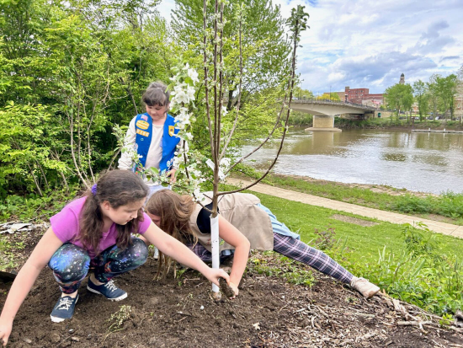(Photo by Nancy Taylor of the Marietta Times)

And—we are getting a bench! The Appalachian Ohio Falls Prevention Coalition has commissioned a custom bench from artist Todd Morrow, to be installed overlooking the habitat and the river. The city is about to pour the concrete pad, and the bench should be finished sometime in the next few weeks.

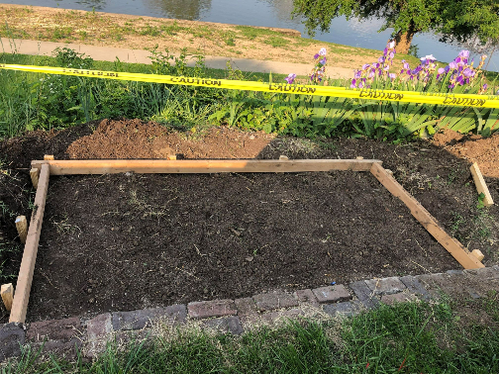

And speaking of the Hoffart/Henderhan Memorial Garden, the originally scheduled planting event was rained out, but heritage plants donated by neighbors and friends are going in the ground on May 21—after church, the Green Sanctuary meeting, and the Danielle Thrasher celebration, of course.
- Rebecca Phillips

Claire’s Logo Designs


FaCT Ohio Agreement
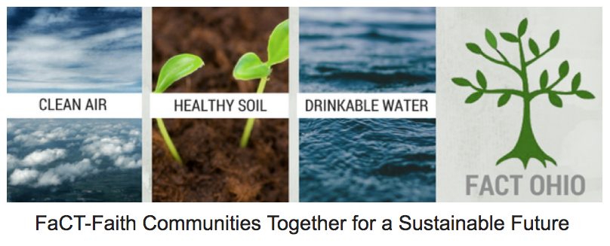
Date:
In a gesture of goodwill, FaCT Ohio enters in the following agreement with: __________________________________________ (name of committee) locate at:
_____________________________________ ______________________(name of church)
____________________________________________________________street address)
_________________ (city) _________(state) _______________________zip code:

- FaCT Ohio is very pleased to accept ____________________________ as a FaCT Ohio Anchor. A ‘FaCT Ohio Anchor’ refers to a faith community which has an important presence in a community and is tied to a certain location and shares an interest in climate change.

- ___________________, as a FaCT Ohio Anchor agrees to partner with FaCT Ohio to protect the air, water and soil and work to mitigate and remediate climate change by:
- Promoting sound environmental values and sustainable lifestyles
- Encouraging and generating individual and faith community action
- Providing educational tools and opportunities
- Teaching constituents to act as environmental watchdogs
- Influencing policy and decision making
- Fostering collaborative partnerships

- _________________, as a FaCT Ohio Anchor agrees with the following Basic Principles:

- FaCT Ohio Anchors are separate entities, under the nonprofit umbrella of their own faith community. There is no legal relationship with FaCT Ohio.
- FaCT Ohio Anchors understand and are guided by the mission statement and values of FaCT Ohio. This is in addition to their own mission and value statements.
- FaCT Ohio Anchors are encouraged to use the FaCT Ohio logo (in addition to their faith communities logo) when doing joint programming.
- FaCT Ohio Anchors will be asked, once per year to take up a collection for FaCT Ohio.
- FaCT Ohio support FaCT Ohio Anchors as reasonably possible.
- FaCT Ohio Anchors are encouraged to contribute to FaCT Ohio’s monthly newsletter.
- In order to report to each other, share ideas and successes, as well as learn new skills, FaCT Ohio Anchors are encouraged to attend semi-annual gatherings in person or via ZOOM.

- As part of this Letter of Agreement, FaCT Ohio offers Anchors the following Benefits:

- History: FaCT Ohio was founded 11 years ago at East Shore Unitarian Universalist (UU) Church in Mentor, OH. It is the oldest interfaith nonprofit organization in Ohio, whose sole purpose is to engage faith communities (originally in opposition to the harmful practices of the oil/gas industry in Ohio) and now includes the mitigation and remediation of climate change.
- Educational Resources: FaCT Ohio Anchors will have access to a range of resources and support materials, such as: books, promotional flyers, newsletters, podcasts and videos.
- Publicity: FaCT Ohio Anchors benefit from exposure through channels at FaCT Ohio’s website and monthly newsletter and e-blasts. FaCT Ohio already has an “established” presence in Ohio.
- Marketing Materials: FaCT Ohio Anchors may use FaCT Ohio’s name and logo on signboards and other materials such as letterheads and brochures.
- Networking and Capacity Building: FaCT Ohio can provide capacity building and networking opportunities for FaCT Anchors.
- Events and Activities: Representatives of FaCT Ohio Anchors may attend (in-person or via ZOOM) FaCT Ohio training workshops free of charge. FaCT Ohio Anchors receive frequent email blasts notifying constituents of important environmental updates, events, discussions and other activities.
- Newsletters: Constituents of each FaCT Ohio Anchor will receive a monthly digital copy of the FaCT Ohio newsletter and semi-monthly a hard copy of the FaCT Ohio newsletter.
- Professional Advice and Support: FaCT Ohio has a great deal of shared experience in contributing to environmental policies and legislation and is able to assist in interpreting environmental legislation as well as refer FaCT Ohio Anchors to relevant contacts in our network, which may be able to offer further assistance.

- A FaCT Ohio Anchor is advised to choose its name in relation to its geographic location. For instance, East Shore FaCT (UU Church in Mentor, OH); or Athens FaCT (St. Mary’s Catholic Church in Athens, OH). In some cases, A FaCT Ohio Anchor may have already chosen a name, such as West Shore FaCT in Westlake, OH.

- FaCT Ohio or _________________ may cancel this agreement at any time, after providing a notice of 30 days.

- General Expectation of FaCT Ohio and FaCT Ohio Anchors:

- FaCT Ohio will provide ______________ with digital format’s of its logo.

- ______________________ will provide constituent contact information from their committees to FaCT Ohio (names, mailing addresses, email addresses, phone #’s) and regularly update new information. These names will be added to FaCT Ohio’s contact list.

- FaCT Ohio will provide a list of Ohio Environmental Groups and their contacts to __________________________.

- ___________________ may not singularly institute legal action in the name of FaCT Ohio.

Signed,

Margaret R. Mills
President, FaCT Ohio

Pastor/Administrator
XYZ Church

