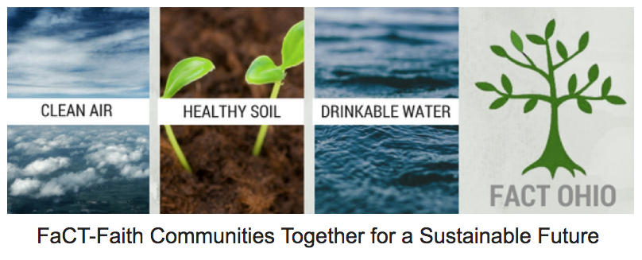
Date:
In a gesture of goodwill, FaCT Ohio enters in the following agreement with: __________________________________________ (name of committee) locate at:
_____________________________________ ______________________(name of church)
____________________________________________________________street address)
_________________ (city) _________(state) _______________________zip code:

- FaCT Ohio is very pleased to accept ____________________________ as a FaCT Ohio Anchor. A ‘FaCT Ohio Anchor’ refers to a faith community which has an important presence in a community and is tied to a certain location and shares an interest in climate change.

- ___________________, as a FaCT Ohio Anchor agrees to partner with FaCT Ohio to protect the air, water and soil and work to mitigate and remediate climate change by:
- Promoting sound environmental values and sustainable lifestyles
- Encouraging and generating individual and faith community action
- Providing educational tools and opportunities
- Teaching constituents to act as environmental watchdogs
- Influencing policy and decision making
- Fostering collaborative partnerships

- _________________, as a FaCT Ohio Anchor agrees with the following Basic Principles:

- FaCT Ohio Anchors are separate entities, under the nonprofit umbrella of their own faith community. There is no legal relationship with FaCT Ohio.
- FaCT Ohio Anchors understand and are guided by the mission statement and values of FaCT Ohio. This is in addition to their own mission and value statements.
- FaCT Ohio Anchors are encouraged to use the FaCT Ohio logo (in addition to their faith communities logo) when doing joint programming.
- FaCT Ohio Anchors will be asked, once per year to take up a collection for FaCT Ohio.
- FaCT Ohio support FaCT Ohio Anchors as reasonably possible.
- FaCT Ohio Anchors are encouraged to contribute to FaCT Ohio’s monthly newsletter.
- In order to report to each other, share ideas and successes, as well as learn new skills, FaCT Ohio Anchors are encouraged to attend semi-annual gatherings in person or via ZOOM.

- As part of this Letter of Agreement, FaCT Ohio offers Anchors the following Benefits:

- History: FaCT Ohio was founded 11 years ago at East Shore Unitarian Universalist (UU) Church in Mentor, OH. It is the oldest interfaith nonprofit organization in Ohio, whose sole purpose is to engage faith communities (originally in opposition to the harmful practices of the oil/gas industry in Ohio) and now includes the mitigation and remediation of climate change.
- Educational Resources: FaCT Ohio Anchors will have access to a range of resources and support materials, such as: books, promotional flyers, newsletters, podcasts and videos.
- Publicity: FaCT Ohio Anchors benefit from exposure through channels at FaCT Ohio’s website and monthly newsletter and e-blasts. FaCT Ohio already has an “established” presence in Ohio.
- Marketing Materials: FaCT Ohio Anchors may use FaCT Ohio’s name and logo on signboards and other materials such as letterheads and brochures.
- Networking and Capacity Building: FaCT Ohio can provide capacity building and networking opportunities for FaCT Anchors.
- Events and Activities: Representatives of FaCT Ohio Anchors may attend (in-person or via ZOOM )FaCT Ohio training workshops free of charge. FaCT Ohio Anchors receive frequent email blasts notifying constituents of important environmental updates, events, discussions and other activities.
- Newsletters: Constituents of each FaCT Ohio Anchor will receive a monthly digital copy of the FaCT Ohio newsletter and semi-monthly a hard copy of the FaCT Ohio newsletter.
- Professional Advice and Support: FaCT Ohio has a great deal of shared experience in contributing to environmental policies and legislation and is able to assist in interpreting environmental legislation as well as refer FaCT Ohio Anchors to relevant contacts in our network, which may be able to offer further assistance.

- A FaCT Ohio Anchor is advised to choose its name in relation to its geographic location. For instance, East Shore FaCT (UU Church in Mentor, OH); or Athens FaCT (St. Mary’s Catholic Church in Athens, OH). In some cases, A FaCT Ohio Anchor may have already chosen a name, such as West Shore FaCT in Westlake, OH.

- FaCT Ohio or _________________ may cancel this agreement at any time, after providing a notice of 30 days.

- General Expectation of FaCT Ohio and FaCT Ohio Anchors:

- FaCT Ohio will provide ______________ with digital format’s of its logo.

- ______________________ will provide constituent contact information from their committees to FaCT Ohio (names, mailing addresses, email addresses, phone #’s) and regularly update new information. These names will be added to FaCT Ohio’s contact list.

- FaCT Ohio will provide a list of Ohio Environmental Groups and their contacts to __________________________.

- ___________________ may not singularly institute legal action in the name of FaCT Ohio.

Signed,

Margaret R. Mills
President, FaCT Ohio

Pastor/Administrator
XYZ Church

