**Ohio Health Alert:**

**What You Need to Know About the Spreading   
of Radioactive Oil/Gas Well Brine Waste**

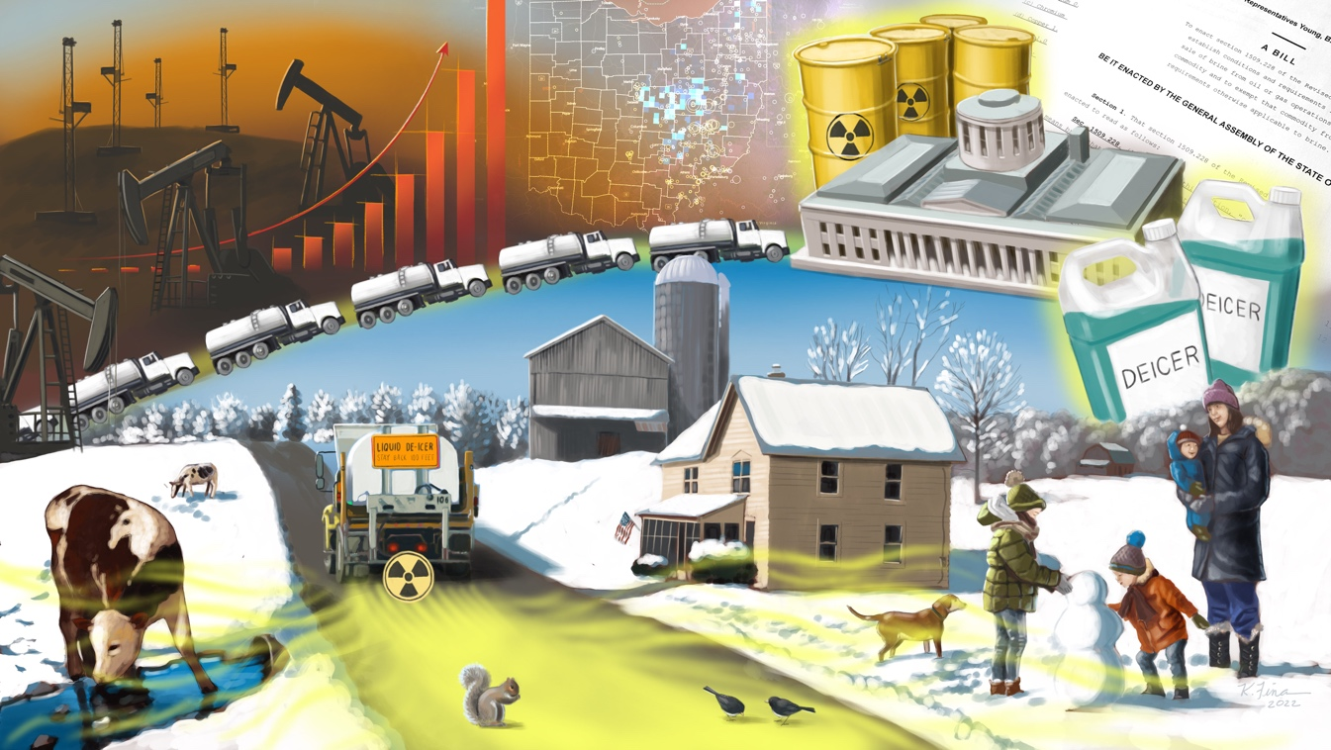

**Special Zoom Event**

**November 16 at 7 PM**

**Sponsored by Kent United Church of Christ**

**& Presented By**

**FaCT-Faith Communities Together for a Sustainable Future**

**If you live, drive, or walk on roads in Ohio, your health may be at risk from radioactive and toxic oil/gas well waste brine that is being applied to roads for deicing and/or for dust control. Your health and the health of your family is at risk. Please register and join FaCT’s Zoom presentation on November 16 to find out more and to find out what can be done to stop this dangerous practice.**

**Register here for this special Zoom event:** [**Dangerous Brine Spreading**](https://us02web.zoom.us/meeting/register/tZEtdeutqDovEtSAx6P4gWsRQ56ksutv9fin)