Volunteer Restoration Workday

Middle Island—St. Mary’s West Virginia

Hosted by the Friends of the Ohio River Islands

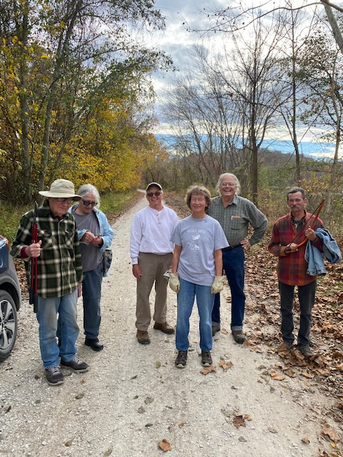

**When: Sunday, March 5th, 1-4PM, 2023**

**Where: Meet at the parking lot near park building—towards the center of the island.**

* We are continuing our removal of invasive plants along the entrance road to Middle Island.
* Removing these invasives plants will allow native critters and plants a chance to flourish on this restored bird and wildlife sanctuary.
* **No previous experience is necessary!** We will provide tools and snacks for the workday. Learn about the plants, birds, and wildlife at this beautiful Ohio rivers island (one of the few that has easy access by car.)
* Dress for working outdoors in weeds and shrubs: good work shoes, long pants, and long-sleeved shirts!

For more information contact: Mark Krivchenia [mark.krivchenia@gmail.com](mailto:mark.krivchenia@gmail.com) or Elaine Barr ([elaine_barr@fws.gov](mailto:elaine_barr@fws.gov) )