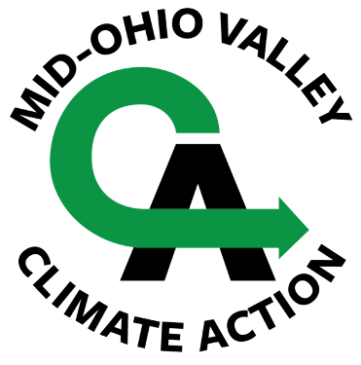
Mid-Ohio Valley Climate Action presents
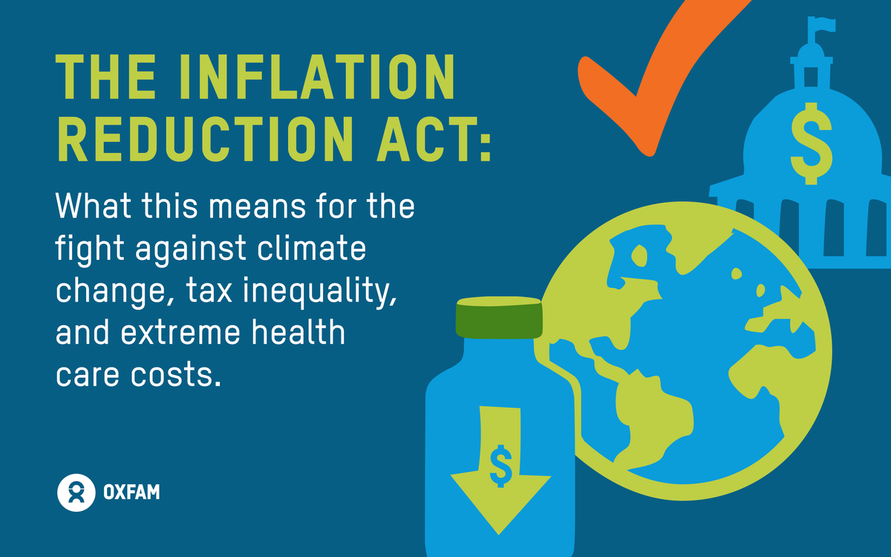
The Inflation Reduction Act –
Transition to a Clean Economy
Thursday, February 16, 2023
7:00 pm on Zoom

Illustration by Sandra Stowe for Oxfam

The IRA was signed into law in August of 2022, but many of us still don’t know much about it. As the provisions of the bill begin to roll out, this presentation offers an ideal opportunity to learn how this legislation will affect us - individual citizens - and our economy.

● Advance Registration Required! Register Here: https://us02web.zoom.us/meeting/register/tZwrc-yoqj8pHtRjvLW9Raopg4uRWklnqd2m
After registering, you will receive a confirmation email containing information about joining the meeting.
Guest Presenter: Perry Bryant
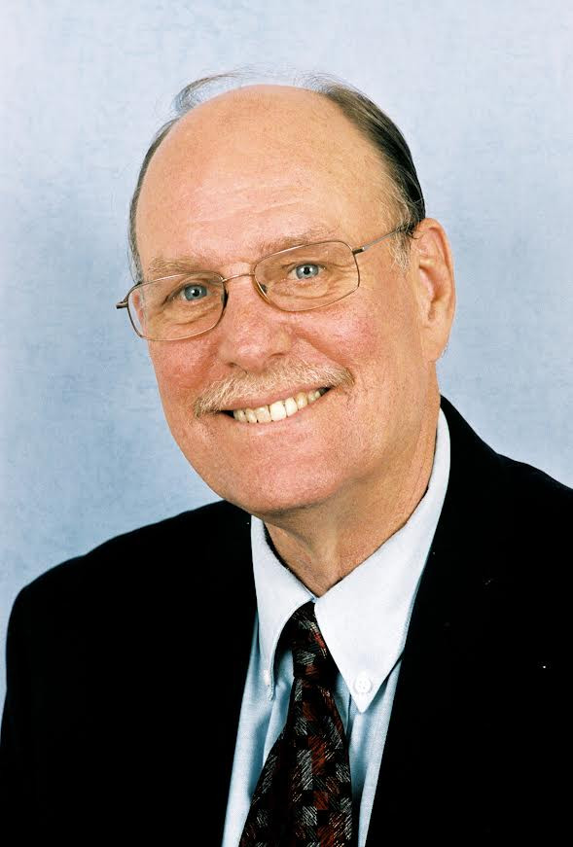
Perry Bryant has a degree in Sociology from Fairmont State University and did graduate work in Public Administration at West Virginia University. He retired from West Virginia Education Association, and founded West Virginians for Affordable Health Care. WVAHC is a public interest, non-profit organization that represents the interest of consumers in the health care debate. After retiring from WVAHC, Perry founded the West Virginia Climate Alliance, a broad-base coalition working on climate change. Perry was the principal author of a Citizens’ Guide to Climate Change: The Causes, Impacts and Potential Solutions. He also wrote A Summary of the Inflation Reduction Act.

All Are Welcome! Please join us!

