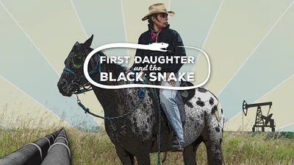
The prequel to Standing Rock
Wild rice. Pipelines. Prophecy. Family. food. Treaties.
Historical Trauma. Horses. Water.
Love Water, Not Oil.

Winona LaDuke believes Big Oil is the black snake predicted in Indigenous prophecy to bring the earth's distruction.When proposed new oil pipelines threaten sacred wild rice lakes, Winona dreams of organizing a spiritual ride, riding her horse against the current of oil, "because a horse can kill a snake."

Free Screening!
Sunday, August 28th, 2022
1:00 - 3:00 p.m.
in the Social Hall at
First Unitarian Universalist Society
232 Third Street, Marietta

The Green Sanctuary's 'Honoring Indigenous Peoples' team invites you to join us for this documentary film as we continue to learn about the courageous Indigenous People who are Water and Land Protectors.

