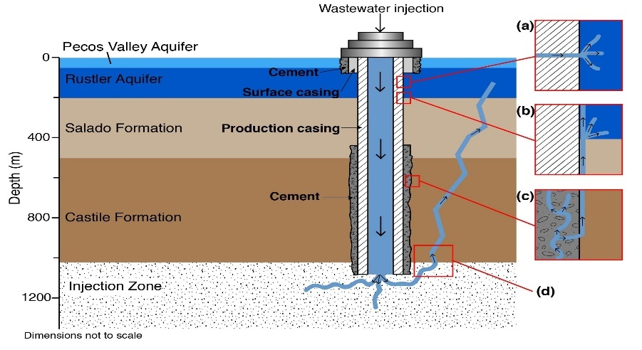
No More Injection Wells in Washington County
In 2021 Washington County ranked #1 in the state for the amount of brine waste injected into wells – 5 million barrels. Brine waste is the waste product of hydraulic fracturing (fracking), most of which is radioactive and contains harmful substances such as lead, arsenic, formaldehyde, mercury. Much of this brine waste comes from out of state (PA & WV), where stricter regulations about injection wells apply. Spills, leaks, and other accidents around these wells pose a danger to drinking water and even to oil & gas production wells. Increased truck traffic of this waste crowds our roads and provides further risks. There are few jobs associated with this capital-intensive industry, and companies that own these wells are from outside our county & state.
We the undersigned, therefore, oppose more injection wells and urge the Ohio Department of Natural Resources (Division of Oil & Gas Resources Management) not to approve any more permits for Class II injection wells in Washington County.
Name | Address | Email | Telephone #

