First Unitarian Universalist Society of Marietta
Green Sanctuary Committee Meeting
12:30 p.m., Sunday, February 20, 2022
Zoom platform

In attendance: George Banziger, Dawn Hewitt, Ginnie McNeil, Maggie Meyer, Mark Krivchenia (newcomer), Meghan Neibler (visitor from Fair Shake Environmental Services, invited by George), Jim Grecni and Debra Miller, Kelcey and Chris Jacobs, Patty Troisi, Cindy Taylor, Shari and Dave Ballantyne, and Mike and Adeline Bailey.

Dawn Hewitt called the meeting to order at 12:35 p.m.

Minutes of the January meeting were presumed approved as submitted.

Dawn invited Meagan Niebler, a visitor from Fair Shake Environmental Legal Services, to introduce herself. Meghan said that Fair Shake is a nonprofit legal firm, working on an initiative involving community democracy in the Marietta-Parkersburg area. At present, they are listening to area residents to learn what we envision for our communities, and to see what they can do to help move our vision forward. Thus far, she has heard interest in preservation of more natural areas for recreation and residents' concerns about water protection from such things as injection wells. She looks forward to working with GSC and other local environmental groups.

Clear into the Future Grant Projects Update

- Pollinator Habitat

In an email from Dawn sent after her inspection of the drip irrigation installation, she expressed concern about the shifting mulch that was no longer covering the system. She said covering all the exposed hose with mulch will take many hours on steep, muddy slopes, and probably contributed to erosion and soil compaction. She recommends that volunteers hold off with any major efforts but continue to check on the status and do a general clean-up until the weather is more favorable.

Inspection of the drip irrigation installation - schedule of volunteers:
Late February - George Banziger
Early March - Maggie Meyer
Late March - Dawn Hewitt

George Banziger announced that he had been approached by Marcus McCarty of OSU Extension services, who said that there is an opportunity to involve volunteers from the Master Gardeners program in the pollinator garden project.

- Solar Bench and Lock One Park Project
Dawn said there was no update on the Lock One Park, but suggested that she would contact Steve Wetz, city services director, to see if someone from GSC could participate on the city's committee in Rebecca's absence.
River Trail Sweeping Responsibility
Dawn reported the standing schedule for volunteers, as follows:
1 - Chris & Kelcey Jacobs … Jan & July
2 - Dawn Hewitt & Tim Finkel … Feb & Aug
3 - Patty Troisi & Cindy Taylor … Mar & Sept
4 - Dave Ballantyne & Mike Lang … Apr & Oct
5 - Jim Grecni & Debra Miller … May & Nov
6 - George Banziger & Darryl Ting … June & Dec
Sub list: Vic Elam and Maggie Meyer. Newcomer Mark Krivchenia has volunteered to help with this once a month when he is in town. He will work with Dawn in February to learn the scope of work, which Darryl Ting spelled out, as follows:
* We are responsible for the section of the River Trail in Muskingum Park from the Putnam Street Bridge to the sidewalk at the north end of the park.
* Cleaning frequency of twice a month … roughly every two weeks.
* Minimum requirement … keep the paved surface clear. Pick up all trash and natural debris (e.g., leaves, twigs and sweetgum balls) from the paved surface of the River Trail.
* If you have the time, also clear out a foot out from the edge of the pavement (to make the cleaning last longer).
* Natural debris can be deposited on the riverbank edge of the park.
* Trash can be put in the park trash containers or those outside FUUSM.
* If seasonal debris gets heavy, call for additional help from the sub list.
* If you can’t make it, it is YOUR responsibility to trade or find a substitute from the sub list.

GSC signs on to UUMFE letter to President Biden re: Build Back Fossil-Free campaign
Dawn reported that GSC (as an organization) signed on to a letter asking President Biden to make Build Back Better programs fossil-fuel free. Thanks to all who voted.
Also thanks to Adeline, I, and I hope others (as individuals) sent a letter to the president via Interfaith Power and Light, asking him to stick to his plans to address clean energy, climate change, and justice in Build Back Better.

The Condor and The Eagle Follow-up Project
Adeline Bailey reported that an organizing committee has met; she laid out general goals the committee has set:
1. Raise funds to support indigenous peoples' efforts to protect the environment.
2. Learn about indigenous peoples' understanding of nature
3. Involve young people ; reach out to schools
4. Make connections with other groups and individuals who share common interests
She requested support and participation from GSC members on the project. The team is looking into how the goals might be reached. The committee will next meet on Saturday, February 26th at 7 p.m. on Zoom. Adeline's notes from the last meeting are in the addendum.

Injection Wells Update - George Banziger's full reports are included in the addendum.
Highlights:
George said the brine waste issue is of great concern. Ben Hunkler of the Ohio River Valley Institute has drafted a one-page summary of brine waste from fracking wells that he developed for the group, Fresh Water Accountability Project. Meagan Niebler's group, Fair Shake Environmental, is also interested in work against brine waste and contamination of water supplies. Ben's article is in the addendum as a PDF file. George awaits word of filing of the lawsuit against Deep Rock disposal by independent gas and oil producers who posit that their production wells have been contaminated by escaping brine waste. Dawn noted that these "strange bedfellows" ultimately share our concern for assuring clean drinking water for our children and grandchildren.

ReImagine Appalachia update George Banziger's report in the addendum
George has added information to his draft letter to the Commissioners: two researchers from the Ohio River Valley Institute (ORVI) were very helpful in providing feedback on the draft letter, particularly with a case study of Centralia,WA.
George also attended a virtual ReImagine update meeting featuring speakers from the DOE. Grants are available through the bipartisan Infrastructure law that may be of interest to the Commissioners relating to rebuilding the economy in our county similar to the progress reported in the Centralia, WA, study. This meeting also touched upon the issue of hydrogen as a renewable energy source, something George says ORVI is quite skeptical about, since 95% of its production for energy use is derived from natural gas (methane).

Vic Elam could not attend this meeting, but he sent a link to an article about using hydrogen as a renewable energy source and a solution to fluctuations of power in wind and solar renewables. (link in addendum).

Joining Interfaith Power and Light
Dawn has reached out to Board President Chris Hoke to confirm our intention to covenant as a congregation with the Ohio IPL group. The Board will consider it at their next meeting.
Rebecca's report
- Paperwork for IPL certification is ready; we need to decide if we want to pay to officially join Ohio IPL or just be listed as an official Cool Congregation on the national site.

CCL Marietta Update: George Banziger's report is included in the addendum.
George said that CCL continues to request sending letters asking senators to support including carbon fee and dividend provisions in whatever form the bill eventually takes. Legislative efforts of CCL have recently been complicated by the initiative of some Democratic senators to waive the gasoline tax.
The Marietta chapter of CCL will meet tomorrow (Monday, February 21) on Zoom at 7 p.m. and will discuss, among other items, an agenda for their meeting with Congressman Bill Johnson’s staffer, Sam Hattrup, on February 23.

Mid-Ohio Valley Climate Action Update
Adeline reported that the group's February 17 program, a screening of the documentary Polar Extremes, offered a good lead-in to the planned program for March: “What Are The Poles (North and South) Telling Us About Earth’s Climate Future?” a webinar presented 7 p.m. on March 23 on Zoom by West Virginia Center on Climate Change. (Webinar ID: 977 4819 0388) Cindy Taylor reported that MOVCA is close to launching a Climate Ambassadors Program for middle-to-high school students, working with an intern from Marietta College. She reminded all to visit the MOVCA website (movclimateaction.org) to learn more about that program and other activities.

FACT Ohio Update
Ginnie McNeil reported that FaCT has been working with UU Justice Ohio and Rural Action to develop brine education materials and a series of Zoom webinars under the header "Connecting the Dots." A program on lead dangers is scheduled for February 26.

Earth Day Marietta 2022
Dawn is on the planning committee, but she asked for volunteers to take her place because she will be out of town if the event is held on April 23. (Subsequent to this meeting, the planning committee confirmed the April 23 date, at the Armory, 10 a.m. to 1 p.m.)

Other business
Earth Day Worship Service
Adeline reported that the Worship & Music committee suggested either April 17 (Easter) or April 24 as probable dates for a GSC-planned service. The committee favored April 24. Discussion of ideas for the service will be on the March meeting agenda.

The meeting was unanimously adjourned at 1:32 p.m.

Respectfully submitted,
Adeline Bailey, scribe

Next GSC meeting: Sunday, March 20, 12:30 p.m., probably on Zoom

Addenda February 2022
Dawn Hewitt - Pollinator Habitat Irrigation Inspection
Hi Green friends, especially Rebecca and Andrew,
I visited the riverbank today—the snow has finally melted!!

But I wasn’t sure what to do there. Some of the watering system is exposed, but it would be onerous and probably short-lived if I attempted to recover it with mulch. One area has netting covering the bed, but even there, the hoses are exposed. So, all I did there was to pick up a small amount of trash, and take photos. Oh, and I straightened the sign, which was cockeyed. I was tempted to weed out the creeping Charlie, but thought it might be helping to hold the soil.

Here are the highlights. Please advise me on what needs to be done, and I’ll endeavor to do it—although covering all the exposed hose with mulch will take many hours on steep, muddy slopes, and probably contributed to erosion and soil compaction.

I was tempted to weed out the creeping Charlie but thought it might be helping to hold the soil.

***********

Adeline Bailey - Condor and Eagle Project

The Condor and The Eagle follow-up project committee met February 5, 2022, on Zoom to discuss what we would like to accomplish. In general, we agreed that we had five goals in mind, and we discussed what we might do to reach those goals

1. Raise funds to support indigenous peoples' efforts to protect the environment
  - Sponsor craft/art "market" of items from native artisans - Kelcey and Chris Jacobs and Karen Binkley are looking into forging a relationship with a 10,000 Villages store in Pittsburgh to provide us with products from indigenous artisans and share in profits from sales that we would sponsor. Maybe do this in the fall.
  - Look into Equal Exchange or UUSC catalog sales - Adeline Bailey will continue to investigate what partnerships we might develop, possibly near the holiday seasono.
  - Ask for donations at events . Dawn Hewitt suggested hosting an in-person dinner in honor of indigenous people (foods, educational displays, documentary screening, guest speakers—see the next entry) with a suggested per person donation. Possible May date.
  - Plan public program(s) for documentary screening and/or guest speakers, either on Zoom or in person

2. Learn about indigenous peoples' understanding of nature
- Guest speakers as above—Rebecca Phillips had done some preliminary looking online and Jane Tumas-Serna had some suggestions, especially related to the indigenous people who act as water protectors (Line 3, Line 5, many other actions and protests). Cindy Taylor suggested Eileen Flanagan of EarthQuakers; Jane suggested Winona LaDuke, author of To Be a Water Protector
- Book study of Braiding Sweetgrass or to be a Water Protector
- Share information with the congregation and the community
- Sunday Service
- Study group or "RE" class maybe using TED Talks or other
- ILR at Marietta College. Adeline asked Martha McGovern, current ILR program director, about offering a class in the summer or next fall. Ted Goertzel and Rebecca may also have possible connections to help.

3. Involve young people: reach out to schools
- FUUSM RE classes (adult and kids)
- Marietta College George Banziger will contact Tony Mayle to see if there are events in the works planned by the Diversity and Inclusion program .
- WVUP - Rebecca and Maggie Meyer suggested as starting contacts
- WCCC
- Public Schools - Crystal Barnett- Sheaves suggested as able to direct us to appropriate contact with public school system

4. Make connections with other groups and individuals who could help us
  - MOVCA - Adeline has been in contact with a member who participated in Line 3 protest; Cindy Taylor suggested Eileen Flanagan; Jane suggested Winona LaDuke
  - Local groups involved with Native American studies or activities - Jane will look into some nearby powwows sponsored by Native American groups in our area. Christina Thrasher suggested as possible contact facilitator.
  - UUMFE - The Spring for Change events and activities resources will be helpful.
  - Interfaith Power and Light - Chris will investigate their spring/Earth Day resources
  - Friends Meeting - Kelcey reported that they are interested in keeping up with our plans and may want to participate.
  - Earth Day Marietta Celebration - maybe make the theme of GSC's booth tie in with Indigenous People/Water Protectors/
  - MultiCultural Festival - George says the date is third weekend in June (Fathers Day); a website or Facebook page with more info is forthcoming. (Carol Sedgewick from their planning committee says to beware of Facebook scam postings requesting $$)

5. Propose the project to GSC at February 20th meeting
- Ask others to join the project team
- Consult church calendar for possible dates

Next meeting: February 26, 2022, 7 p.m. on Zoom. Adeline or Mike will send the link.

George Banziger's reports

Letter to County Commissioners & ReImagine Appalachia.
In my cover message to the Green Sanctuary Committee that included my draft letter to the Washington County Commissioners, I explained the background leading to my drafting of the letter. One piece of advice I got from ReImagine Appalachia was to get additional signatories to the letter. So far seven people from the GSC have agreed to sign the letter. I am seeking other signatories from representatives of other groups in the county. Two researchers from the Ohio River Valley Institute were very helpful in providing feedback on the draft letter, particularly on the case study of Centralia WA. After the February 20 meeting I am hoping that other members of GSC will agree to sign the letter. I anticipate sending the letter on Monday, February 21. During the week leading up to this meeting I have received some additional minor edits in response to comments from some people on GSC and others.
On February 15 I attended the (virtual) meeting of the ReImagine Appalachia group. The major portion of the meeting was devoted to a presentation by two officials from the U.S. Department of Energy, who described several funding programs available through the Bipartisan Infrastructure Law. There are grant programs to provide assistance for revitalizing the economy in economically distressed areas that have relied on fossil-fuel industries I have followed up with one of the DOE officials to ask her about these grants. This opportunity relates to the letter to the commissioners because these grants might be a chance to rebuild the economy in our county along the lines of the Centralia WA model.
This meeting also touched upon the issue of hydrogen as a renewable energy source since the two DOE officials mentioned a public comment period on this topic. ORVI has published a quite skeptical article about the limits of hydrogen as an energy source. The major issue with hydrogen is that 95% of its production for energy use is derived from natural gas (methane), which is not renewable. I can share this publication with any GSC members who are interested.
Injection Wells
In addition to the two letters published on this topic previously in the Marietta Times (written by Maggie Meyer and by me), Vic Elam wrote an excellent LTE on this topic which was published in the Times on January 31. Dave Ballantyne told me he is drafting a letter as well—I sent him some background materials for “some grist for his mill.” Ben Hunkler of the ORVI has drafted a one-page summary of brine waste from fracking wells that he developed for the group, Fresh Water Accountability Project. It addresses that group’s concern about waste barging of brine waste, but it relates to injection wells as well. I have placed this one-page PDFile in a separate attachment.
Meagan Niebler of the Fair Shake group, an organization committed to environmental justice, will be a visitor to our GSC meeting on February 20. I think she will be interested in the brine waste issue because of her organization’s concern for those affected by fossil-fuel waste & emissions, such as people in our area impacted by leaks, spills, and other problems associated with injection wells in eastern Ohio, many of which are located in low-income areas.
I am still waiting for the news about the filing of the legal suit against injection well companies by the independent owners oil & gas production wells. Bob Lane, who is leading this legal effort, told me that he will let me know when the case is filed.
Citizens Climate Lobby
Citizen Climate Lobby continues to encourage its members (and others) to urge Democratic senators to support a carbon fee & dividend in whatever form the Build Back Better will take in the near future. The legislative efforts of CCL have recently been complicated by the initiative of some Democratic senators to waive the gasoline tax (an assumption of the carbon fee has been to make fossil fuels like gasoline more expensive in order to discourage its use). Some in CCL have made the point that gasoline accounts for only a small portion of greenhouse gas emissions. I assume that this effort by Democratic senators is designed to reduce the impact of inflation.
Our local chapter of CCL will meet on February 21 and will discuss, among other items, an agenda for our meeting with Congressman Bill Johnson’s staffer, Sam Hattrup, on February 23.
Muskingum Watershed Plan
I have heard nothing from Senator Sherrod Brown’s office or from the U.S. Army Corps of Engineers since Senator Brown’s letter to the head of the USACE asking him to attend to the concerns about the plan expressed by Ted Auch, Randi Pokladnik, and me.
George Banziger

************
Hydrogen 101
A backgrounder on hydrogen and its uses in the Ohio River Valley
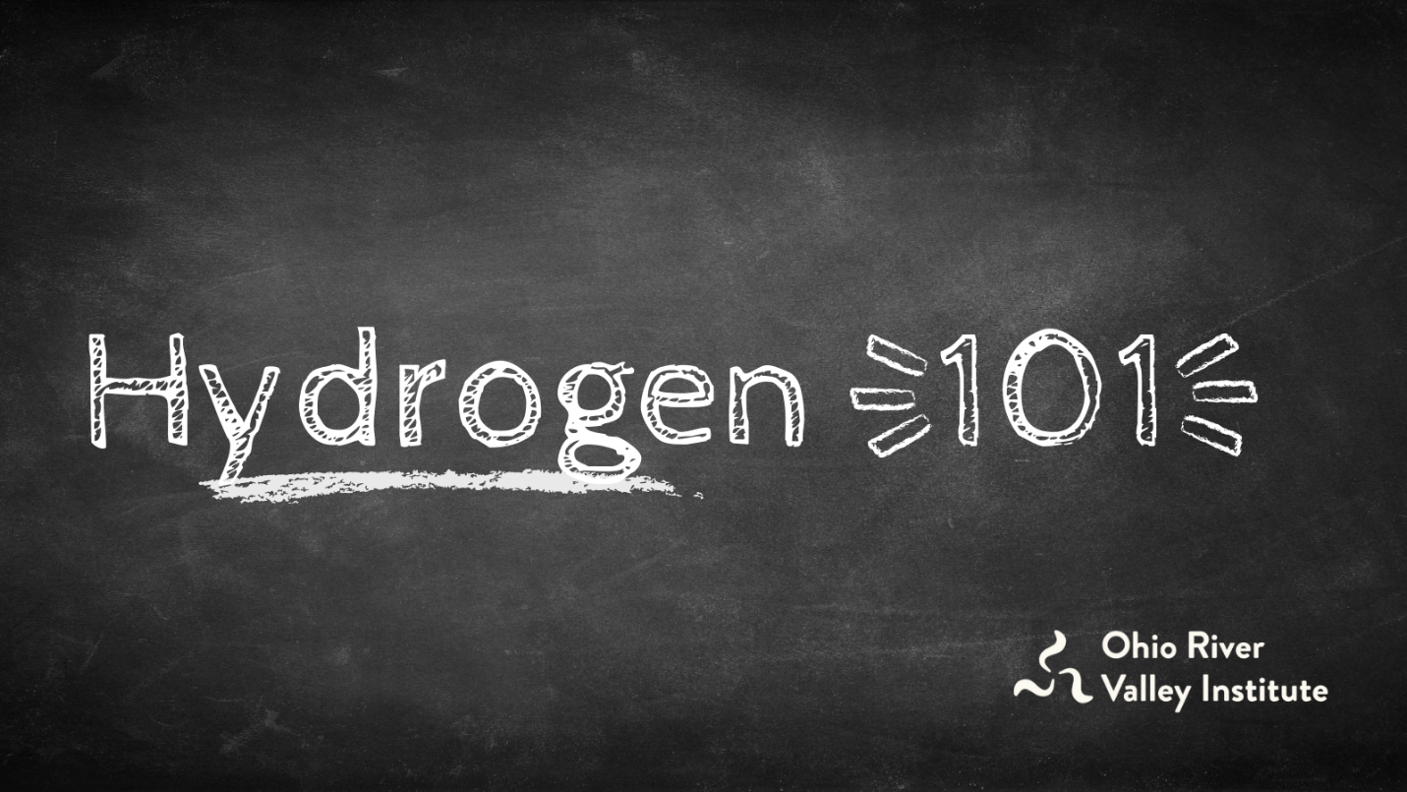
by Eric de Place
Aug 16, 2021 | Blog Posts, Clean Energy
In the last few months, hydrogen has garnered serious hype across the Ohio Valley as the zero-emissions fuel of the future. But should proponents’ claims be taken at face value? Is more skepticism warranted? What is hydrogen, really, and what are its uses and challenges in an economy transitioning toward clean energy? The Ohio River Valley Institute has prepared this explainer and infographic to shed light on the roles that various forms of hydrogen development and carbon capture and sequestration (CCS) should play in Appalachia and beyond.

Key Points
- Some of the hype about hydrogen and carbon capture is a false promise. There is a major risk that so-called “blue hydrogen” development will delay decarbonization, prolong fracking, and extend the economic failures of the fossil fuel industry. Protecting against the risks will require serious guardrails on hydrogen development.
- Nearly all hydrogen produced today is dirty. More than 95% of hydrogen currently on the market sources methane from fracked natural gas, a process that releases planet-warming methane and other pollution. Only green hydrogen, produced using water and electrolysis powered by renewable energy, has the potential to eliminate CO2 emissions while meeting need cost effectively, but it is not yet market-ready.
- To reduce carbon emissions, as well as prevent local pollution from fossil fuel extraction, the best strategy is twofold: electrify everything while cleaning up power generation. Any use of energy that can be electrified, should be. Even at its best, hydrogen and other “next generation” fuels should not be used for lighting, home appliances, and most transportation, but should instead be reserved for the small share of activities that cannot be powered by clean electricity.
- Green hydrogen should play a specific, limited role in a decarbonized future, many experts say. Green hydrogen is the best potential solution for a set of applications that are responsible for 15 to 25% of all greenhouse gas emissions. (Cement, steel, niche manufacturing, and heavy transport by sea and air comprise roughly 15% of emissions. The further 10% depends on the degree to which hydrogen is used for large-scale heating and other forms of transportation in which electricity is a capable but very expensive option, such as long-range trucking.) It is therefore unwise to oppose hydrogen in all forms, but rather to focus on opposing the various forms of dirty hydrogen, including “blue hydrogen.”
- Just so, there is a specific, limited role for carbon capture and sequestration (CCS). But it should not be used to justify business as usual for the fossil fuel industry because it is expensive, unreliable, and not technically feasible at a large scale. Drawdown author John Foley and many other energy experts point out that there are abundant, low-cost opportunities to decarbonize the economy immediately.

Hydrogen basics
There are several ways to produce hydrogen, but most of them use methane, a natural gas. This process, called steam reforming, converts methane into hydrogen and carbon dioxide and is known as “gray hydrogen.” If the carbon dioxide released during production is captured and sequestered, it is called “blue hydrogen.” Unfortunately, carbon capture and sequestration (CCS)—the defining feature of blue hydrogen—is expensive, unreliable, and not yet technically feasible at a large scale.
Hydrogen is only green if it is created using renewable energy though the process of electrolysis using water, rather than methane, as the feedstock. The future of green hydrogen inherently depends on increasing the production of low cost, reliable energy from sources like wind and solar. So if Pennsylvania aspires to be a center of green hydrogen, it should pursue rapid and widespread deployment of clean energy.
The gas industry is intent on pursuing blue–not green–hydrogen for the simple reason that the process relies on natural gas. There is no reason to believe that the current backers of the gas industry would want to pursue green hydrogen because it directly undercuts their interests. For example, participants in a recent forum sponsored by the Energy Futures Initiative made virtually no mention of green hydrogen.
Even if blue hydrogen producers somehow manage to safely trap the carbon that is emitted by steam reforming of methane gas, it would still require an extensive network of frack wells, compressor stations, pipelines, and other infrastructure that leaks methane and creates a welter of other problems.

What should hydrogen be used for?
There are a limited number of cases where green hydrogen could play an important role in a clean energy future. For example:
- Hydrogen fuel cells are better suited than batteries for long distance travel and transporting heavy loads, so green hydrogen could play a role in trucking, shipping, and aviation.
- Green hydrogen could replace fossil fuels in some industrial applications, like steel and cement production. (Still, the International Energy Agency forecasts that only 10 percent of steel will be produced with green hydrogen by 2050.)
- Hydrogen can store excess renewable energy, using electrolysis to produce green hydrogen for later use. (Analysts point out, however, that this process is highly inefficient, wasting a lot of energy in the process of converting and transferring it.)

What should hydrogen not be used for?
At the same time, there are major challenges to hydrogen, even in its cleanest form:
- Hydrogen should not be used for heating buildings. Heat pumps powered by clean electricity are a far better solution, using 80% less energy than hydrogen.
- Hydrogen is not a good choice for powering light and medium-duty vehicles. Electric vehicles powered by batteries are cheaper, perform better, and are easier to refuel.
- All forms of hydrogen production require substantial amounts of water. Many of the places in the US with the most abundant solar and wind resources are also facing meaningful constraints on their water supply.
- Large-scale hydrogen storage and transportation creates potentially serious risks for public safety. Hydrogen’s unique safety issues deserve careful analysis and planning.
- The main cost for producing green hydrogen is renewable electricity, which powers the electrolysis process that creates it. Analysts say that, to be competitive, green hydrogen prices will need to fall 65 to 85%, which they estimate will take 10 to 20 years.
- Falling prices for renewable electricity, which are necessary to support green hydrogen development, will directly compete with many (though not all) of the possible applications for hydrogen, such as powering buildings and vehicles.

What carbon capture and sequestration (CCS) should—and should not—be used for
Much like hydrogen, carbon capture and sequestration (CCS) has a specific, limited role to play in a clean energy future. For example, it could be used to reduce the carbon emissions from burning fossil fuels while the economy transitions to genuinely low-carbon energy production or for the small set of industrial activities that may not be possible to decarbonize.
CCS should not be used to prolong business as usual for the fossil fuel industry because there is simply not enough capacity to safely sequester all the carbon emitted by current activities nor is there a guarantee that trapped carbon would remain sequestered permanently. As Drawdown author John Foley points out, “Even the best technologies available today are stretching to absorb a few thousand tonnes of carbon dioxide. The problem is we currently emit about 50 billion tonnes of greenhouse gases every year… Even if removal technology can scale 1,000x to the million-tonne range, which is still years away, it would still need to grow by another 1,000-fold to even be a tiny percentage of the solution we need.” There is also a risk CCS will be used to justify ongoing operations of the coal, oil, and gas industries, which will result in continued air pollution, water pollution, health problems, and economic failures.

The current state of play for hydrogen and CCS
According to news reports, the bipartisan infrastructure package contains nearly $86 in new federal spending to support carbon dioxide transport and storage, plus $2.5 billion for research into the technological aspects of CCS. The bill also contains around $9 billion to support the development of blue and green hydrogen.
The newfound popularity of CCS has alarmed much of the environmental movement. In July 2021, more than 500 environmental groups from across North America signed a joint letter that harshly criticizes new plans. (The Center for International Environmental Law published a particularly trenchant critique.) Yet at the same time, a coalition of labor unions, infrastructure developers, and other environmental groups have urged Congress to spend money on carbon storage.

Takeaways
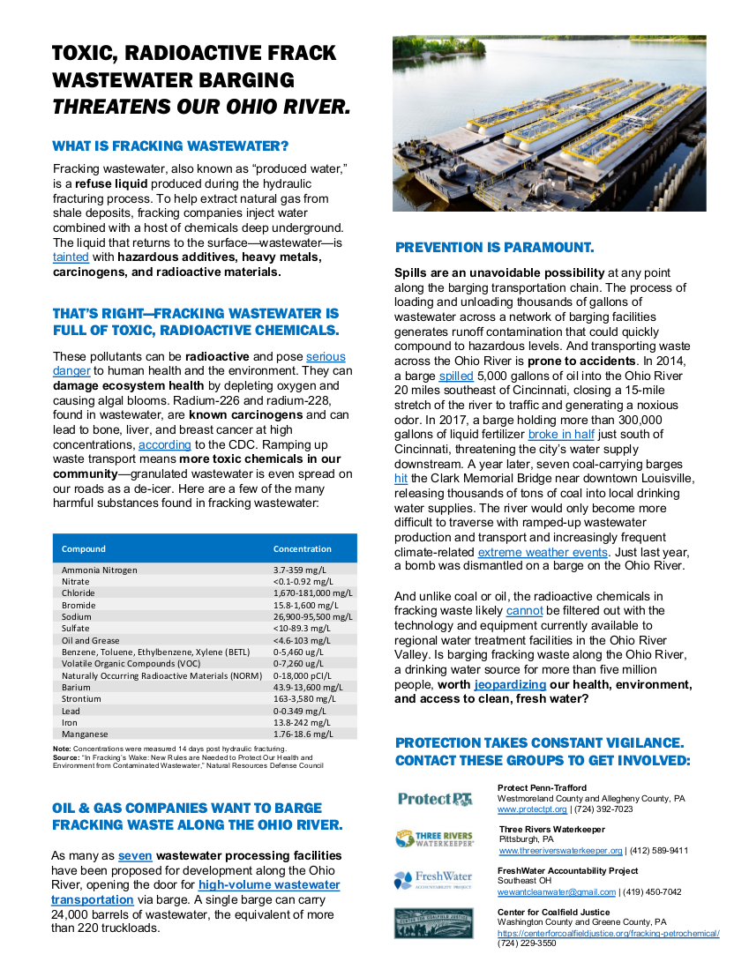
Much of the hype about hydrogen is misleading. Nearly all the hydrogen produced today is dirty, and clean hydrogen is not yet market-ready. Truly clean, green hydrogen has important niche applications in industries that are difficult or costly to electrify, but effective reduction of carbon emissions will result from expanded electrification and cleaning up power generation.
************************

Vic Elam sent this link to an article on hydrogen as energy source https://www.scientificamerican.com/article/solar-and-wind-power-could-ignite-a-hydrogen-energy-comeback/
*****************

