Hydrogen 101
A backgrounder on hydrogen and its uses in the Ohio River Valley
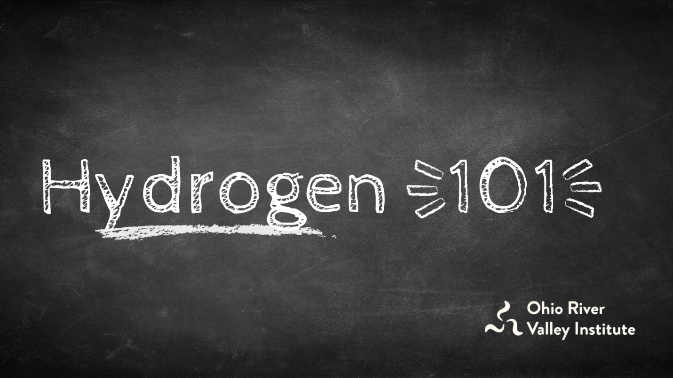
by Eric de Place
Aug 16, 2021 | Blog Posts, Clean Energy
In the last few months, hydrogen has garnered serious hype across the Ohio Valley as the zero-emissions fuel of the future. But should proponents’ claims be taken at face value? Is more skepticism warranted? What is hydrogen, really, and what are its uses and challenges in an economy transitioning toward clean energy? The Ohio River Valley Institute has prepared this explainer and infographic to shed light on the roles that various forms of hydrogen development and carbon capture and sequestration (CCS) should play in Appalachia and beyond.

Key Points
- Some of the hype about hydrogen and carbon capture is a false promise. There is a major risk that so-called “blue hydrogen” development will delay decarbonization, prolong fracking, and extend the economic failures of the fossil fuel industry. Protecting against the risks will require serious guardrails on hydrogen development.
- Nearly all hydrogen produced today is dirty. More than 95% of hydrogen currently on the market sources methane from fracked natural gas, a process that releases planet-warming methane and other pollution. Only green hydrogen, produced using water and electrolysis powered by renewable energy, has the potential to eliminate CO2 emissions while meeting need cost effectively, but it is not yet market-ready.
- To reduce carbon emissions, as well as prevent local pollution from fossil fuel extraction, the best strategy is twofold: electrify everything while cleaning up power generation. Any use of energy that can be electrified, should be. Even at its best, hydrogen and other “next generation” fuels should not be used for lighting, home appliances, and most transportation, but should instead be reserved for the small share of activities that cannot be powered by clean electricity.
- Green hydrogen should play a specific, limited role in a decarbonized future, many experts say. Green hydrogen is the best potential solution for a set of applications that are responsible for 15 to 25% of all greenhouse gas emissions. (Cement, steel, niche manufacturing, and heavy transport by sea and air comprise roughly 15% of emissions. The further 10% depends on the degree to which hydrogen is used for large-scale heating and other forms of transportation in which electricity is a capable but very expensive option, such as long-range trucking.) It is therefore unwise to oppose hydrogen in all forms, but rather to focus on opposing the various forms of dirty hydrogen, including “blue hydrogen.”
- Just so, there is a specific, limited role for carbon capture and sequestration (CCS). But it should not be used to justify business as usual for the fossil fuel industry because it is expensive, unreliable, and not technically feasible at a large scale. Drawdown author John Foley and many other energy experts point out that there are abundant, low-cost opportunities to decarbonize the economy immediately.

Hydrogen basics
There are several ways to produce hydrogen, but most of them use methane, a natural gas. This process, called steam reforming, converts methane into hydrogen and carbon dioxide and is known as “gray hydrogen.” If the carbon dioxide released during production is captured and sequestered, it is called “blue hydrogen.” Unfortunately, carbon capture and sequestration (CCS)—the defining feature of blue hydrogen—is expensive, unreliable, and not yet technically feasible at a large scale.
Hydrogen is only green if it is created using renewable energy though the process of electrolysis using water, rather than methane, as the feedstock. The future of green hydrogen inherently depends on increasing the production of low cost, reliable energy from sources like wind and solar. So if Pennsylvania aspires to be a center of green hydrogen, it should pursue rapid and widespread deployment of clean energy.
The gas industry is intent on pursuing blue–not green–hydrogen for the simple reason that the process relies on natural gas. There is no reason to believe that the current backers of the gas industry would want to pursue green hydrogen because it directly undercuts their interests. For example, participants in a recent forum sponsored by the Energy Futures Initiative made virtually no mention of green hydrogen.
Even if blue hydrogen producers somehow manage to safely trap the carbon that is emitted by steam reforming of methane gas, it would still require an extensive network of frack wells, compressor stations, pipelines, and other infrastructure that leaks methane and creates a welter of other problems.

What should hydrogen be used for?
There are a limited number of cases where green hydrogen could play an important role in a clean energy future. For example:
- Hydrogen fuel cells are better suited than batteries for long distance travel and transporting heavy loads, so green hydrogen could play a role in trucking, shipping, and aviation.
- Green hydrogen could replace fossil fuels in some industrial applications, like steel and cement production. (Still, the International Energy Agency forecasts that only 10 percent of steel will be produced with green hydrogen by 2050.)
- Hydrogen can store excess renewable energy, using electrolysis to produce green hydrogen for later use. (Analysts point out, however, that this process is highly inefficient, wasting a lot of energy in the process of converting and transferring it.)

What should hydrogen not be used for?
At the same time, there are major challenges to hydrogen, even in its cleanest form:
- Hydrogen should not be used for heating buildings. Heat pumps powered by clean electricity are a far better solution, using 80% less energy than hydrogen.
- Hydrogen is not a good choice for powering light and medium-duty vehicles. Electric vehicles powered by batteries are cheaper, perform better, and are easier to refuel.
- All forms of hydrogen production require substantial amounts of water. Many of the places in the US with the most abundant solar and wind resources are also facing meaningful constraints on their water supply.
- Large-scale hydrogen storage and transportation creates potentially serious risks for public safety. Hydrogen’s unique safety issues deserve careful analysis and planning.
- The main cost for producing green hydrogen is renewable electricity, which powers the electrolysis process that creates it. Analysts say that, to be competitive, green hydrogen prices will need to fall 65 to 85%, which they estimate will take 10 to 20 years.
- Falling prices for renewable electricity, which are necessary to support green hydrogen development, will directly compete with many (though not all) of the possible applications for hydrogen, such as powering buildings and vehicles.

What carbon capture and sequestration (CCS) should—and should not—be used for
Much like hydrogen, carbon capture and sequestration (CCS) has a specific, limited role to play in a clean energy future. For example, it could be used to reduce the carbon emissions from burning fossil fuels while the economy transitions to genuinely low-carbon energy production or for the small set of industrial activities that may not be possible to decarbonize.
CCS should not be used to prolong business as usual for the fossil fuel industry because there is simply not enough capacity to safely sequester all the carbon emitted by current activities nor is there a guarantee that trapped carbon would remain sequestered permanently. As Drawdown author John Foley points out, “Even the best technologies available today are stretching to absorb a few thousand tonnes of carbon dioxide. The problem is we currently emit about 50 billion tonnes of greenhouse gases every year… Even if removal technology can scale 1,000x to the million-tonne range, which is still years away, it would still need to grow by another 1,000-fold to even be a tiny percentage of the solution we need.” There is also a risk CCS will be used to justify ongoing operations of the coal, oil, and gas industries, which will result in continued air pollution, water pollution, health problems, and economic failures.

The current state of play for hydrogen and CCS
According to news reports, the bipartisan infrastructure package contains nearly $86 in new federal spending to support carbon dioxide transport and storage, plus $2.5 billion for research into the technological aspects of CCS. The bill also contains around $9 billion to support the development of blue and green hydrogen.
The newfound popularity of CCS has alarmed much of the environmental movement. In July 2021, more than 500 environmental groups from across North America signed a joint letter that harshly criticizes new plans. (The Center for International Environmental Law published a particularly trenchant critique.) Yet at the same time, a coalition of labor unions, infrastructure developers, and other environmental groups have urged Congress to spend money on carbon storage.

Takeaways
Much of the hype about hydrogen is misleading. Nearly all the hydrogen produced today is dirty, and clean hydrogen is not yet market-ready. Truly clean, green hydrogen has important niche applications in industries that are difficult or costly to electrify, but effective reduction of carbon emissions will result from expanded electrification and cleaning up power generation.

Eric de Place

