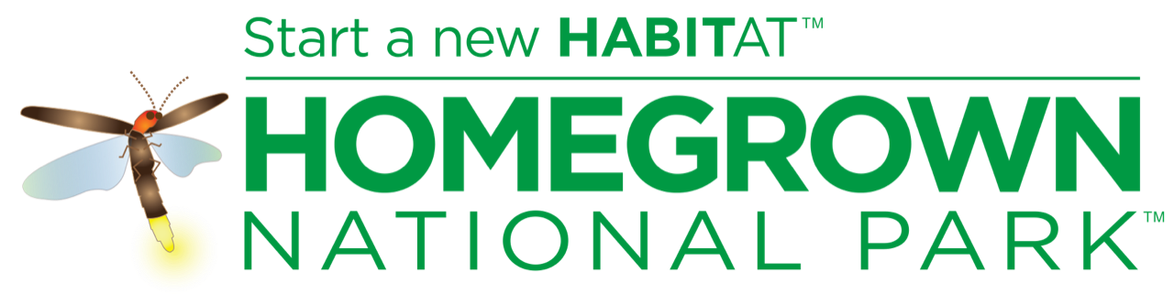
THE PROBLEM
Our planet is experiencing an increasing rate of species extinction. Bird and insect populations are particularly in decline. North America has lost a quarter of its bird population--three billion birds--since 1970. Much of this loss relates directly to the loss of insects. More than 95% of songbirds, for example, feed their young almost exclusively on caterpillars. Ohio alone has seen a 30% decline in the number of butterflies over the last twenty years. Monarch butterfly populations have plummeted by 90%. The populations of bees and other pollinating insects are also declining. In some parts of Europe, the decline has reached 70%.

WHY SHOULD I CARE?
Humans cannot exist without biodiversity. Most of the flowering plants that are the basis of all terrestrial food webs are insect-pollinated. Basically, without insects and the plants that feed them, we have no food.

HOW CAN I HELP?
Plant native! HOMEGROWN NATIONAL PARK™ is a grassroots call-to-action to restore biodiversity and ecosystem function by planting native plants and creating new ecological networks.

OUR MISSION
TO RESTORE BIODIVERSITY AND ECOSYSTEM FUNCTION because every human being on this planet needs diverse highly productive ecosystems to survive.

OUR GOAL
Our goal is 20 million acres of native plantings in the U.S. This represents approximately ½ of the green lawns of privately-owned properties and will effectively double the area of our existing national parks.

THIS PLANTING
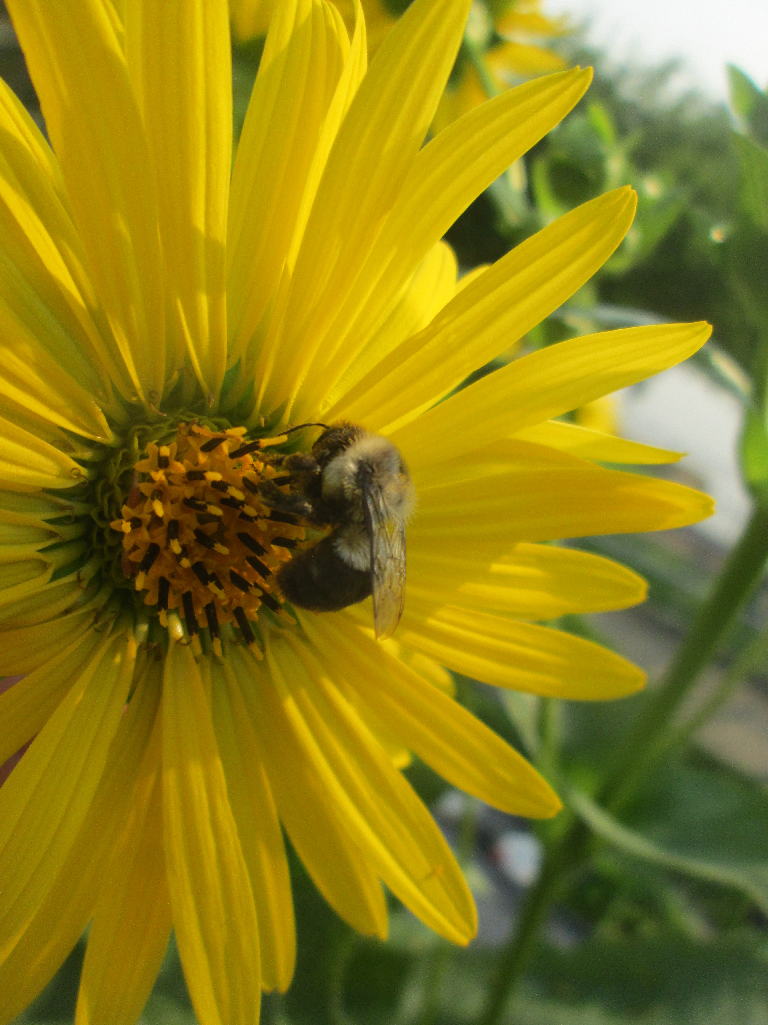
This Fort Street pollinator planting is a project of the Green Sanctuary Committee of the First Unitarian Universalist Society in partnership with the City of Marietta, made possible by a grant from Dupont's Clear Into the Future program. When fully planted, it will provide a more than 200-foot sweep of native flowering plants that will not only provide habitat but reduce erosion, filter toxins from street runoff, and reduce maintenance on the site. In the meantime, mulch donated by Greenleaf Landscapes is protecting the soil.

WHY NATIVE PLANTS?
All plants protect themselves with naturally-occurring chemicals to deter predation. Over time, plant-eating insects have developed the physiological adaptations required to digest the chemicals in their host plant’s leaves and have specialized to eat only the plants sharing those particular chemicals. When we present insects from Ohio with plants that evolved on another continent, chances are those insects will be unable to eat them.
HOW DO I START?
Based on advice from Doug Tallamy of the University of Delaware, author of Nature's Best Hope and originator of Homegrown National Park.

- SHRINK THE LAWN. Every square foot dedicated to lawn is a square foot that is degrading local ecosystems. Turfgrass offers no ecological benefits (though it is nice to walk on). Replacing half your lawn with native plants creates wildlife habitat and increases our Homegrown National Park.
- REMOVE INVASIVE SPECIES. Invasive plants are those that can spread unchecked into natural ecosystems; the worst offenders vary from state to state. Some of the villains in our area are barberry, Bradford pear, burning bush, English ivy, privet, and purple loosestrife.
- ADD KEYSTONE PLANTS TO YOUR LANDSCAPE.
Professor Tallamy's research at the University of Delaware has shown that a few keystone genera of native plants form the backbone of local ecosystems, particularly in terms of serving as larval hosts for insects.
Landscapes that do not contain one or more species from keystone genera will have failed food webs, even if the diversity of other plants is very high.
MOV NATIVE PLANT SUPERSTARS:
- Oaks. These long-lived trees feed 477 species of butterflies and moths in our area.
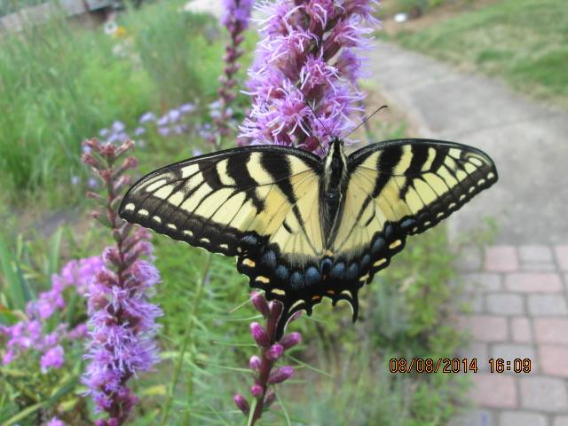
- Native cherries and plums. 381 species.
- Willow. 328 species.
- Maple. 273 species.
- Goldenrod. 122 species.
- Perennial sunflower. 76 species.
- Joe-Pye weed. 32 species.
- Violets. 29 species.
- Switchgrass. 27 species.
- Wild geranium. 25 species.
- BUILD A CONSERVATION HARDSCAPE (you don’t have to be a gardener!)
- Each year millions of toads, frogs, and other small creatures become trapped in our window wells where they slowly starve to death. Installing cheap window well covers can reduce these needless deaths to zero.
- Use motion sensor security lights that light up only when an intruder enters your yard. Blazing security lights kill thousands of moths.
- Set your mower height no lower than 3 inches. This will give you healthier greener grass that requires less watering but also mows safely over a box turtle! Try not to mow in the evening when many nocturnal species leave their hiding places.
- Install a bubbler. Small water features with gentle gurgling sounds are irresistible to migrating and resident birds.
5. EDUCATE YOURSELF.
Libraries and the internet are full of great resources. Good places to start are Doug Tallamy's books and the following websites:
- https://www.nwf.org/NativePlantFinder/Plants
- https://homegrownnationalpark.org
We can do this!

