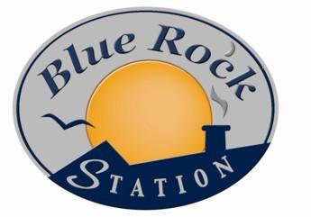

Blue Rock Station LLC
1190 Virginia Ridge
Philo OH 43772
(740) 674-4300
annie@bluerockstation.com
www.bluerockstation.com

To: Dawn Hewitt, First Unitarian Universalist Society – Marietta Ohio

Memo of Understanding for the First Unitarian Universalist Society (FUUSM) and Blue Rock Station (BRS)

Jay Warmke will teach the Solar Installer Level I class on April 30th – May 3rd 2020 for a minimum of six (6) students. The maximum number is 10 students.

The fee for the class is $970 per student with $150 of the fee paid to ETA for the international certification. BRS will share 25% ($205.00 minus credit card fees) of the $820 registration fee per student with FUUSM. All student registration fees will be due 10 days prior to the beginning of class. All fees due to FUUSM will be paid within 14 days of the completion of a class.

FUUSM will:
- market the class to obtain students
- provide coffee/tea
- provide three tables for the lab portion of the class
- provide classroom space, large enough to accommodate the students registered
- provide chairs for each participant and the instructor
- Provide a daily lunch

BRS will:
- market the class on social media and the BRS Website, plus may mention it at public appearances and at their two regularly scheduled radio programs.
- take all registrations
- provide instruction for five days
- provide a study guide textbook
- notify the UU designated contact when a new person registers
- provide the registrant’s contact information. All registrants will receive an update with site location, etc. one week prior to the class date.
- proctor the certification exam.

All checks or transfers for the ETA certification test will be made to Blue Rock Station LLC. BRS will be responsible for paying the exam fees to ETA International at the time of submitting the exams for grading (usually sent the day after the exam).

ETA International will notify each student directly regarding their certification and provide them with appropriate credentials for their certification. If the student does not pass the exam ETA allows one re-take for free within one year of the test. Blue Rock Station offers that the student can re-take the test one time for free on a space available basis.

