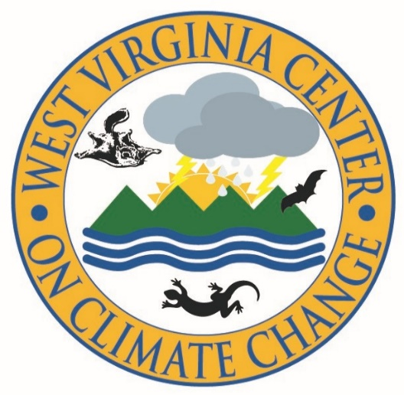

**Saturday, September 21, 2019 9:30 AM – 4:00 PM**

A free public educational workshop program in Morgantown, West Virginia

**Climate Change and Public Health:**

**Addressing the Growing Crisis**

Accelerating global warming and climate change are affecting every facet of human life and well-being. Economic, physical, and mental injuries from increased heat and extreme weather – as well as the deadly political and national security impacts of global disease, food scarcity, and forced migration – these growing impacts and more threaten human health and safety worldwide.

What is at stake, and what can we do? At this free public educational program, attendees will hear and discuss presentations from experts in the field of climate change and public health – and learn about the latest developments, issues, and practices we can use to successfully confront this crisis.

**The program will be held on Saturday, September 21, 2019 from 9:30 AM to 4:00 PM, at the West Virginia University College of Law Event Hall in Morgantown, WV.**

**Registration is free and includes a buffet luncheon at 12:00 noon.**

**Continuing Education credits for certified public health professionals (5 CPH-CE hours) are available. To receive credit, participants must attend all sessions and complete an evaluation.**

**To register, please visit** [**https://saveblackwater.org/west-virginia-center-on-climate-change/climate-change-and-public-health**](https://saveblackwater.org/west-virginia-center-on-climate-change/climate-change-and-public-health) **and use the form at the bottom of the page.**

This program is organized by theWest Virginia University College of Law [**Center for Energy and Sustainable Development**](https://energy.law.wvu.edu/)and the [**West Virginia Center on Climate Change (“WV3C”)**](https://saveblackwater.org/west-virginia-center-on-climate-change/), a project of [**Friends of Blackwater**](https://saveblackwater.org/), cooperating with the [**Mid-Atlantic Regional Public Health Training Center**](https://www.jhsph.edu/research/centers-and-institutes/mid-atlantic-public-health-training-center/index.html).

For the latest information, go to the program web page listed above, or contact the WV3C Project Director, Logan Thorne, 304-657-5455, logan.thorne.lt@gmail.com; or Friends of Blackwater, 304-345-7663, [info@saveblackwater.org](mailto:info@saveblackwater.org).

**Updated Topic and Speaker Info on Reverse**

**WELCOMING REMARKS: Dr. Robert Duval, Ph.D.,** Professor of Health Policy, Management, and Leadership, WVU School of Public Health

**KEYNOTE LUNCEHON SPEAKER: Dr. Bernard D. Goldstein, M.D.,** Professor Emeritus of Environmental and Occupational Health, and former Dean of the University of Pittsburgh Graduate School of Public Health, is an environmental toxicologist and science historian who has amassed nearly six decades of research in global public health and air quality issues. Before coming to the University of Pittsburgh, Dr. Goldstein was professor and chairman of the department of environmental and community medicine at the University of Medicine and Dentistry of New Jersey-Robert Wood Johnson Medical School, where he established and directed the largest academic environmental and occupational health program in the United States -- the Environmental and Occupational Health Sciences Institute. He has also served as an officer with the U.S. Public Health Service and as assistant administrator for research and development at the U.S. Environmental Protection Agency. Dr. Goldstein recently testified before the House of Representatives Committee on Oversight and Reform to bring attention to the public health implications of climate change. He received his medical degree from New York University and a B.S. in Psychology from the University of Wisconsin.

**MENTAL HEALTH IMPACTS:** The public health implications of climate change are no longer solely being felt in physical ailments. As evidenced by the urgent nature of global climate change movements and the recent uptick of climate change themes in contemporary literature, television, and film—the lens through which we illustrate societal feelings—it is clear that anxieties about the prospects of a livable future in the face of widespread political and social inaction are creeping into the psyche of global citizens with increasing frequency. In this section, expert presenters and group discussion will examine the mental health implications of global climate change and provide guidance for mental health professionals and concerned citizens alike that can help build resilience to this psychological distress.

**Dr. Lise Van Susteren, M.D.,** Board Certified General and Forensic Psychiatrist, Washington, DC, Former Assistant Clinical Professor of Psychiatry, Georgetown University Department of Psychiatry

**Dr. Susan Clayton, Ph.D,** Whitmore-Williams Professor of Psychology and Chair of Environmental Studies, College of Wooster, Fellow, American Psychological Association

**EMERGENCY AND DISASTER PREPAREDNESS:** From the political and national security implications of increased famine and drought, to the dismantling of existing safety systems resulting from repeated record-breaking natural disasters, climate change threatens to destabilize emergency preparedness and disaster response worldwide. In this section, expert presenters and group discussion will examine these political, social, and public health implications and the adaptation measures necessary to support current procedures in the wake of this growing threat.

**SPEAKERS: Dr. Daniel Barnett**, M.D., M.P.H., Associate Professor, Department of Environmental Health & Engineering, Johns Hopkins Bloomberg School of Public Health

****.