**Blue Rock Station Visit – May 18 2019**

**Annie giving initial introduction**

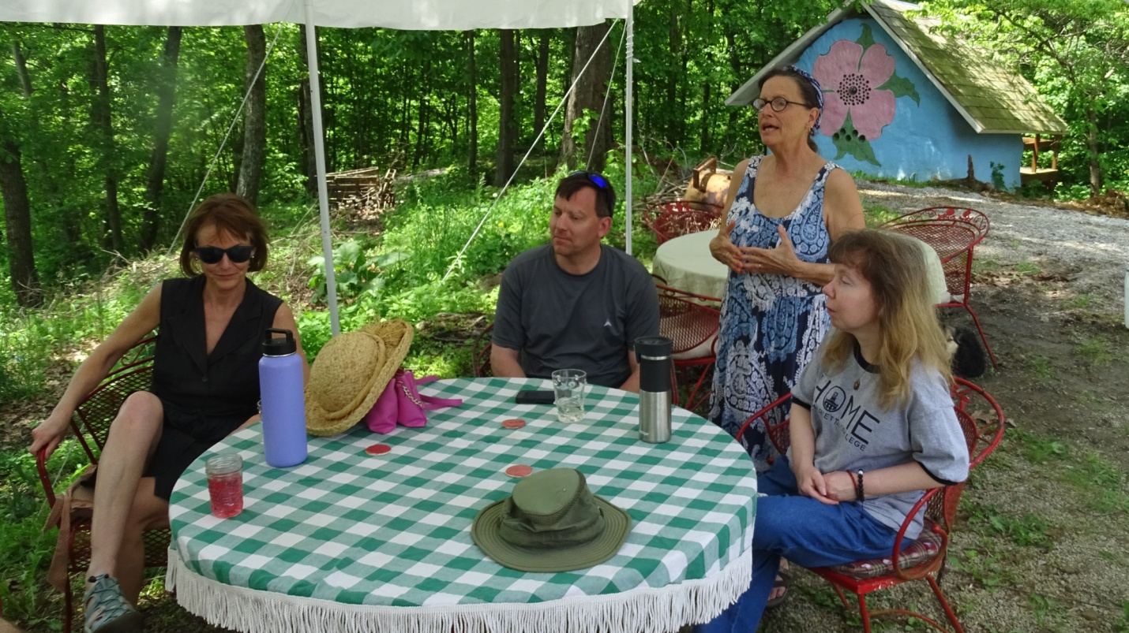

**Dogwood House**

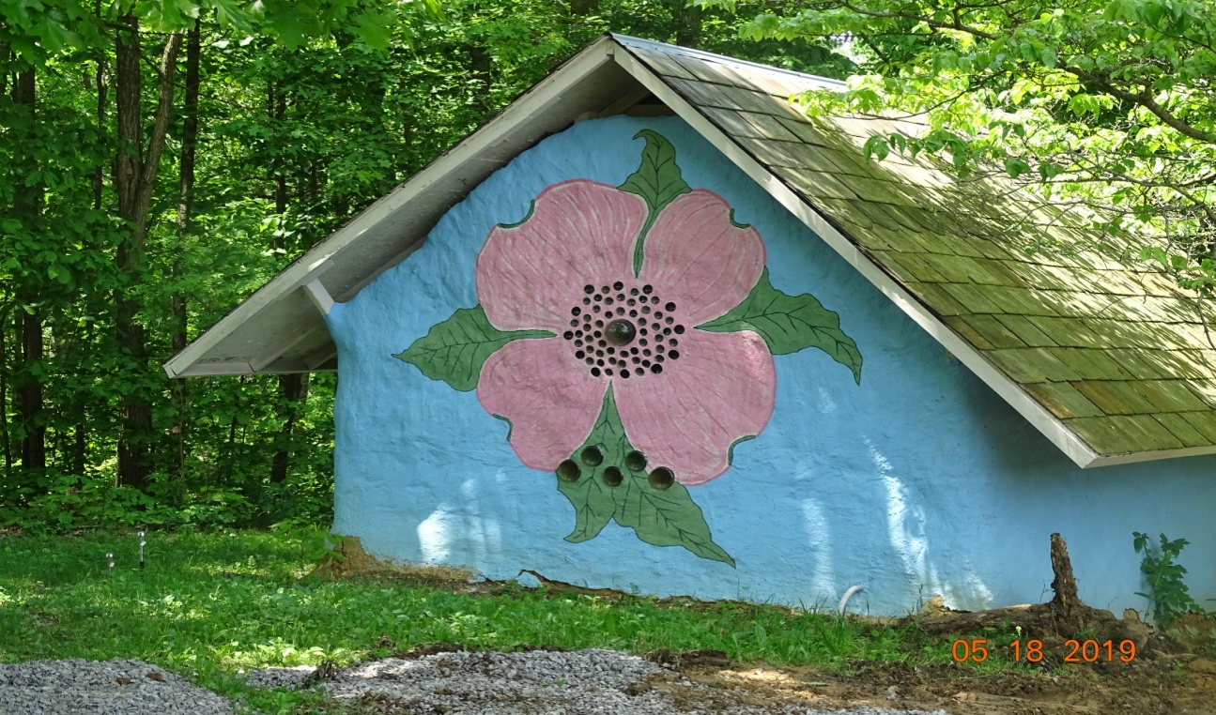

**Dragon House**

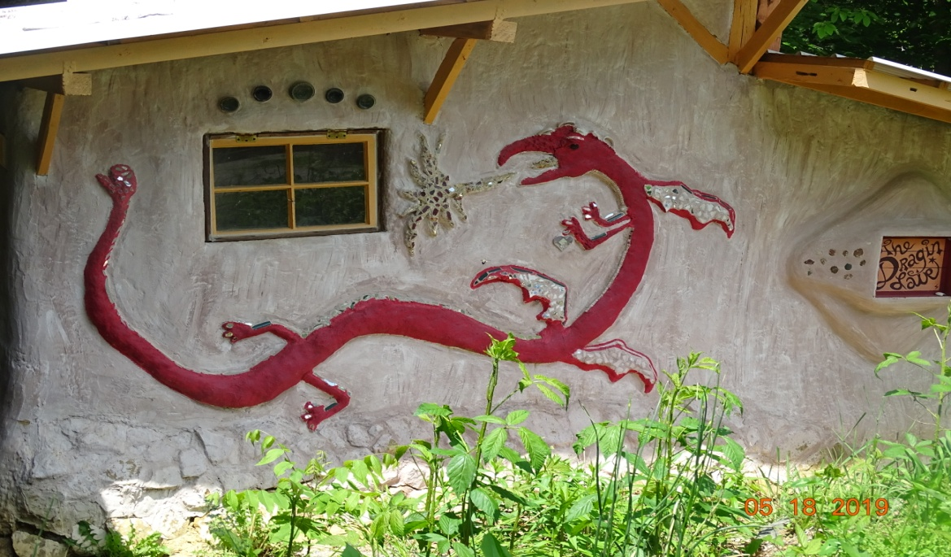

**Self-service – washing dishes**

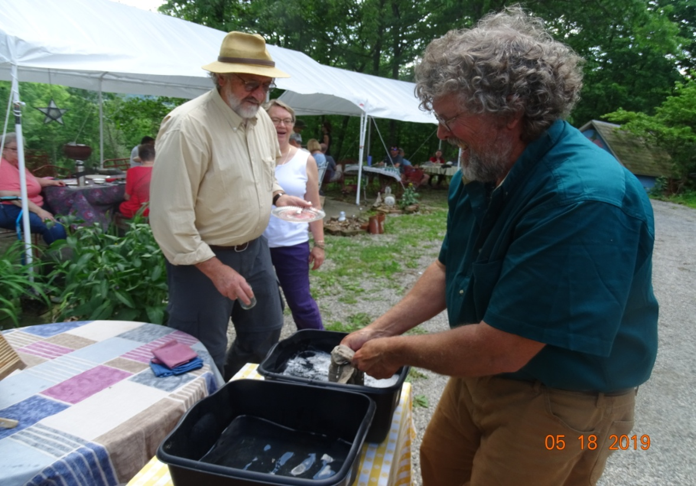

**Solar-heated shower**

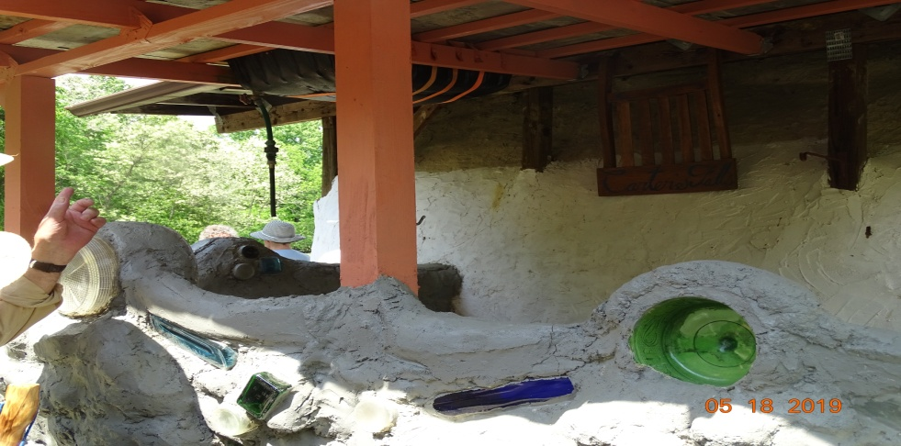

**Privy with a view**

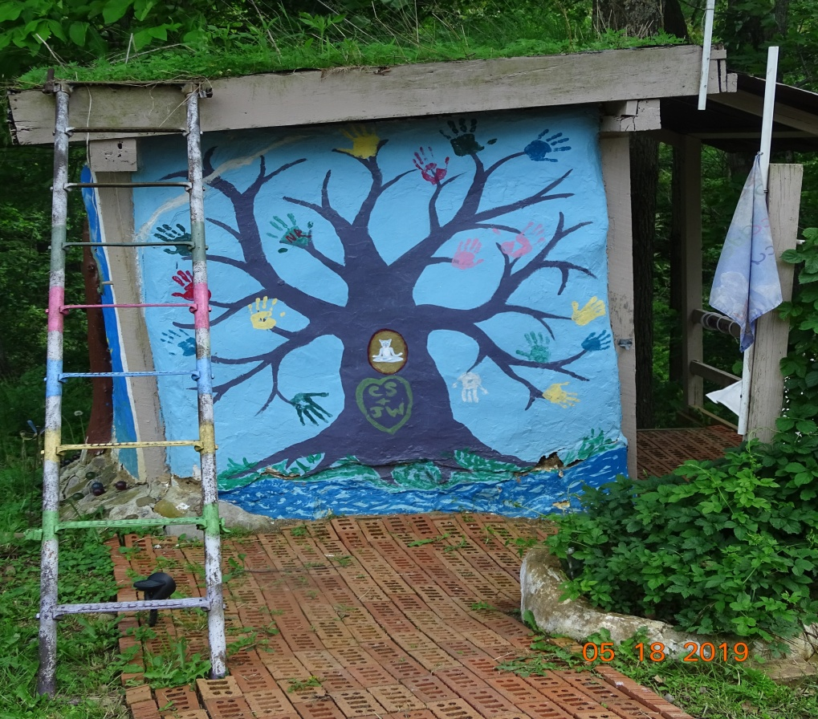

**Waddle & daub wall**

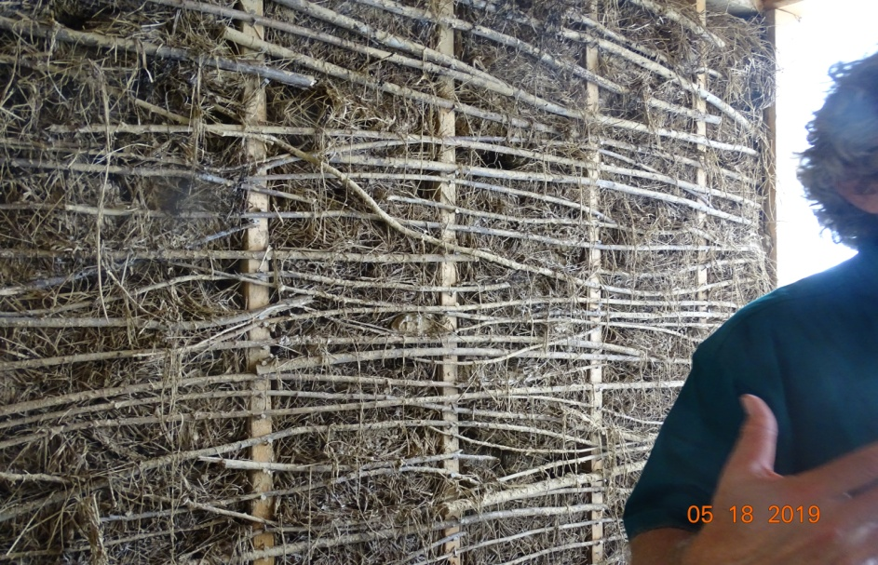

**In the Warmke’s living room**

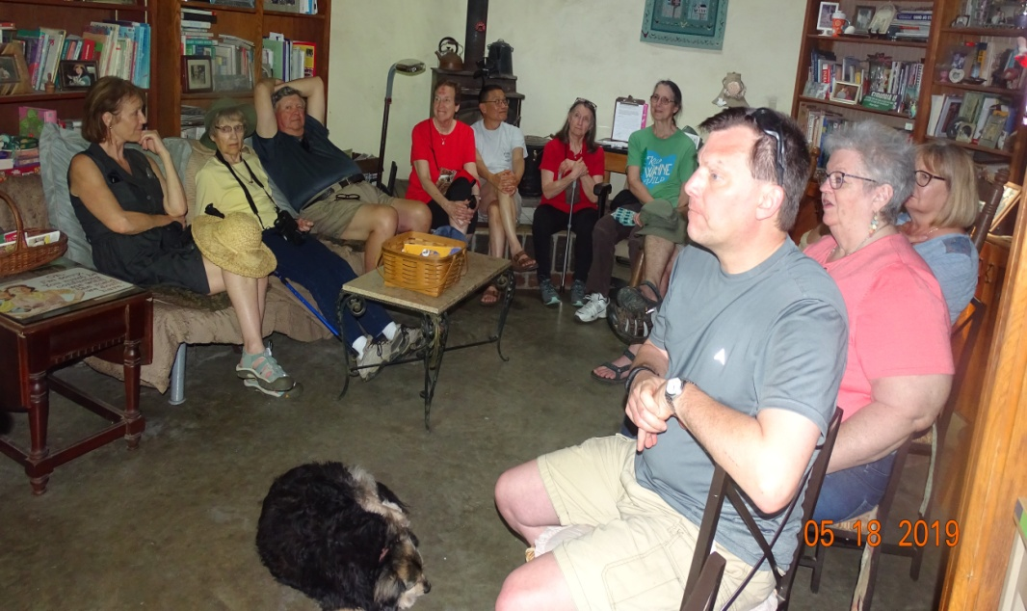

**Beer-bottle light opening in sleeping hut**

