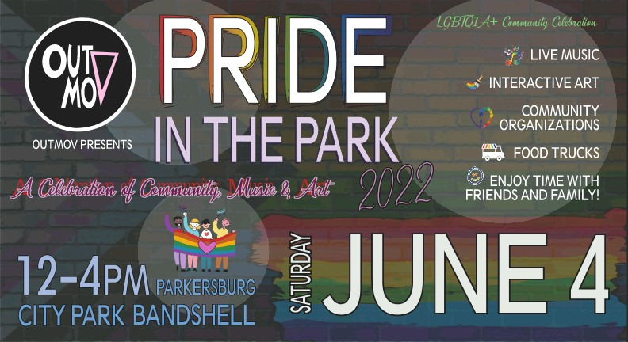
PRIDE MONTH

Sat. June 4 OutMOV
sponsors
Pride in the Park (12-4pm)
at Parkersburg City Park with live music, celebration & community organizations.

Flower Communion Service for the start of Pride Month
Homecoming Sunday June 5, 2022
Join us on Zoom (open to gather @ 10:30am) FUUSM Sunday Services Link
https://zoom.us/j/94822183499?pwd=ZVhkMHZWSnR1bTI5czZWRk1zdFFmQT09
.
Meeting ID: 948 2218 3499 Passcode: fuusm2323
or Facebook - First Unitarian Universalist Society of Marietta

Sunday Schedule
9:30am Today’s Issues discussion group meets in the Parlor, and on Zoom.
See fuusm-l for information on weekly topics and articles.
9:30am Choir Rehearsal - record Life Calls You
11am Sunday Service in the Sanctuary with safety guidelines.
Committee on Ministries serves as Greeters & meets in the Parlor (12:30pm).

Guest Speaker:
Michelle Wilson, owner of Athens Impact Socially Responsible Investments,
and past president of the FUUSM Board of Trustees.
Sometimes it's hard to know where to focus to make a real impact for equality. One way is working within organizations and companies. Michelle Wilson will share
her work with Rotary International and how it's made a difference across the globe.

The Annual Flower Communion will be part of the service this Sunday,
so please bring a flower or 2 to contribute to the bouquets that will be created
to demonstrate the power of diversity, and celebrate our connections
with the natural world. (There will NOT be a congregational photo taken at this time.)

UU Flower Ceremony
Created in 1923 by Unitarian minister Norbert Capek of Prague, Czechoslovakia, a Flower Ceremony was introduced to the U.S. by Rev. Maya Capek, Norbert's widow.

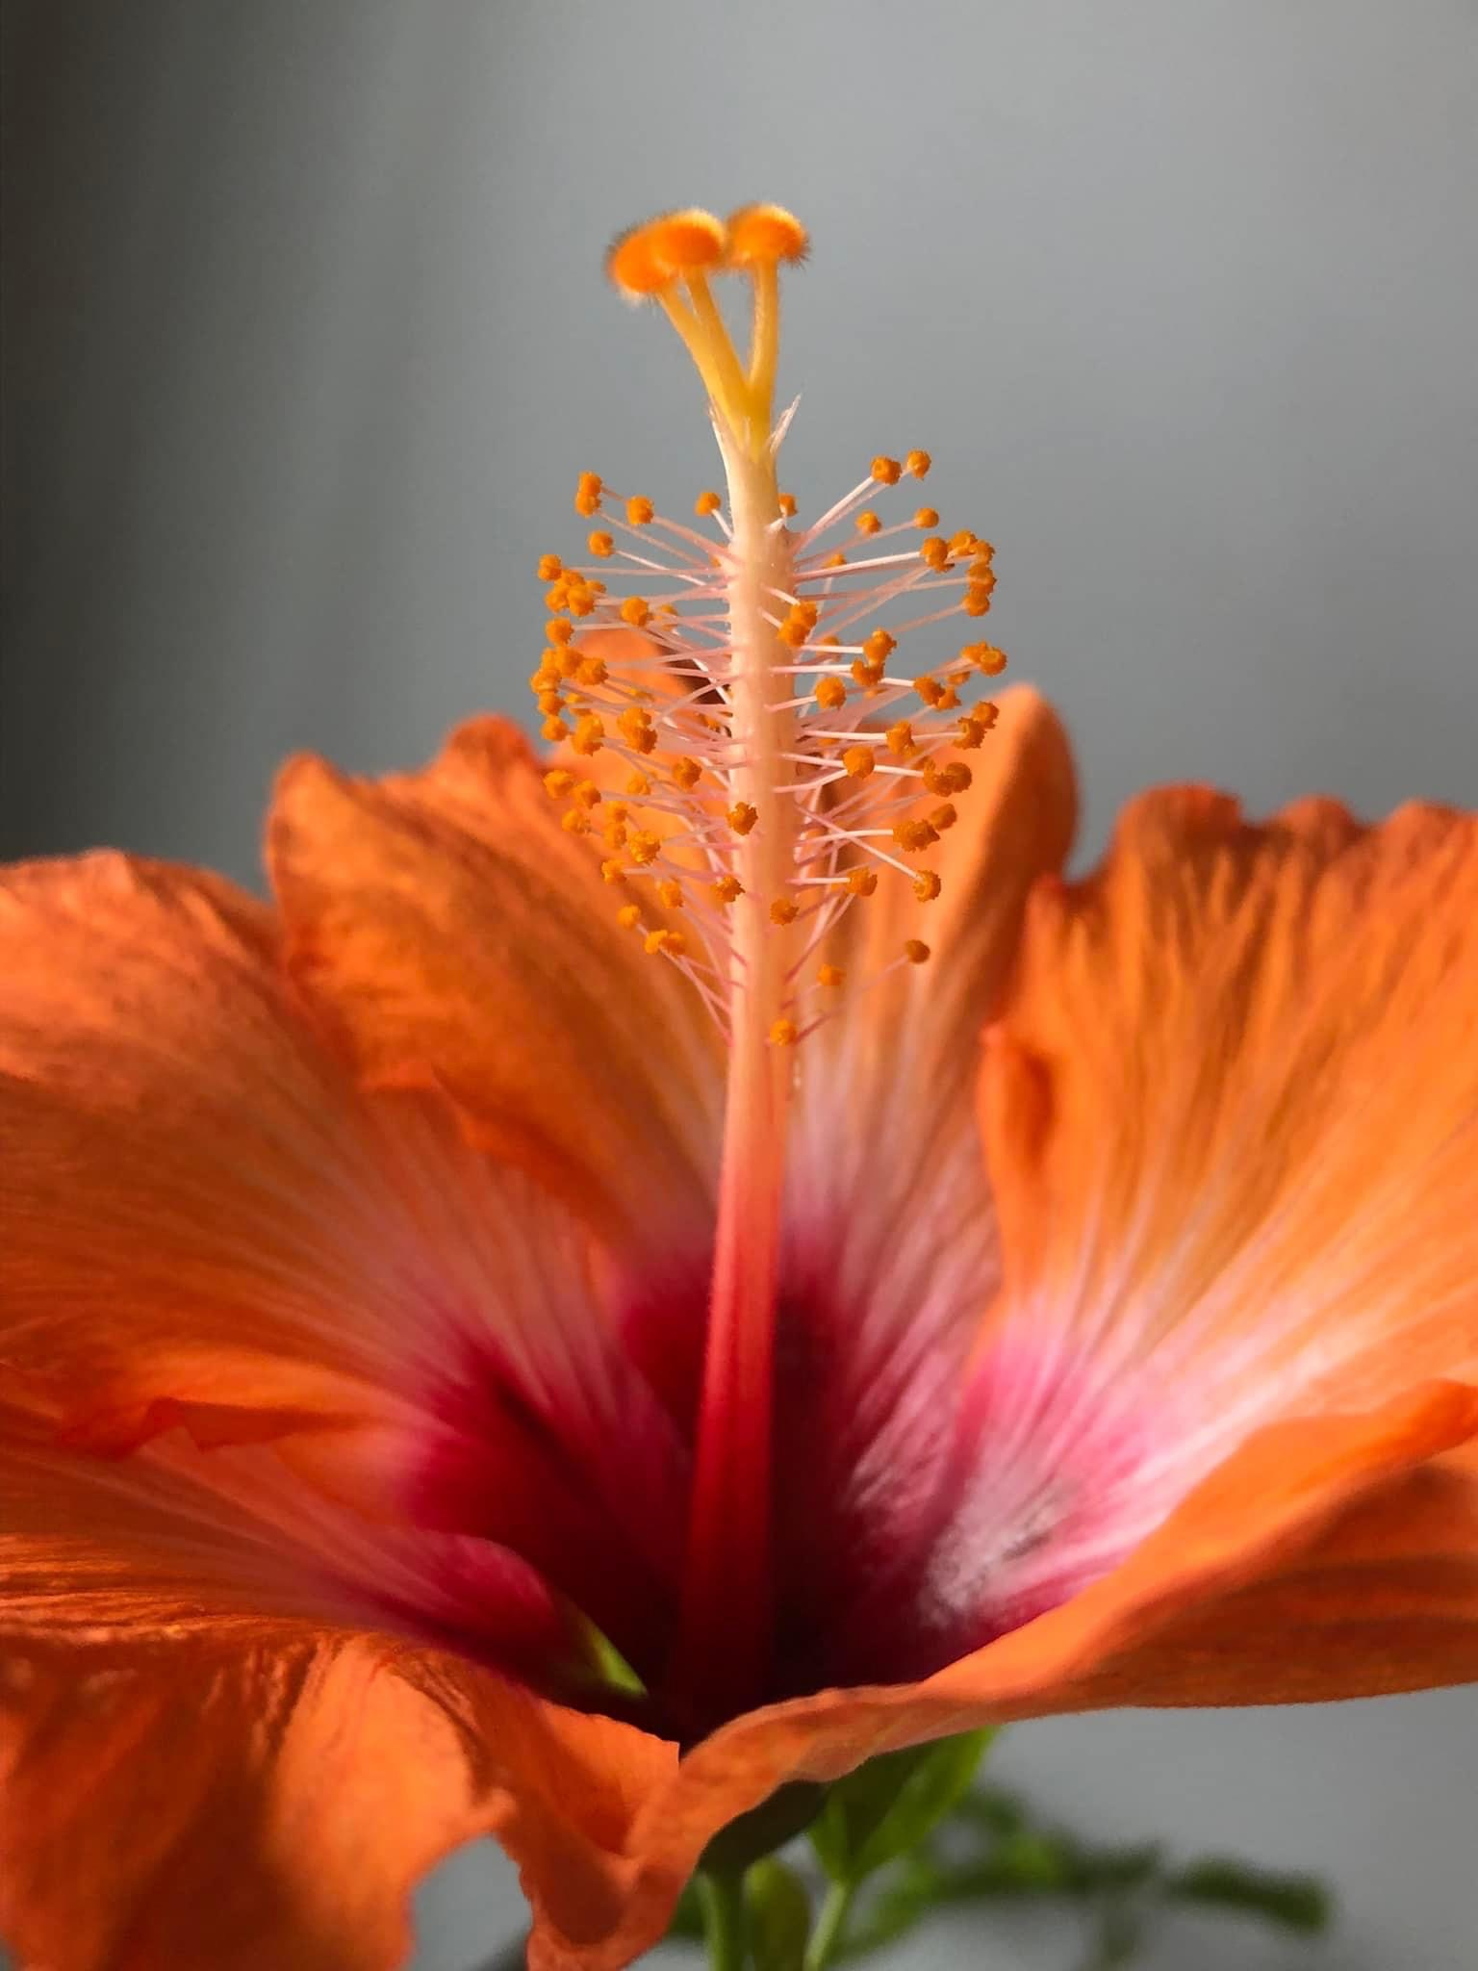
[Faith Without Borders]
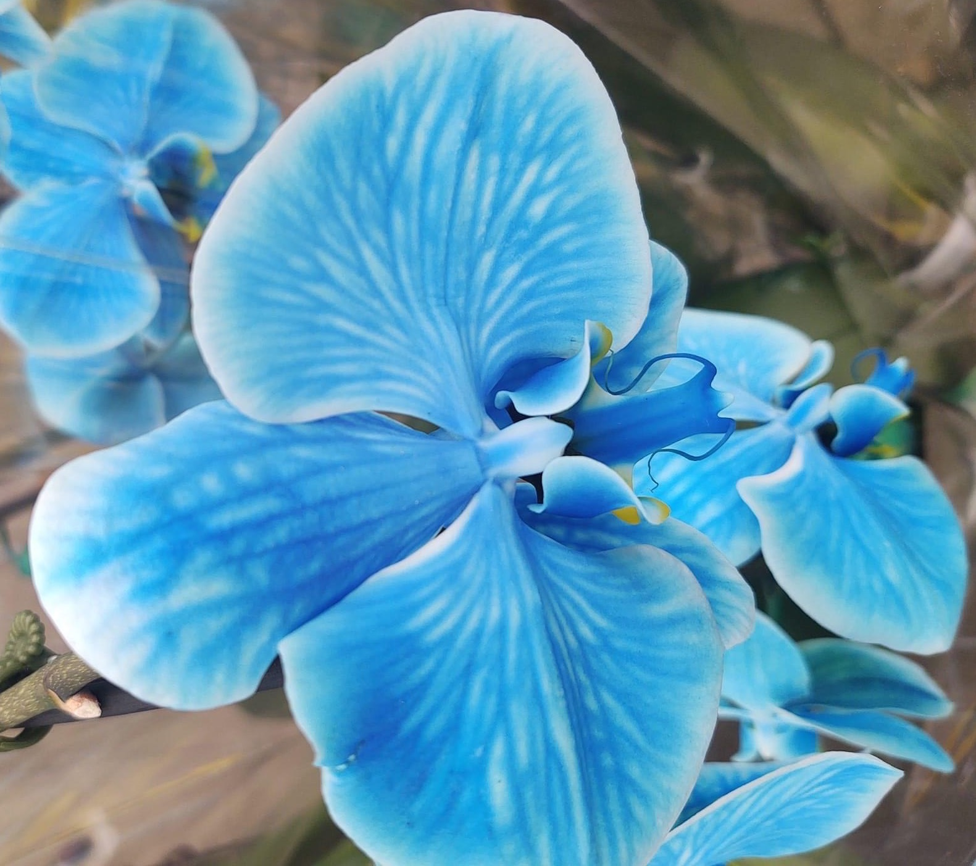
Celebrating the Flower Ceremony is an excellent opportunity for U.U. congregations to express their commitment to our Sixth Principle:
We covenant to affirm and promote the goal of world community with peace, liberty and justice for all.

FUUSM Philosophy of Inclusion (introduced in 2017, adopted in 2020)
(Unison-bold)
In keeping with our Unitarian Universalist principles,
we strive to be a congregation that truly welcomes all persons,
and we commit to structuring our congregational life in ways
that empower and enhance everyone's participation.

We strive to embody what we hope to see in the world
– a just and loving humanity;
a community where people are free to be themselves, fully and without fear;
a community where no one is exiled, silenced or exploited
for reasons such as age, racial or cultural identity or national origin,
gender expression or identity, sexual or affectional orientation,
familial structures or relationship status,
range of physical and mental ability, education or socioeconomic status,
religious background, or political perspective.
We welcome all to share in the fellowship, worship, responsibilities,
leadership, ministry, blessings and joys of our congregation's life.

How to be an LGBTQ+ Ally
- Learn about LGBTQ+ history and the fight for equality ● Listen to members of the community ● Stand/show up against inequality ● Respect safe spaces ● Be aware of language ● Parents—provide inclusive reading material ● Support LGBTQ+ owned businesses
- We are all learning—don't be upset if you're called out ● Don't do it for the glory.

First Unitarian Universalist Society of Marietta
Homecoming Sunday ~ Flower Ceremony
Order of Service June 5, 2022

Call to Worship Spirit of Life
Welcome Song #188 Come, Come, Whoever You Are
Words by Rumi (1207-1273) wanderer, worshipper, lover of leaving.
Music by Lynn A. Ungar (1963- ) Ours is no caravan of despair.
Singing the Living Tradition Come, yet again come.
(Descant: Tho you’ve broken your vows a thousand times.)
Welcome Rev. Kathryn Hawbaker
Acknowledging Native Lands
Prelude Nature's Afternoon -Paul Cardall Randall Kidder, Pianist

Chalice Lighting
Opening Song #402 From You I Receive, To You I Give
Singing the Living Tradition Together we share, and from this we live.
Joseph & Nathan Segal

Philosophy of Inclusion (adopted in 2020)

Reflection Making a Difference through Networks and Organizations
Michelle Wilson, AIF, CSRIC Financial Planner and Fiduciary

Collection of Offerings
Offertory Down By the Salley Gardens -Traditional Irish Folksong
(Bringing the flowers forward)

Reading Flower Communion -Lynn Ungar from Blessing the Bread

Postlude Fragrant Fields -Art Lande
Announcements (Facebook Live ends)
Joys & Sorrows
Benediction (Take a flower with you as you go)

Join us downstairs in the Social Hall for light refreshments and conversation.

Thanks to the Tech Team for their ongoing commitment to enhancing the Audio Visual support of our services, making them more accessible to so many.

Committee on Ministries meets today (12:30) in the Parlor.

SYMBOLS https://symbolsage.com/lgbtq-symbols-and-their-meaning
Note that the term ‘LGBTQ’ is a blanket name for the entire community and does not represent each part of the gender spectrum. Even the longer version,‘LGBTQIA+’ is not fully representative of the diversity within the community. To increase visibility for each sub-sector and sub-culture, different flags have been designed such as the bisexual flag, a lipstick lesbian flag, a pansexual flag, and others.

Rainbow The most recognizable symbol that represents the LGBTQ community today is the rainbow. Strewn across flags, banners, and pins, the rainbow symbolizes the diversity of gays and lesbians around the world. First designed by Gilbert Baker in 1978, the original version of the LGBTQ rainbow had 8 colors representing different things necessary for liberation.
Pink – sexuality Red – life Orange – healing Yellow – sun
Green – nature Turquoise – art Indigo – harmony Violet – spirit

ANNOUNCEMENTS
Use the Dance Cards as a way to share information to invite friends and neighbors
to join us for Homecoming Weekend July 29-31.
Please share your call/contact list by June 15 as we’ll be sending postcards.
Send to Annie Warmke - annie@bluerockstation.com

Mon. June 6 Caring Committee @ (2pm) on Zoom (Sun. Service link)
Wed. June 8 Women’s Group (6pm) in the FUUSM Social Hall for potluck.

Sat. June 11 March for Our Lives -A national event
(local march from FUUSM (10am Registration/10:30 Step-off) to Front St. (11am)
Congregational Church (UCC). A Public Witness response to increasing gun violence.
Please help if you care about these issues in our schools and communities.

Next Sunday June 12 Social Justice Sunday
(9:30am) Today’s Issues in the RE/Office Parlor
(11am) Sunday Service in Sanctuary and on Zoom. Guest: Jeanne Peters
Where Will You Be? Reflections on Dangers Facing LGBTQIA+ Americans.
(11:15-Noon) Kid’s Program in Social Hall after family opening of the service.

(11am-Noon) Society of Friends (Quakers) in the Parlor.
(Noon) Social Time with light refreshments & conversation.
(12:15 pm) Discussion of Braiding Sweetgrass in the FUUSM Sanctuary.

(1-3pm) Social Justice Forum Building a Web of Power: How to Survive the Storm.
Jeanne Peters and Kim Williams will address threats and challenges to LGBTGIA+ rights. A question and answer session will follow their presentation.

UPCOMING EVENTS
June 18/19/20 FUUSM @ the Multi Cultural Festival. (Sign-up to help with our booth!)
Sun. June 20 Potluck Picnic (11am @ Shelter #11 -near the Park Office)
Interfaith Prayer Service @ Noon (Main Stage)

June 22-26 UUA General Assembly
Meet the Moment: Reimagining Radical Faith Community.
The pandemic has changed so much and opened up the possibility for greater innovation and creativity across our congregations and for GA. Polls are open in June for the election of UUA Boards, Committees & Commissions. Learn more about candidates up for election.

July 16 - 3 Sisters Dinner presented by the HIP team
(Honoring Indigenous People) A Fundraiser for Water & Land Protectors

Homecoming Weekend Schedule July 29-31, 2022
Friday 7/29 FUUSM Family Picnic. Saturday 7/30 Art Unveiling & salad potluck
Sunday 7/31 Homecoming Sunday 11am Worship and a celebratory coffee bar.

