Join us on Sundays
Live in-person in the Sanctuary with safety protocols - masks are welcome & optional.

on Zoom (open to gather @ 10:30am) FUUSM Sunday Services Link
https://zoom.us/j/94822183499?pwd=ZVhkMHZWSnR1bTI5czZWRk1zdFFmQT09
Meeting ID: 948 2218 3499 Passcode: fuusm2323
.
or Facebook - First Unitarian Universalist Society of Marietta

THIS Sunday Schedule
Today’s Issues discussion in Parlor (9:30am) Choir in the Sanctuary
(10-12pm) Kid’s Program: Lela Erb & Deborah Lauer
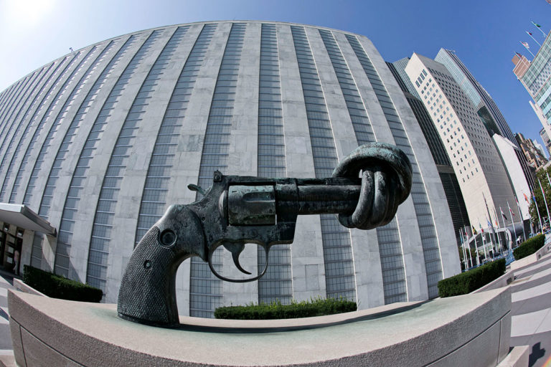
Society of Friends Meeting (11am-12) Parlor

Sculptor: Carl Frederik Reutersward (Sweden)
knotted gun @ UN Headquarters, NYC

First Unitarian Universalist Society of Marietta
Order of Service ~ Sunday, May 22, 2022
Migrations

Welcome Rev. Kathryn Hawbaker
Prelude Let This Be A House of Peace Randall Kidder, Pianist
Singing the Journey #1054 Words and music: Jim Scott

Chalice Lighting

F.U.U.S.M. Choir Tumekuja Kuimba Martha Webster, Choir Director
Words and music: Lynn Zettlemoyer Randall Kidder, Pianist
"We have come to Sing. We have come to praise."

Time for All Ages I am Golden Martha McGovern
Author: Eva Chen and Illustrator: Sophie Diao

Meditation The Silence by Wendell Berry

Collection of Offerings May what you give bring you joy.
Offertory Poor Wayfaring Stranger Afro-American Spiritual

Reflection Migrations Rev. Kathryn Hawbaker
Poem Where I am From - George Ella Lyons

Closing Hymn #15 The Lone Wild Bird
Singing the Living Tradition Words: H. R. MacFayden (1877-1964)
Music: William Walker’s Southern Harmony, 1835
Benediction
Postlude Music of the Sayyids and Dervishes (Music for the Piano Vol. II)
No. 39 Kurdo-Greek Melody - Georges Ivanovich Gurdjieff and Thomas de Hartmann

Announcements
[ Facebook Live ends.]
Joys & Sorrows
(Please use a microphone and make a brief mention of what is on your heart.
Those in the sanctuary come forward; those on Zoom please signal & unmute yourself.)

* * * * * * * * * * Tech Team: Mike Bailey, Ralph Olander, Elaine Barr & Al Tuttle.
Do you have skill or interest in helping with our services? - Talk with the Tech Team.

Help create photo slideshows for future Sunday Services.
Share photos or help work to compile a short presentation in Powerpoint.
PRIDE Events FUUSM Members & Events
Flowers & Flower Ceremony All Ages & Family Activities
Other Ideas You Have….

ANNOUNCEMENTS TODAY 5/22 is PFLAG Parents Day
Today's Issues group meets in person in the RE/Office building next to the church
at 9:30am (every Sunday) and also on Zoom at: https://us02web.zoom.us/j/8583258484?pwd=RFdJUGZOZkU4THArWFpnVkllZzh1dz09

Mon. May 23 (7pm) Finance Committee on Zoom
https://us02web.zoom.us/j/89096327726?pwd=ZDhOS1JkRGJid29DelQ1LzF1d1Fpdz09
Meeting ID: 890 9632 7726 Passcode: fuusm$

Wed. May 25 Meditation (12:00 - 1pm) on Zoom
https://zoom.us/j/9062049940?pwd=TEtGeE90WCtJeHB0UmJsRElhTEJVdz09

NEXT MONTH
Sat. June 4 (12-4pm) Out MOV - Pride in the Park (Parkersburg City Park Bandshell)
Sun. June 5 Flower Ceremony - bring a flower, take a different one home.
Reflection by Wayne Waldeck & Lee Rector I Am What I Am
Fri. 6/17 Juneteenth @ Marietta College (4-7pm)

Sun. June 19 (11am) FUUSM Picnic at Parkersburg City Park
MOV Multi Cultural Festival Interfaith Prayer Service.

June 22-26 UUA General Assembly ~ Multi Platform

RESOURCES
The I AM FROM Project George Ella Lyons & Julie Landsman
–a way to celebrate diversity at a time when our country is divided by hatred and fear
We want to be heard, not herded; we want to speak, not be spoken at or for; we want to break through stereotypes, profiling, and dismissal to be listened to in our full humanity.
Our central goals:
*To help people of all ages and backgrounds use the “Where I’m From” poem as a prompt
to write about experiences that shape them. *To bring these voices together in community.

Where I’m From by George Ella Lyon
I am from clothespins, from Clorox and carbon-tetrachloride.
I am from the dirt under the back porch. (Black, glistening, it tasted like beets.)
I am from the forsythia bush the Dutch elm whose long-gone limbs I remember as if they were my own.
I’m from fudge and eyeglasses, from Imogene and Alafair.
I’m from the know-it-alls and the pass-it-ons, from Perk up! and Pipe down!
I’m from He restoreth my soul with a cottonball lamb and ten verses I can say myself.
I’m from Artemus and Billie’s Branch, fried corn and strong coffee.
From the finger my grandfather lost to the auger, the eye my father shut to keep his sight.
Under my bed was a dress box spilling old pictures, a sift of lost faces to drift beneath my dreams.
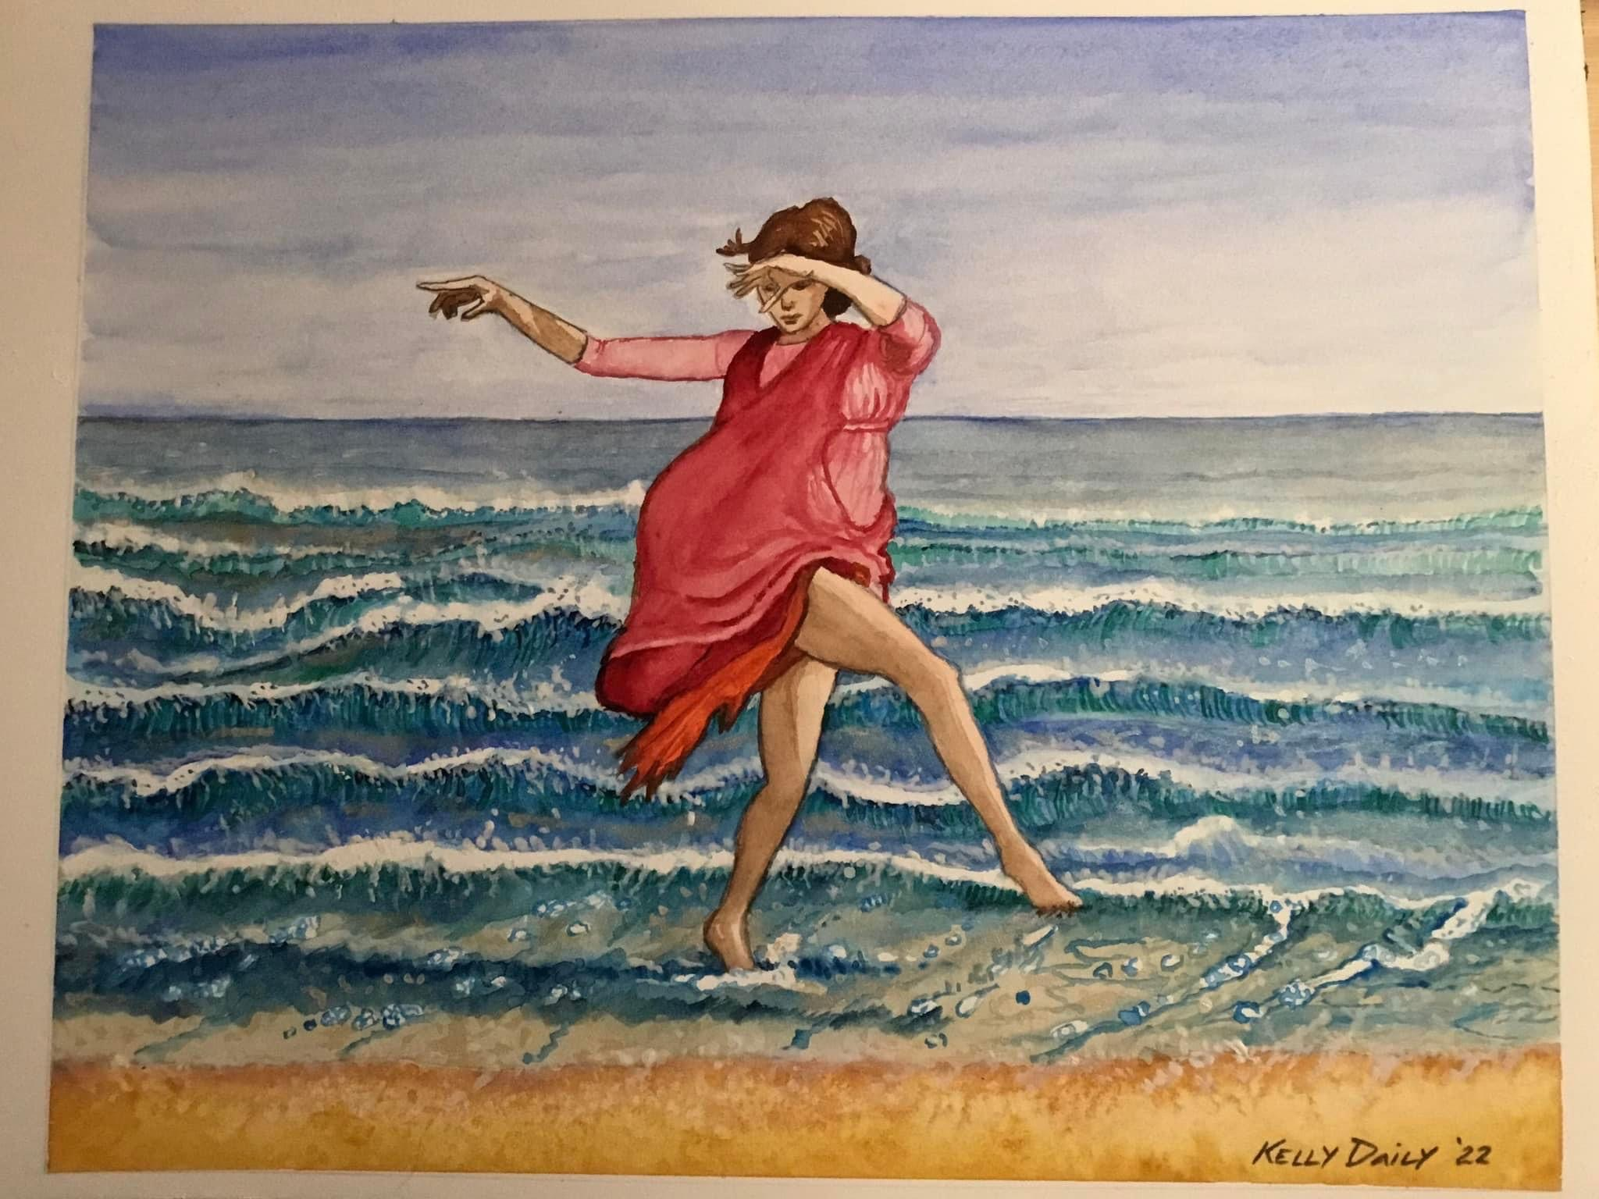
I am from those moments– snapped before I budded — leaf-fall from the family tree.
Isadora Duncan on the beach by Kelly Daily

Your Dance Card Efforts Are Priceless! And Every Penny Counts . . .
Homecoming is scheduled for the last weekend in July (July 29-31), and we’re inviting the community to celebrate the 167 years of FUUSM’s history with us.
For the Homecoming Project, we need everyone to reach out to current/former/future FUUSM members and friends. Some may have moved away, or become involved in other endeavors, or slipped out of touch, or overlooked us as an option.
To facilitate your efforts, we are providing red “Dance Cards.”
Step One: Pick up a dance card. The cards are available in the FUUSM Office and church foyer and as an attachment in The Confluence and Weekly Update.
Step Two: Make contact with someone in any way that is comfortable for you – phone, in-person, email, snail mail, social media.
Step Three: On the dance card, record your name, the person’s name, how they can be reached, and the date you made contact. You can record numerous contacts on one card. [or on paper].
Step Four: Turn in the red dance card to boxes in the FUUSM Office or in the church foyer.
[Yes, you can simply email the information to annie@bluerockstation.com]
* For each contact listed, Worship & Music Committee will donate a penny.
The pennies will help defray some of the costs of the actual Homecoming events.
What to expect at Homecoming Weekend:
Friday Family Night Picnic (July 29): Games, treasure hunt, music, tours of the church (to schedule a tour contact Annie Warmke annie@bluerockstation.com or 740/252-6295).
Saturday Buffet (July 30) with art work unveiling in the Courtyard.
Sunday (July 31) Worship Service with special coffee hour with baristas serving coffee,
guided church tours and Randall Kidder's fantastic piano recordings.
(To schedule a tour contact Annie Warmke 740/252-6295)

Volunteers are needed for each part of the Homecoming Weekend Event.
Please contact Roger Kalter for more information. 740/525-1833

