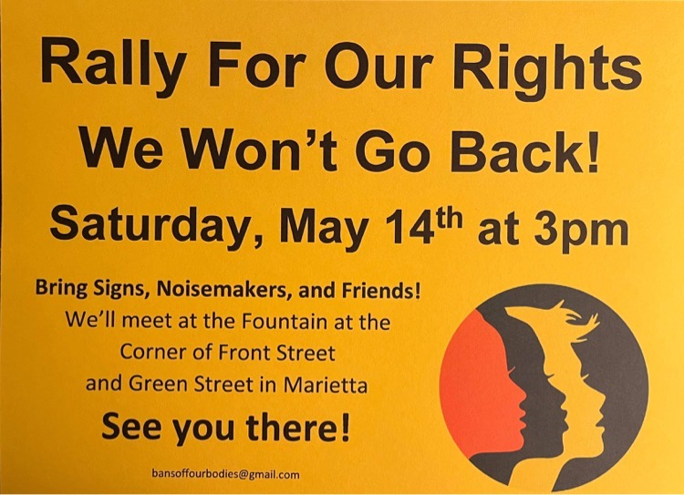
TODAY/SAT. African Drumming Class with Lawrence Greene
will be at FUUSM after gathering at the rally. ~3:30-5pm

* * *
Join us Sunday live in-person in the sanctuary with safety protocols
- masks are welcome & optional *See updated Safety Guidelines

on Zoom (open to gather @ 10:30am) FUUSM Sunday Services Link
https://zoom.us/j/94822183499?pwd=ZVhkMHZWSnR1bTI5czZWRk1zdFFmQT09
Meeting ID: 948 2218 3499 Passcode: fuusm2323
.
or Facebook - First Unitarian Universalist Society of Marietta

THIS Sunday Schedule
Today’s Issues discussion in parlor (9:30am) Choir in the Sanctuary
FUUSM Sunday Service (11am) Families attend together. All Ages
Green Sanctuary (12:30pm) on Zoom
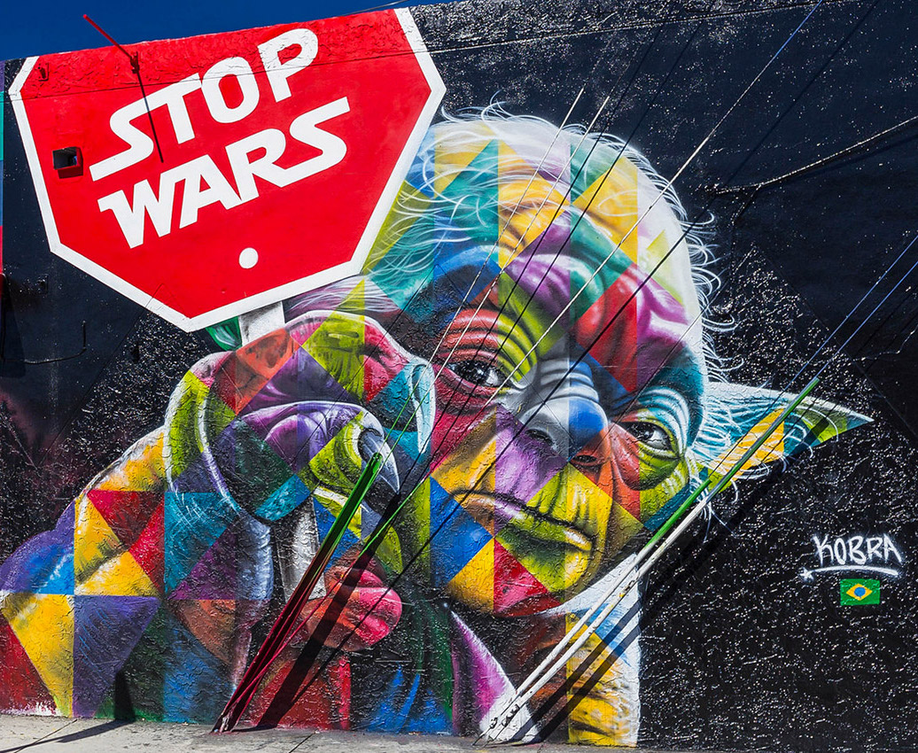
Service Auction event (2-4pm) in Fellowship Hall.
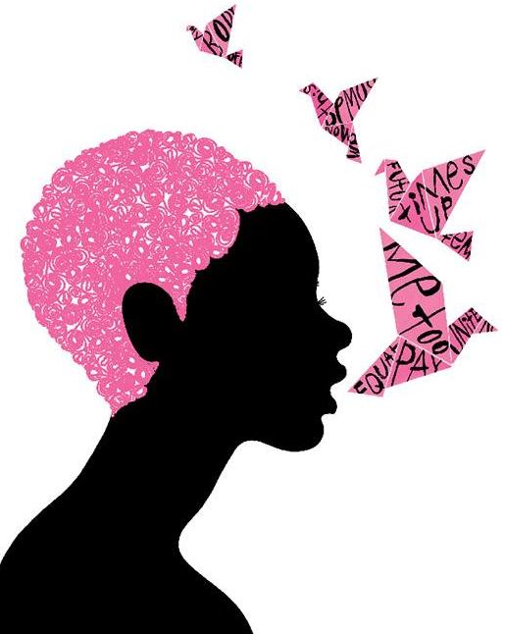

Freedom of Speech
Melinda Beck (4 Freedoms renewed)

First Unitarian Universalist Society of Marietta
Order of Service ~ Sunday, March 15, 2022
Art and the
A-May-Zing Month of May

Art is a reflection of who we are.
When communities make art, everyone has a place.

Welcome Rev. Kathryn Hawbaker

Prelude The Arching Sky of Morning Glows Randall Kidder, Pianist
Singing the Living Tradition Hymn #330 - Music: Thomas Tallis Words: Mark L. Belletini

Chalice Lighting Central East Region of the U.U.A.

Time for All Ages CommUNITY Mural in Topeka, KS

Collection of Offerings
Offertory Watermark - Enya

Reflection Art Communicates Social Change in Community

“We have the facts, we have policy solutions to the climate crisis,”
says Christina Uribe, The Center for Cultural Power,
“What we don’t have is the popular imagination,
and that’s why we need artists. We need those new stories.

Benediction
Postlude Music for the Piano Volume II Music of the Sayyids and Dervishes
No. 29 Sayyid Chant and Dance - Georges Ivanovich Gurdjieff and Thomas de Hartmann

Musical Note on Postlude: The Sayyids, whether by blood relation or spiritual lineage, are considered to be direct descendants of the prophet Mohammed. In composing music for this volume, the composers frequently employed a binary form indigenous to the Middle East. The first section, a "taksim," is a free melodic or rhapsodic improvisation based on a particular mode usually underscored by a drone or pedal point. The second section is a slow to fast rhythmic dance.

Announcements
TODAY Green Sanctuary Meeting (12:30) Zoom
[ Facebook Live ends.]
Joys & Sorrows
(Please use a microphone and make a brief mention of what is on your heart.
Those in the sanctuary come forward, those on Zoom please signal & unmute yourself.)

* * * * * * * * * * *
Tech Team: Mike Bailey, Ralph Olander, Elaine Barr & Al Tuttle.
Do you have skill or interest in helping with our services? - Talk with the Tech Team.

Total eclipse of the Flower Moon sweeps across Americas this Sunday evening!

ANNOUNCEMENTS
Today's Issues group meets in person in the RE/Office building next to the church
at 9:30am (every Sunday) and also on Zoom at: https://us02web.zoom.us/j/8583258484?pwd=RFdJUGZOZkU4THArWFpnVkllZzh1dz09

Wed. May 18 - Meditation (12:00 - 1pm) on Zoom
https://zoom.us/j/9062049940?pwd=TEtGeE90WCtJeHB0UmJsRElhTEJVdz09
(6pm) Men’s Group meets at Jim Grecni’s home.

Confluence Calendar of Events Click here for the latest updated version.
Fri. May 20 Confluence Newsletter Deadline
Send material to Ted Goertzel, tedgoertzel@gmail.com

Sat. May 21 Plant Sale in the F.U.U.S.M. yard.

Chalice Lighters! Your donations provide the funds to make grants to UU congregations and groups of congregations throughout our region, helping them to build strong, resilient, and justice-loving communities.

Dance Cards
We would like you to help us by getting as many signatures as possible on the red Dance Card Program that is available in the entrance foyer. The first person has returned their dance card -we're hoping each of you will too! Telephone, text, messenger or visit friends, neighbors, FUUSM folks you haven't talked to in a while and of course friends or members of FUUSM who have moved away. They might join us for the Homecoming Weekend July 29-31.
We would love to know how to get in touch with the folks you speak with, and your Dance Card is key to that information. Just record their name and a phone number or email or both. When the card is full please turn it in on Sunday mornings, and look for the “Penny Jar”. Keep the pennies out of the landfill by putting in a penny for each signature (next to the place for filled Dance Cards) and then start another Dance Card.

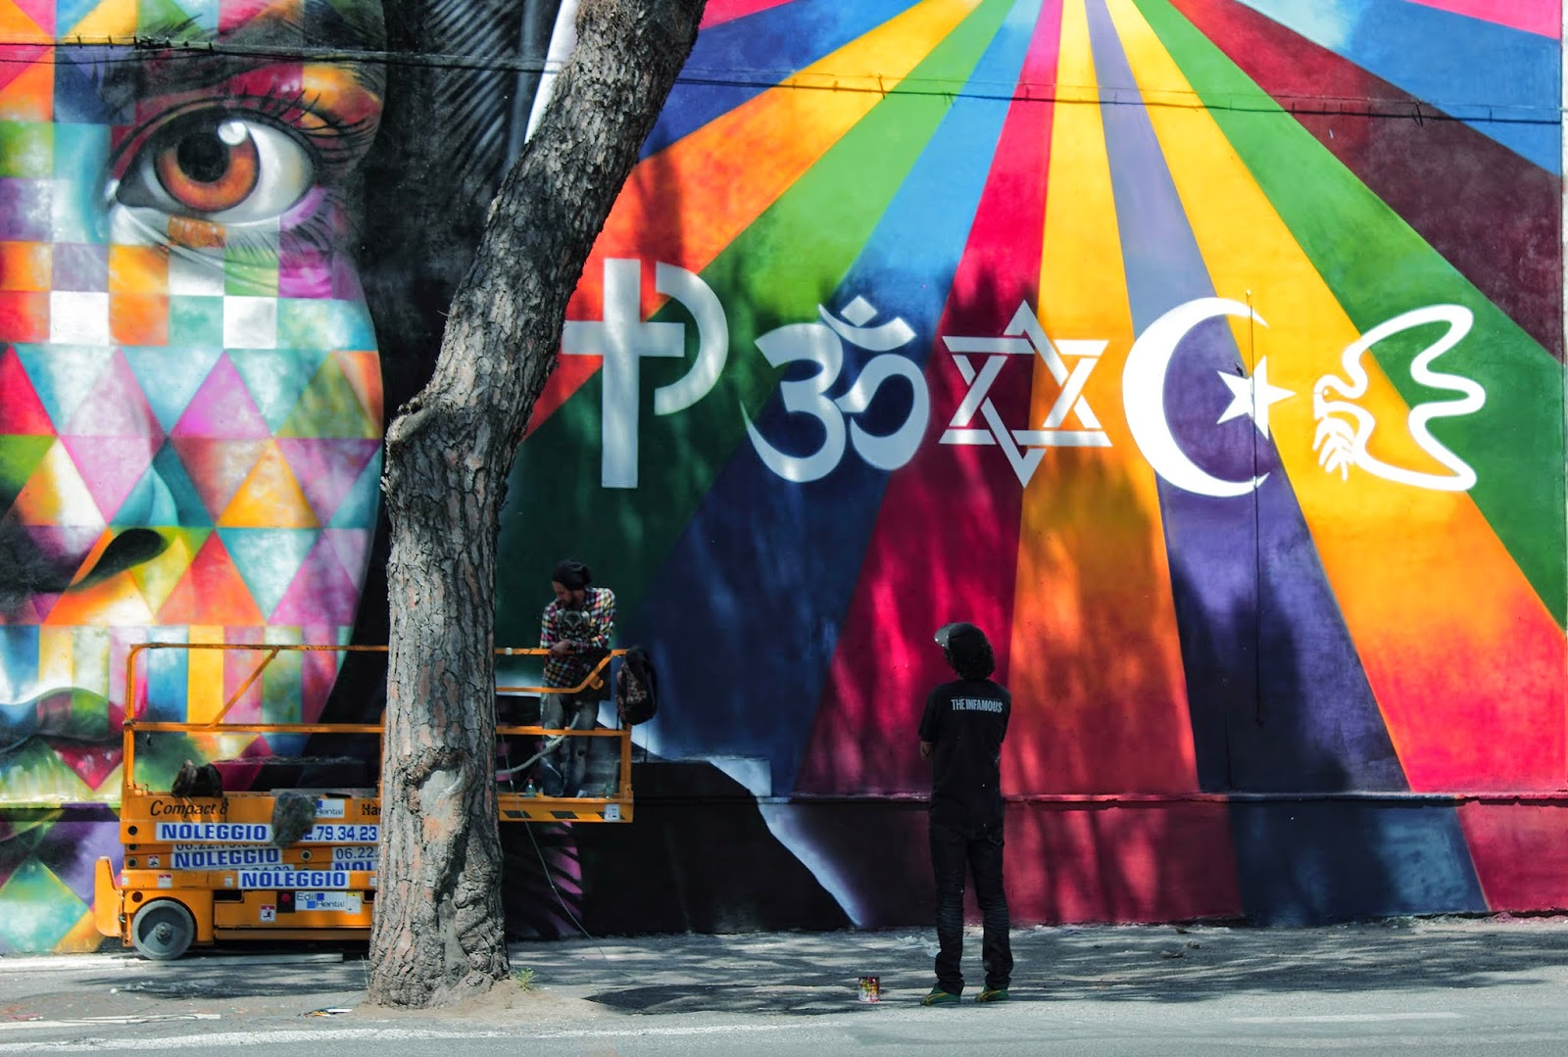
RESOURCES

Peace
-by Eduardo Kobra
(Rome, Italy)

15 Public Art Projects - Katie Dupere
Ethnicities ~ Eduardo Kobra, (Brazil) graffiti artist, created a mural for the 2016 Rio Olympic Games to convey that “we are all connected”. [ View online. ]

Invisible Homeless ~ Luke Jerram (England)

The Za’atari Project ~ Joel Artista (Jordan) & children in refugee camp.

Non-Violence ~ Carl Frederik Reutersward (Sweden)
knotted gun @ UN Headquarters, NYC

Reimagining Norman Rockwell’s Four Freedoms
Freedom of Worship - Tim O’Brien Freedom of Speech - Melinda Beck [ cover art ]

The National Memorial for Peace & Justice (NYT) 2018 Montgomery, Alabama
Bryan Stevenson, Equal Justice Initiative

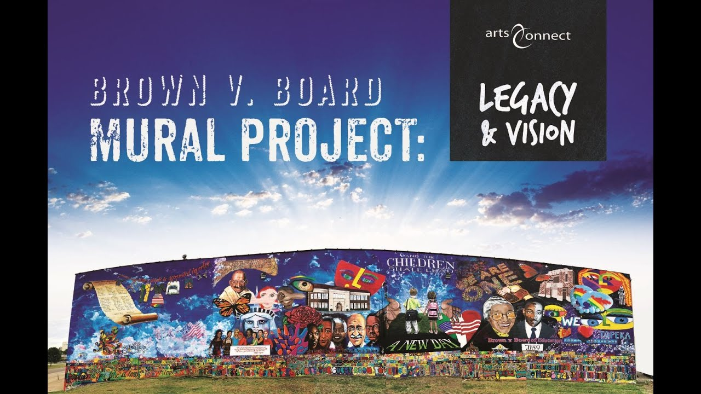
CommUNITY Mural - Brown vs. Board of Education, Topeka, Kansas

roots.muralmosaic.com Mural Mosaic’s Global Roots Project is connecting the world
through the joy and sharing of artistic expression…

Interesting Engineering
Strandbeesten (Dutch) [ Wind powered- walking sculpture. ]

