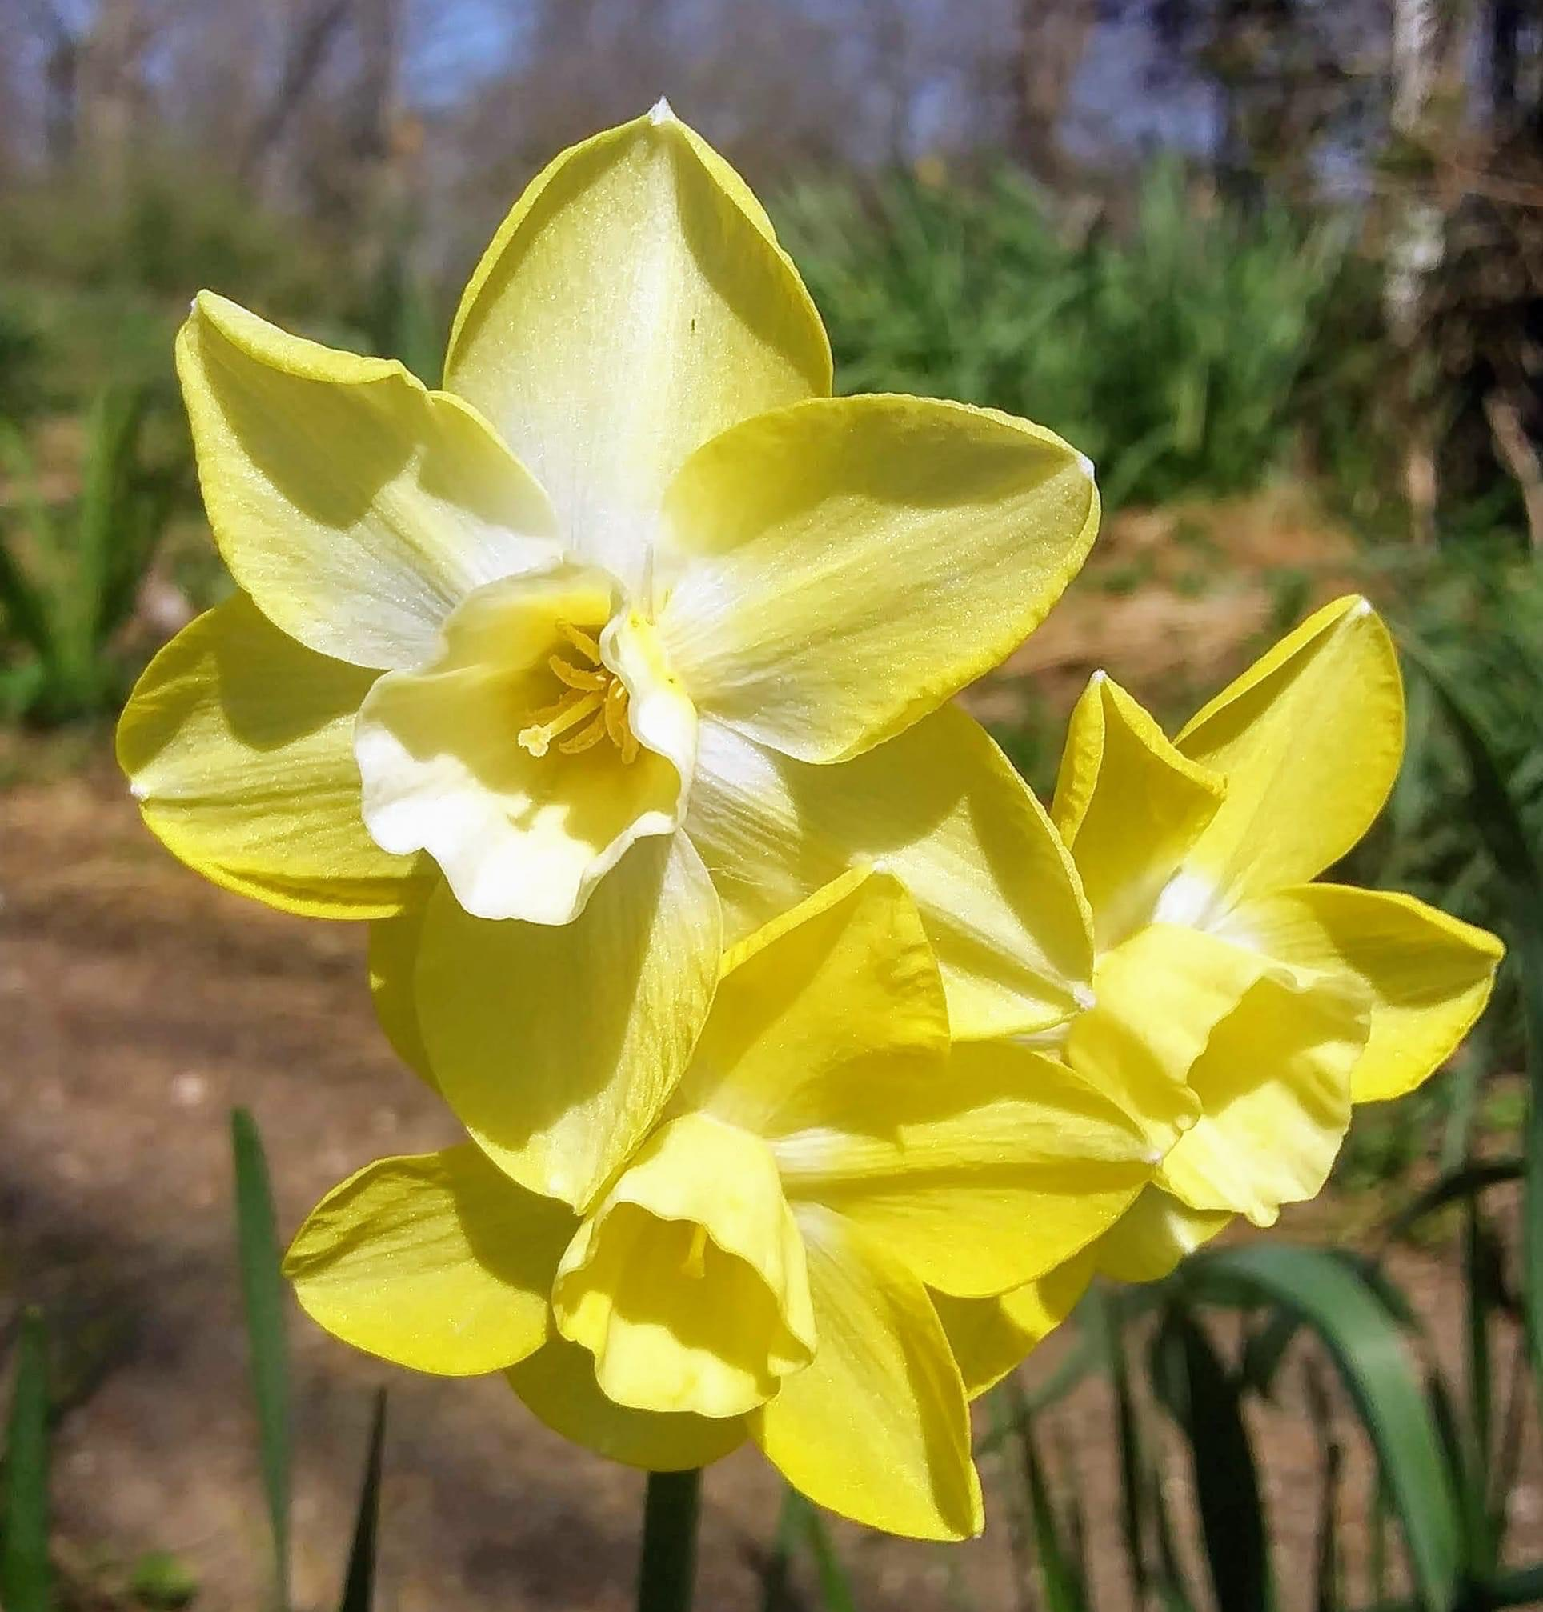
First Unitarian Universalist Society of Marietta
232 Third St. Marietta, OH 45750 www.fuusm.org
Our Mission is to nurture a diverse community
devoted to spiritual growth
and freedom of thought for the benefit of all.

Order of Service ~ April 17, 2022
Praise now for the budding green,
April’s Resurrection scene;
-William C. Gannett (1840-1923).

Gathering Here Comes the Sun -George Harrison

Welcome Song by Hal Walker
Whoever you are, we welcome you Wherever you come from, we welcome you
Whomever you love, we welcome you.
Welcome Rev. Kathryn Hawbaker

Prelude Spring has Now Unwrapped the Flowers
(recorded) Choir and Randall Kidder, Pianist

Chalice Lighting Earth Charter
Native Lands The Earth is all that lasts. . . by Nancy Wood
Opening Music I Will Sing words & music by Andy Beck
(recorded) Martha Webster, Choir Director and Randall Kidder, Pianist
Choir: Adeline Bailey, Dave Ballantyne, Karen Binkley, Dawn Hewitt, Kelsey Jacobs, Nancy Luthy,
Martha McGovern, Suzyn Mills, Cynthia & Darryl Ting. Recorded by Mike Bailey.

Unison FUUSM Affirmation (found in the front of the hymnal)
We, the members & friends of the First Unitarian Universalist Society of Marietta:
- Support the free and disciplined search for truth as the center of religious
community and encourage an acceptance of pluralistic views;
- Recognize our Judeo-Christian heritage as well as other traditions
and seek lasting values and new insights;
- Affirm, defend, and promote the equality, worth, and dignity of every person
- Strive for a world community of love, justice, and peace;
- Support the democratic process & mutual respect in all human relationships;
- Cherish the universe and its resources and recognize the unity of all life.

Hymn #21 For the Beauty of the Earth Singing the Living Tradition
Words: Folliott S. Pierpoint, 1835-1872 Music: Conrad Kocher, 1786-1872, abridged.
Reading We are all on a journey together… -Anne Hillman
Moving Meditation
Offertory Fields of Flowers -William Bolcolm (recorded) Randall Kidder, Pianist

Prayer
(Unison) Affirmation #471 Love is the doctrine of our congregations
-L. Griswold Williams the quest of truth is our sacrament
and service is our prayer.

Reflection Easter for Earth Rev. Kathryn Hawbaker

Closing Song Benedicta Es (Blessed Be) Martha Webster, Choir Director
& Choir by Chris Carol, arranged by Susan Schleef Randall Kidder, Pianist

Announcements Facebook ends.
Joys & Sorrows

TODAY Easter Egg Hunt in the FUUSM Courtyard & Social Hall.

Sat. April 23 Marietta Earth Day (10am-1pm) Marietta Armory Square

Next Sunday April 24, 2022 FUUSM Annual Meeting (12:15pm)
Live in the Sanctuary or on Zoom
https://zoom.us/j/94822183499?pwd=ZVhkMHZWSnR1bTI5czZWRk1zdFFmQT09
Meeting ID: 948 2218 3499 Passcode: fuusm2323

Chalice Lighting & Business Agenda
• 2022-2023 Budget
• Elections: Board of Trustees, and Committee on Ministries
- Selection of UUA General Assembly Delegates
- Policies and Items for the Good of the Society

U.U.J.O. Join Street Seders in Cleveland & Columbus on Tu. April 19.
The Exodus Alliance and Dayenu: A Jewish Climate Action are
sponsoring and hosting “Street Seder” actions around the nation during Passover.
The concurrent events will culminate with delivery of a letter
to management of Chase locations in each city to be passed up to the
executive level and demand that Chase Bank divest of fossil fuels.

I Will Sing words & music by Andy Beck
Listen all around you, listen to the wind and sky.
Listen in the forest, listen as the clouds go by.
I think I hear some singing. I think I hear a song.
And when I hear sweet music, I have to sing along.
Oh, I will sing with the Rising Sun.
At the dawn of morning I will sing.
And I will sing when the day is done.
When the stars are shining, I will sing.

Listen in the winter, listen to the falling snow.
Listen in the summer, listen as the breezes blow.
And when the leaves of autumn scatter on the ground,
Or sparrows in the springtime make a joyful sound,

Oh, I will sing with the Rising Sun,
At the dawn of morning I will sing.
And I will sing when the day is done.
When the stars are shining, I will sing.
There's music in the ocean, in the rush of the tide.
And if you listen closely there's music that's inside.

