Sunday March 27, 2022 International Day of Remembrance
of Victims of Slavery and the Transatlantic Slave Trade
Worship Leaders: Martha McGovern & Rev. K. Hawbaker

Today’s Issues (9:30am) meets in the parlor of RE/Office building & on Zoom
https://us02web.zoom.us/j/8583258484?pwd=RFdJUGZOZkU4THArWFpnVkllZzh1dz09

(9:30-10:30am) Choir Practice in the Sanctuary.

(12:15) in the Parlor. The Society of Friends (Quakers) invites all those interested
to join in a discussion of podcasts on Buddhist Boot Camp by Timber Hawkeye.
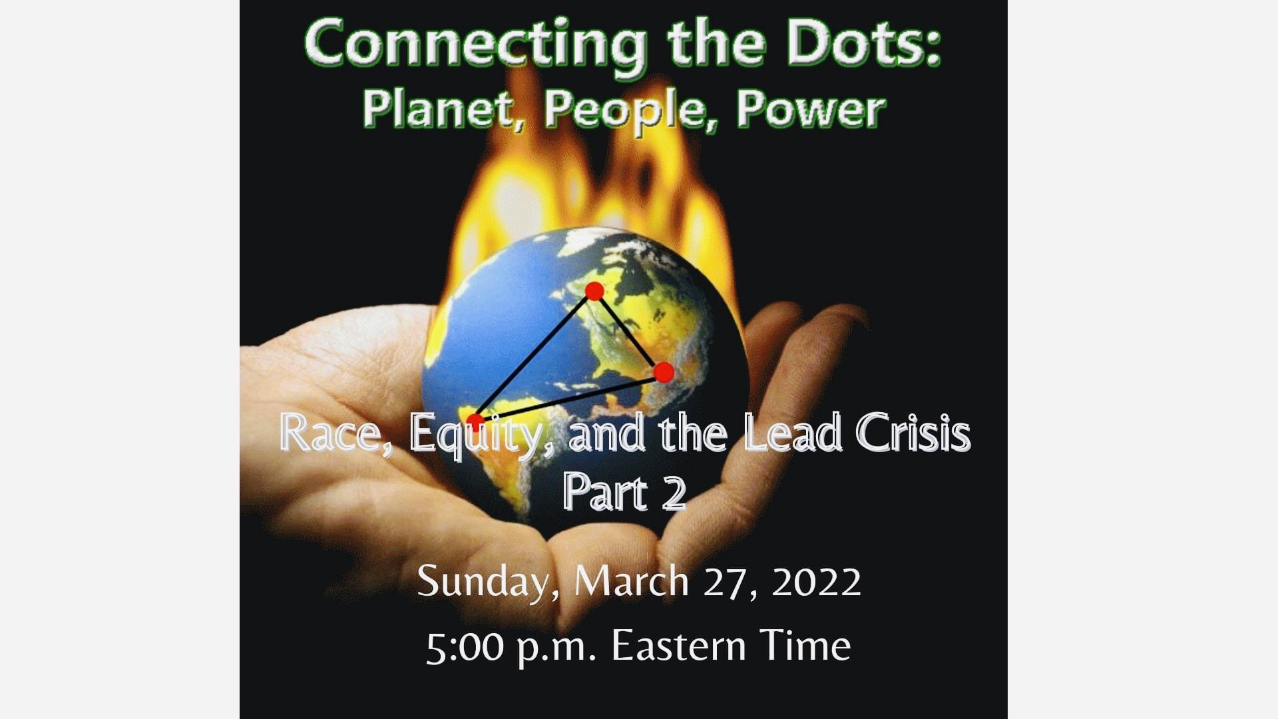
March 27, we’ll view & respond to Timber’s Ted Talk which can be found at
https://www.youtube.com/watch?v=LIFTxRJfLTM

(5pm) U.U.J.O. on Zoom
This is a monthly meeting. Participants are encouraged
to commit to an action to bring justice to this issue
of lead contamination for vulnerable Ohio families.
Click here to register.
Contact Ginnie McNeil for more information:
(304) 613-9138

Announcements follow at the end.

Order of Service First Unitarian Universalist Society of Marietta
March 27, 2022 International Day of Remembrance of Victims of Slavery
and the Transatlantic Slave Trade

You may write me down in history with your bitter, twisted lies,
You may trod me in the very dirt But still, like dust, I’ll rise.
from Still I Rise -Maya Angelou

Welcome Song Whoever you are, we welcome you
by Hal Walker Wherever you come from, we welcome you.
(Kent, OH) Whomever you love, we welcome you.

Welcome Martha McGovern

Prelude Sleepless -Ola Gjeilo Randall Kidder, Pianist

Chalice Lighting from To Wake, To Rise ed. by William G. Sinkford
excerpt from When the Unimaginable Happens by Anne Barker
The Love that is still true draws us once again together . . .
Into places of tender knowing, remembering to restore us, mend us, piece by broken piece.

Time for All Ages Reader’s Theater presentation of
The 1619 Project ~ Born on the Water
Readers: Ami Rush, Martha McGovern, Adeline Bailey & Kat Hawbaker

Collection of the Offering
Recorded Offertory Breaths -Sweet Honey in the Rock

Reflection Remembrance, Resolve, & Resilience Rev. Kathryn Hawbaker

Video Tour The Ark of Return Memorial Art by Rodney Leon
Acknowledge the tragedy Consider the legacy Lest we forget
Video U.N. International Day of Remembrance (2021)
Dr. Natalia Kanem UNFPA Exec. Dir.
includes Poem Still I Rise -Maya Angelou

Closing Hymn #1007 There’s A River Flowin’ in my Soul
1) There’s a river flowin’ in my soul (2x)
And it’s telling me that I’m somebody.
There’s a river flowin’ in my soul
2) mind, 3) heart, 4) thru my hands

Benediction
Postlude Sea -George Winston Randall Kidder, Pianist

Great appreciation to our talented and dedicated Tech Team: Mike Bailey, & Ralph Olander,
Elaine Barr, Jonathon Bier, Al Tuttle, and Rev. Kat Hawbaker.

ANNOUNCEMENTS
THIS WEEK Finance Committee
Mon. March 28, 2022 (7pm), via Zoom -Meeting ID: 842 3241 9914; Pass Code: fuusm$

Wed. March 30 Meditation on Zoom
https://zoom.us/j/9062049940?pwd=TEtGeE90WCtJeHB0UmJsRElhTEJVdz09
Meeting ID: 906 204 9940 Passcode: OMWed12

Welcome Home Haley Shukla is organizing our collection effort of items
we will present to the Barnett-Sheaves family to support the arrival of Aronn.
We plan to present the basket of goodies now that they are home in Marietta,
so please bring your items or gift cards before our first Social Hour -Sunday April 3.

Sun. April 24th @ 12 Noon- Annual Congregational Meeting
Annual Reports are due by Mon. April 11, 2022. Please send directly to fuusm-l@fuusm.org

Dance Cards
are part of the Homecoming campaign to increase participation in FUUSM activities.
The goal of the card is to have FUUSM friends and members fill in names & contact info.
as they reach out to other members, friends and anyone else in the community
to share the good work, values, and principles and mission of FUUSM.
A Joyous Homecoming event will happen each first Sunday of the month,
with a July Homecoming Celebration the last weekend in July (7/29-31, 2022).
Homecoming 2022 Support Team is meeting weekly on Mondays at 6 pm on Zoom.
If anyone wants to join in the planning fun for the weekend event or volunteer
please contact Roger Kalter. <rogerkalter1@gmail.com>

RESOURCES
www.un.org › en › events
English Printable Ark of Return Brochure - United Nations

Still I Rise by Maya Angelou
You may write me down in history You may shoot me with your words,
With your bitter, twisted lies, You may cut me with your eyes,
You may trod me in the very dirt You may kill me with your hatefulness,
But still, like dust, I’ll rise. But still, like air, I’ll rise.

Does my sassiness upset you? Does my sexiness upset you?
Why are you beset with gloom? Does it come as a surprise
‘Cause I walk like I’ve got oil wells That I dance like I’ve got diamonds
Pumping in my living room. At the meeting of my thighs?
Just like moons and like suns,
With the certainty of tides, Out of the huts of history’s shame
Just like hopes springing high, I rise
Still I’ll rise. Up from a past that’s rooted in pain
I rise
Did you want to see me broken? I’m a black ocean, leaping and wide,
Bowed head and lowered eyes? Welling and swelling I bear in the tide.
Shoulders falling down like teardrops,
Weakened by my soulful cries? Leaving behind nights of terror and fear
I rise
Does my haughtiness offend you? Into a daybreak that’s wondrously clear
Don’t you take it awful hard I rise
‘Cause I laugh like I’ve got gold mines Bringing the gifts that my ancestors gave,
Diggin’ in my own backyard. I am the dream and the hope of the slave.
I rise
I rise
I rise.

