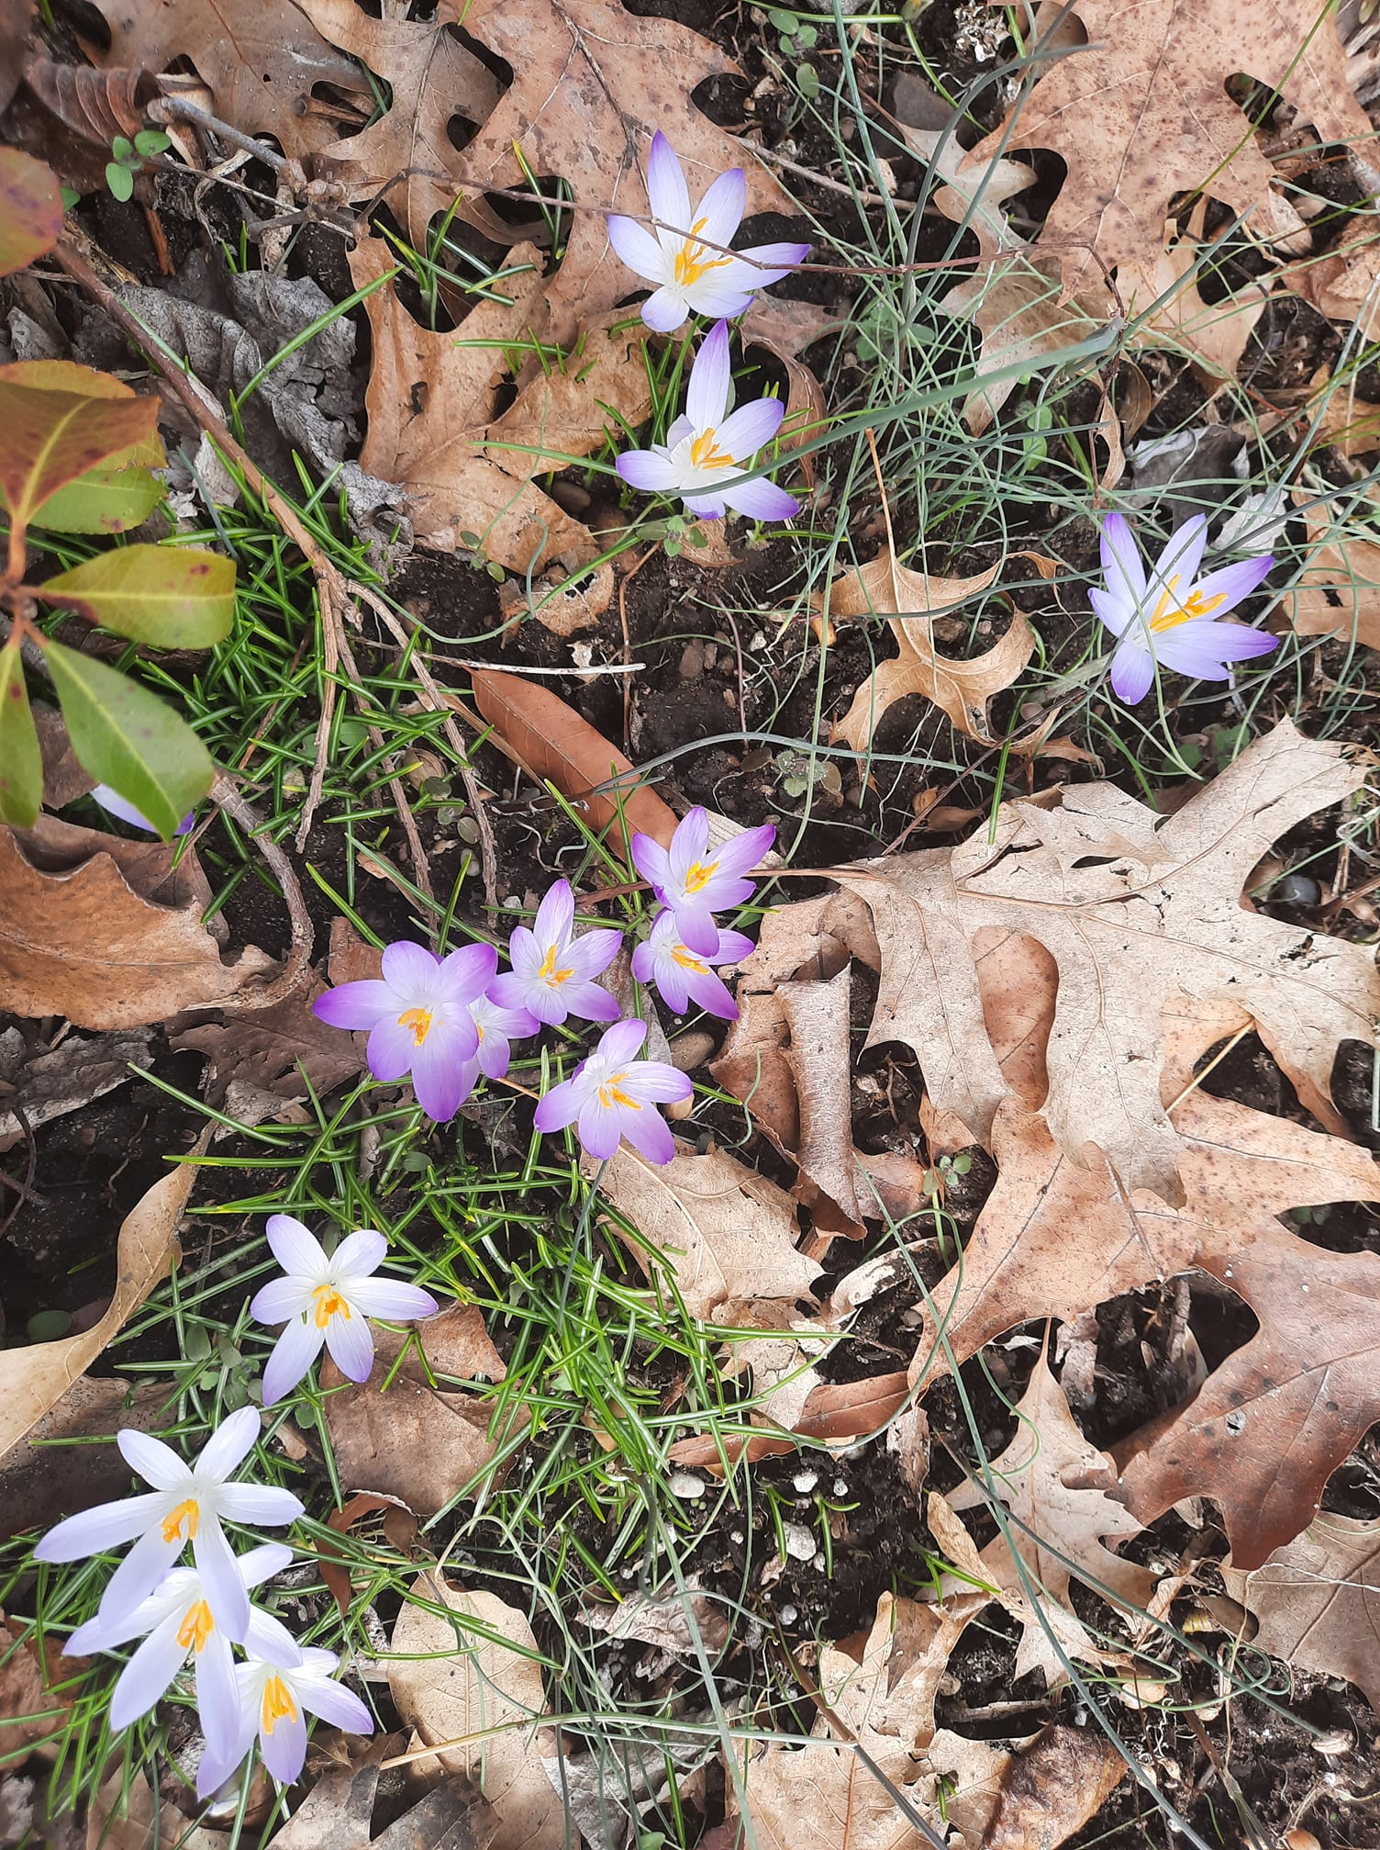
Join us Sundays on Zoom (open to gather @ 10:30am)
FUUSM Sunday Services Link
https://zoom.us/j/94822183499?pwd=ZVhkMHZWSnR1bTI5czZWRk1zdFFmQT09
Meeting ID: 948 2218 3499 Passcode: fuusm2323

Facebook - First Unitarian Universalist Society of Marietta
or live in-person in the sanctuary w/ masks & safety protocols.

First Unitarian Universalist Society of Marietta
Founded by Nahum Ward in 1855
Our FUUSM Mission is to nurture a diverse community
devoted to spiritual growth and freedom of thought for the benefit of all
(Photo by Jane Tumas Serna - Spring is blooming!)
Order of Service A Homecoming Sunday March 6, 2022
part of the ongoing series presented by the Homecoming Celebration Planning Team
We are more than a church.
We are a spiritual home for all, a beloved community,
an active part of the larger community. Come join us.

Gathering Music Journey Home -A. R. Rahman
The journey home Is never too long Your heart arrives before the train
The journey home Is never too long Some yesterdays always remain.
(complete lyrics listed on the last page)

Welcome Song by Hal Walker Whoever you are, we welcome you.
Wherever you come from, we welcome you.
Whomever you love, we welcome you.

Welcome Rev. Kathryn Hawbaker
Chalice Lighting
Our FUUSM Mission (Unison)
We, the members & friends of the First Unitarian Universalist Society of Marietta: strive to nurture
a diverse community, devoted to spiritual growth and freedom of thought for the benefit of all.
Choir Become Yourself words & music by Vicki Tucker Courtney
(complete text listed on the last page) Martha Webster, Choir Director and Randall Kidder, Pianist. Singers: Adeline Bailey, David Ballantyne, Karen Binkley, Dawn Hewitt, Kelsey Jacobs,
Martha McGovern, Suzyn Mills, and Darryl & Cynthia Ting.
Like ev'ry snowflake, ev'ry fingerprint, you are unique in who you are.
Become yourself, your own true self, one of a kind like ev'ry star.
Time for All Ages Church for All Lyndsey, Jimmy & Beatrice Bennett
Family Day Shukla Family

Song From You I Receive -words & music by Joseph & Nathan Segal
#402 Singing the Living Tradition From you I receive, to you I give,
Together we share, and from this we live.

Responsive Reading To Be of Use -Marge Piercy
#567 Singing the Living Tradition
Poem A Journey -Nikki Giovanni
Offering Give thanks for the past, for those who had vision,
who planted and watered so dreams could come true.
Give thanks for the now, for study, for worship, for mission that bids us turn prayer into deed.
Offertory Where Do We Come From? Words by Paul Gaugin, music by Brian Tate
#1003 Singing the Journey UU Family Values CD
Where do we come from, what are we, where are we going?
Mystery, mystery, life is a riddle and a mystery.
Slideshow Our FUUSM Fundraising Fun Produced by Mike Bailey
Photos by Ralph Olander

FUUSM Stories Elaine Barr, and Betsy Hune-Kalter
Service Auction Stories Rev. K. Hawbaker
Break-Out Rooms for more sharing of Service Auction Highlights.
Announcements
*(Facebook Live ends- thank-you for joining us)
Joys & Sorrows
Open Time Time to connect and fill in your dance card - and make new friends.
The Dance Card is a way to reach out and connect with people to invite them to the
Homecoming Celebration July 29-30-31, 2020 (when you complete yours, please turn it in to Roger K. or Annie W.) to create a Summary Call Sheet.

Thanks to the Tech Team, Mike Bailey, Ralph Olander, Al Tuttle, Elaine Barr, & K. Hawbaker. Join the team if you can help.
Greeters: (Comm. on Ministries) Ron Rees, John Kidd, Nina Redd, Haley Shukla, & Beth Lepore. Zoom Greeter: Annie Warmke Childcare: Lela Erb, Laura Cejka & Deborah Lauer.

Thank-you for your generosity in the 2022-23 Pledge Drive for next fiscal year.
Pledges to date ($98,270) will serve as the basis for projected income in the budget,
and expenses (including committee budget requests) will be presented to the
Annual Congregational Meeting on Sunday April 24, 2022.

ANNOUNCEMENTS
TODAY 3/6 (9:30am) Buildings & Grounds on Zoom
https://zoom.us/j/99172382606?pwd=eGtONEhwRzJLNUhUdDFOaXByQ3ZPQT09
Meeting ID: 991 7238 2606 Passcode: BanG

The Today's Issues group will meet in person in the RE/Office building next to the church
at 9:30am every Sunday and also on Zoom at:
https://us02web.zoom.us/j/8583258484?pwd=RFdJUGZOZkU4THArWFpnVkllZzh1dz09

Committee on Ministries meets TODAY at 12:15pm in the Parlor.
~ ~ ~ ~ ~ ~ ~ ~ ~ ~
Cool Congregation Challenge - FUUSM is a Runner Up!!
Interfaith Power & Light is mobilizing a religious response to global warming in congregations through the promotion of energy conservation, energy efficiency, and renewable energy.
www.interfaithpowerandlight.org

Mon. 3/7 (2pm) Caring Committee on Zoom (use Sun. Serv. Link)
https://zoom.us/j/94822183499?pwd=ZVhkMHZWSnR1bTI5czZWRk1zdFFmQT09
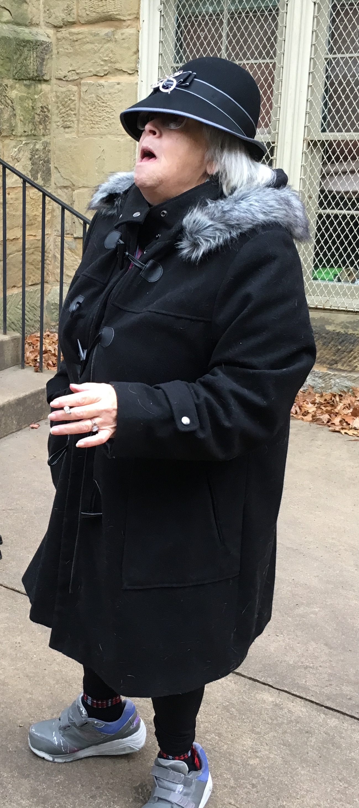
Meeting ID: 948 2218 3499 Passcode: fuusm2323

Wed. 3/9 (6pm) Women’s Group will have a potluck in the Social Hall.
Zoom is available for the time of check-in @ 7pm via Sun. Service link.
Hosted by Geannie Martin.

March 11 Deadline for items for the Service Auction catalog
Send to Cindy Brown lablibn@gmail.com
* * * * * * * * * * * * * * *
Thurs. March 17, 2022 (St. Patrick’s Day)
(5pm) Celebration of Life for Margaret (Peg) Clifford @ FUUSM.

Fri. March 25 (5pm) Service Auction returns
Sun. April 24 Annual Congregational Meeting (12 Noon)

Service Auction Volunteer Sign-Up Sheet is available through FUUSM-l@fuusm.org
Friday March 25, 2020 – Marietta College Gathering Place
Doors open at 5pm - $15 Entry per person (includes Country Store tickets)
5:30-6:30 Entertainment/Food & Silent Auction
6:30pm Live Auction Begins
(A volunteer meeting will be held in the basement on March 13th following the service.)
Questions? please contact Christina Thrasher 740-525-7588 or christinathrasher@yahoo.com

FUUSM Homecoming Celebration July 29-31, 2022
Members and friends are being asked to make 1-3 minute videos of: What the UU Society means to you? What is a special memory you have about some experience you have had through the congregation? Perhaps just a short story about some connection you made through FUUSM.
Our goal is to connect/reconnect/invite folks from the past and the wider community about being part of the UU future. Who have you not seen for a long while that you might give a jingle and have a conversation? What would Nahum Ward say?
“They wouldn’t let you and the girls dance?”
“Then we’ll just build a church where everyone can dance!”

The Journey Home
Composer: A.R. Rahman - Bombay Dreams, produced by Andrew Lloyd Weber
The journey home Is never too long Your heart arrives before the train
The journey home Is never too long Some yesterdays always remain.
I'm going back to where my heart was light
When my pillow was a ship I sailed through the night

The journey home is never too long When open arms are waiting there
The journey home is never too long There's room to love and room to spare
I want to feel the way that I did there And think my wishes through before I wish again

The journey home is never too long Home hopes to heal the deepest pain
The journey home is never too long Your heart arrives before the train
Not every boat you come across is one you have to take
Now sometimes standing still can be the best move you ever make

Become Yourself words & music by Vicki Tucker Courtney
Like ev'ry snowflake, ev'ry fingerprint, you are unique in who you are.
Become yourself, your own true self, one of a kind like ev'ry star.
Do not compare yourself to anyone, you are a special work of art.
Become yourself, your own true self, become the one within your heart.
Listen to the voice deep within you, that calls you to follow your dream.
Listen to the song that sings inside you and join the melody.

You hear the music others may not hear, you feel a rhythm of your own.
Become yourself, your own true self, believe in what may seem unknown.

Listen to the voice deep within you, that calls you to follow your dream.
Listen to the song that sings inside you and join the melody.
Become yourself, your own true self, Become who you were meant to be.

A Journey - Nikki Giovanni
It's a journey . . . that I propose . . . I am not the guide . . .
nor technical assistant . . . I will be your fellow passenger . . .
Though the rail has been ridden . . .
winter clouds cover . . . autumn's exuberant quilt . . .
we must provide our own guide-posts . . .
I have heard . . . from previous visitors . . .
the road washes out sometimes . . . and passengers are compelled . . .
to continue groping . . . or turn back . . . I am not afraid . . .
I am not afraid . . . of rough spots . . . or lonely times . . .
I don't fear . . . the success of this endeavor . . . I am Ra . . .
in a space . . . not to be discovered . . . but invented . . .
I promise you nothing . . . I accept your promise . . . of the same
we are simply riding . . . a wave . . . that may carry . . . or crash . . .
It's a journey . . .

