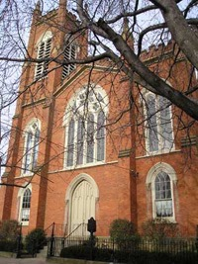
Join us on Zoom (gather10:30am) FUUSM Sunday Services Link
https://zoom.us/j/94822183499?pwd=ZVhkMHZWSnR1bTI5czZWRk1zdFFmQT09
Meeting ID: 948 2218 3499 Passcode: fuusm2323
or Facebook - First Unitarian Universalist Society of Marietta

LIVE in-person in sanctuary with masks and safety protocols.
First Unitarian Universalist Society of Marietta
Founded by Nahum Ward in 1855
(11am) Order of Service Charter Sunday Feb. 6, 2022
We are more than a church.
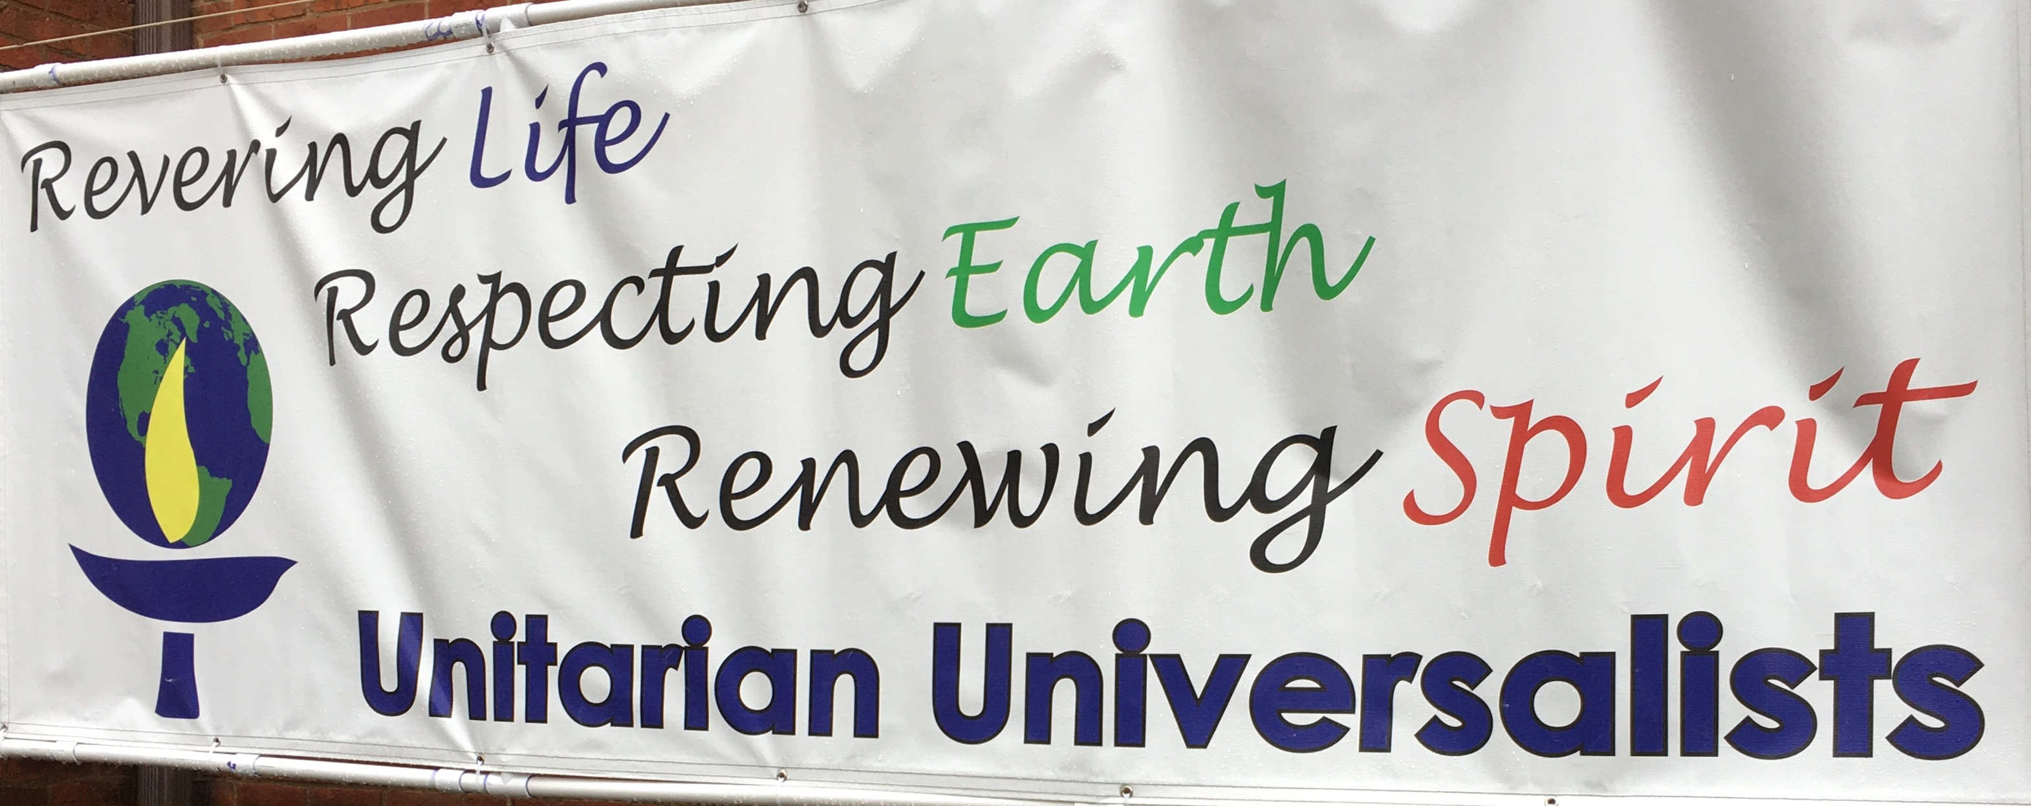
We are a spiritual home for all, a beloved community,
an active part of the larger community. Come join us.

Gathering Music Journey Home -A. R. Rahman

Welcome Song by Hal Walker
Whoever you are, we welcome you.
Wherever you come from, we welcome you.
Whomever you love, we welcome you.

Welcome Rev. Kathryn Hawbaker, Minister
Acknowledging Native Lands

Prelude On My Way Home - Paul Cardall Randall Kidder, Pianist

Chalice Lighting Be ours a religion which, like sunshine, goes everywhere…
Singing the Living Tradition #683 -Theodore Parker

FUUSM Affirmation
We, the members & friends of the First Unitarian Universalist Society of Marietta:
- Support the free and disciplined search for truth as the center of religious
community and encourage an acceptance of pluralistic views;
- Recognize our Judeo-Christian heritage as well as other traditions
and seek lasting values and new insights;
- Affirm, defend, and promote the equality, worth, and dignity of every person;
- Strive for a world community of love, justice, and peace;
- Support the democratic process and mutual respect in all human relationships;
- Cherish the universe and its resources and recognize the unity of all life.

Offering Give thanks for the past, for those who had vision,
who planted and watered so dreams could come true.
Give thanks for the now, for study, for worship,
for mission that bids us turn prayer into deed.
Offertory #404 What Gift Can We Bring Randall Kidder, Pianist
Singing the Living Tradition -Words & Music by Jane Marshall

FUUSM Stories Rileigh Trembly, Margaret Fredricks with Crosby,
Kim & Diane McMichael, Dawn Hewitt, and Michael “Moon” Mullen

(Facebook Live ends- thank-you for joining us)

Announcements
Joys & Sorrows
Reprise Journey Home
Time to connect and fill in your dance card

Thanks to the Tech Team, Mike Bailey, Ralph Olander, Al Tuttle, Elaine Barr, Piyush Shukla
& K. Hawbaker. Join the team if you can help.
Greeters from the Committee on Ministries: Ron Rees, John Kidd, Nina Redd, & Haley Shukla.
Nursery Attendants: Lela Erb, Laura Cejka & Deborah Lauer.

Thank-you for participating in the 2022 Pledge Drive for next fiscal year.

Launch of UU Homecoming 2022
Our goal is to connect/reconnect/invite folks from the past to be part of the UU future.
If you're interested in volunteering to be on the planning committee or for the weekend event July 29-31, 2022 please get in touch with Roger Kalter (rogerkalter1@gmail) or (740) 525-1833.

The Journey Home
Composer: A.R. Rahman - Bombay Dreams, produced by Andrew Lloyd Weber
The journey home Is never too long Your heart arrives before the train
The journey home Is never too long Some yesterdays always remain.
I'm going back to where my heart was light
When my pillow was a ship I sailed through the night

The journey home is never too long When open arms are waiting there
The journey home is never too long There's room to love and room to spare
I want to feel the way that I did there And think my wishes through before I wish again

The journey home is never too long Home hopes to heal the deepest pain
The journey home is never too long Your heart arrives before the train
Not every boat you come across is one you have to take
Now sometimes standing still can be the best move you ever make

ANNOUNCEMENTS
The Today's Issues group will meet in person in the RE/Office building next to the church
at 9:30am this Sunday, Feb 6 (and every Sunday) and also on Zoom at:
https://us02web.zoom.us/j/8583258484?pwd=RFdJUGZOZkU4THArWFpnVkllZzh1dz09

TODAY (9:30am) Choir practice- sanctuary and Buildings & Grounds on Zoom
https://zoom.us/j/99172382606?pwd=eGtONEhwRzJLNUhUdDFOaXByQ3ZPQT09
Meeting ID: 991 7238 2606 Passcode: BanG
Committee on Ministries meets at 12:15 on Zoom (Use Sun. Serv. Zoom Link).
~ ~ ~ ~ ~ ~ ~ ~ ~
Mon. 2/7 (2pm) Caring Committee on Zoom (use Sun. Serv. Link)
https://zoom.us/j/94822183499?pwd=ZVhkMHZWSnR1bTI5czZWRk1zdFFmQT09
Meeting ID: 948 2218 3499 Passcode: fuusm2323

Next Sunday 2/13 - World Interfaith Harmony Week
Society of Friends (Quakers) meets in the Parlor (11am - 12:30)
Mon. 2/14 (6:30pm) Board of Trustees in the Parlor & on Zoom (use Sun. Serv. Link).
Wed. Feb. 16 (6pm) Women’s Group on Zoom (Use Sunday Service Link)

Sat. Feb. 19 (1pm) Celebration of Life for George Lisk at FUUSM

Send in your goods and services that you can contribute for our FUUSM Auction catalog.
These items help build community and build our budget. First items in go first in the catalog.
lablibn@gmail.com (Cindy Brown)
Fri. March 25 (6pm) Service Auction returns to The Gathering Place -Marietta College

FUUSM Homecoming Celebration 2022
Members and friends are being ask to make 1-3 minute videos of: What the UU Society means to you? What is a special memory you have about some experience you have had through the congregation? Perhaps just a short story about some connection you made through FUUSM.

Our goal is to connect/reconnect/invite folks from the past about being part of the UU future. Who have you not seen forever that you might give a jingle and have a conversation?
What would Nahum Ward say? “They wouldn’t let you and the girls dance?”
“Then we’ll just build a church where everyone can dance!”

