First Unitarian Universalist Society of Marietta (MOV)
Family Candlelight Service
Christmas Eve ~ December 24, 2021 (7pm)
Hope ~ Peace ~ Joy ~ Love

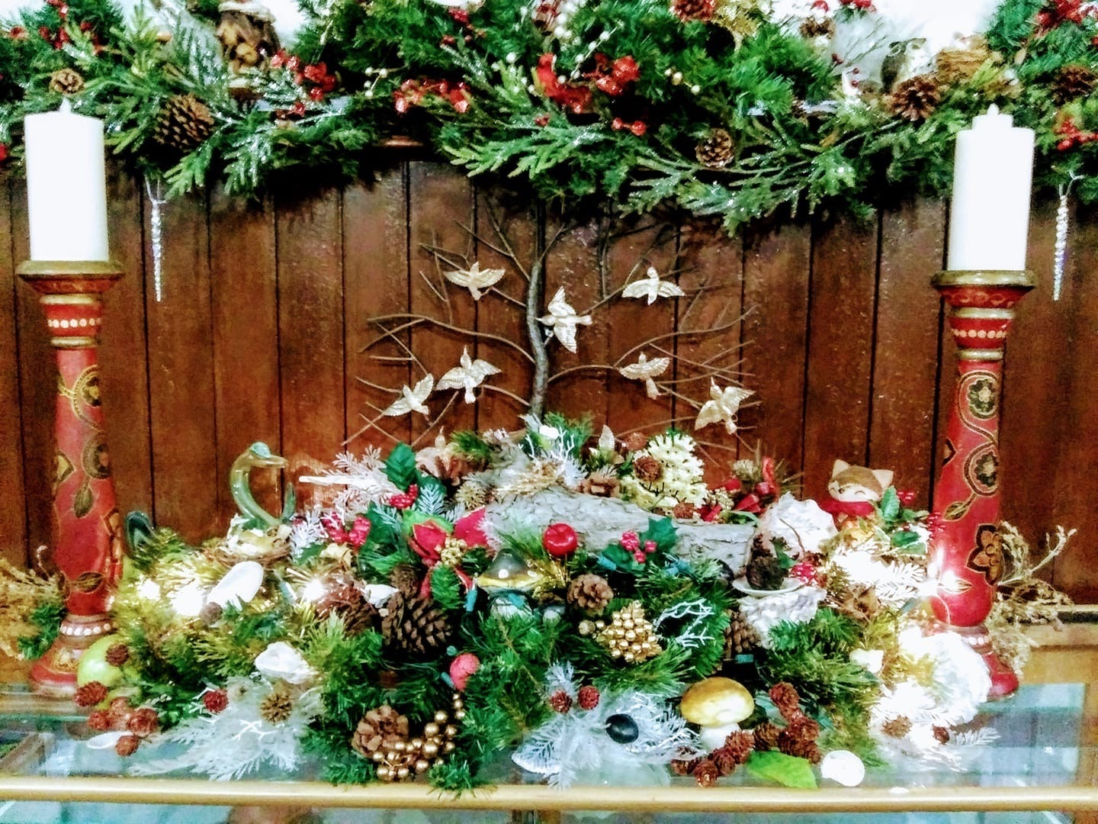
WELCOME
Thank-you for wearing a mask and social distancing by sitting in pews with cushions.
The sign-in sheets assist with contact tracing if needed.

Gathering Music #256 Winter Night -by U.U. Shelley Denham Jackson
Singing the Living Tradition
I Heard the Bells on Christmas Day FUUSM Choir (recorded 2012) Randall Kidder, Pianist

Welcome Whoever you are, we welcome you - Hal Walker
Prelude #245 Joy to the World!

Acknowledging Native Lands Hopewell Moundbuilders

Chalice Lighting A Star

Reading For So the Children Come -Sophia L. Fahs Cindy Burton
Singing the Living Tradition #616

Lullaby Sofou unga astin min (icelandic)

Story for All Ages Mouse’s First Christmas Martha McGovern -Mark Kimball Moulton

Special Music Winter Martha Webster, Choir Director
music by Anthony Giamanco, words by Walter de la Mare, arranged by Andy Beck.

FUUSM Choir: Adeline Bailey, Dave Ballantyne, Gean Martin,
Martha McGovern, Suzyn Mills, Squish Rector, Cynthia & Darryl Ting,
and Jane Tumas-Serna. Choir AV Production - Mike Bailey

Collection of the Offering The Greatest Gifts
Offertory Kore Evohe --John Schragg/Sabina C. Becker
from Winter Solstice Celebration (The story of Demeter & Persephone)

Message Promoting Peace on Earth -Rev. Kathryn Hawbaker

Sharing the Light
(1st Round-Participants on Zoom light their candles at home and dim the lights;
2nd round - Sanctuary lights candles)

Prayer Songs of Peace Night of Silence -David Haas
FUUSM Choir, previously recorded
Silent Night, Holy Night
Words: Joseph Mohr (1792-1848) Music: Franz Xaver Gruber (1787-1863)

Benediction Carry It Home -Betsy Rose, Winter Solstice Celebration

Recessional Sleigh Ride - The Boston Pops

Great appreciation for those who give their gifts of service this evening.
Choir AV Production - Mike Bailey
Tech Team: Mike Bailey, Al Tuttle, Elaine Barr and Kat Hawbaker.
Readers: Martha McGovern and Cindy Burton
Collection Stewards: Christina Thrasher & Joe Baker.
Greeters: Abi, AJ, Haley & Piyush Shukla

Silent night, holy night, all is calm, all is bright
round yon virgin mother and child.
Holy infant so tender and mild,
sleep in heavenly peace, sleep in heavenly peace.

Silent night, holy night, shepherds quake at the sight,
glories stream from heaven afar,
heavenly hosts sing “Alleluia,”
sleep in heavenly peace, sleep in heavenly peace.

Silent night, holy night, child of God,
love’s pure light radiant beams from thy holy face,
with the dawn of redeeming grace,
sleep in heavenly peace, sleep in heavenly peace.

Announcements
Sun. Dec. 26 2021 (11am) Live in-person in the Sanctuary, and on Zoom.
Kwanzaa - a celebration of community.

Sun. Dec. 26 (1pm) Lawrence Greene honors Kwanzaa, with African drumming -an Artsbridge program of music at the Grand Central Mall in Vienna, WV.

Mon. Dec. 27 (7pm) Finance Committee Zoom Meeting
https://us02web.zoom.us/j/84846131311?pwd=WFdqTWt3cGpmU1lhMWpiS2owMGpudz09
Meeting ID: 848 4613 1311 Passcode: fuusm$

