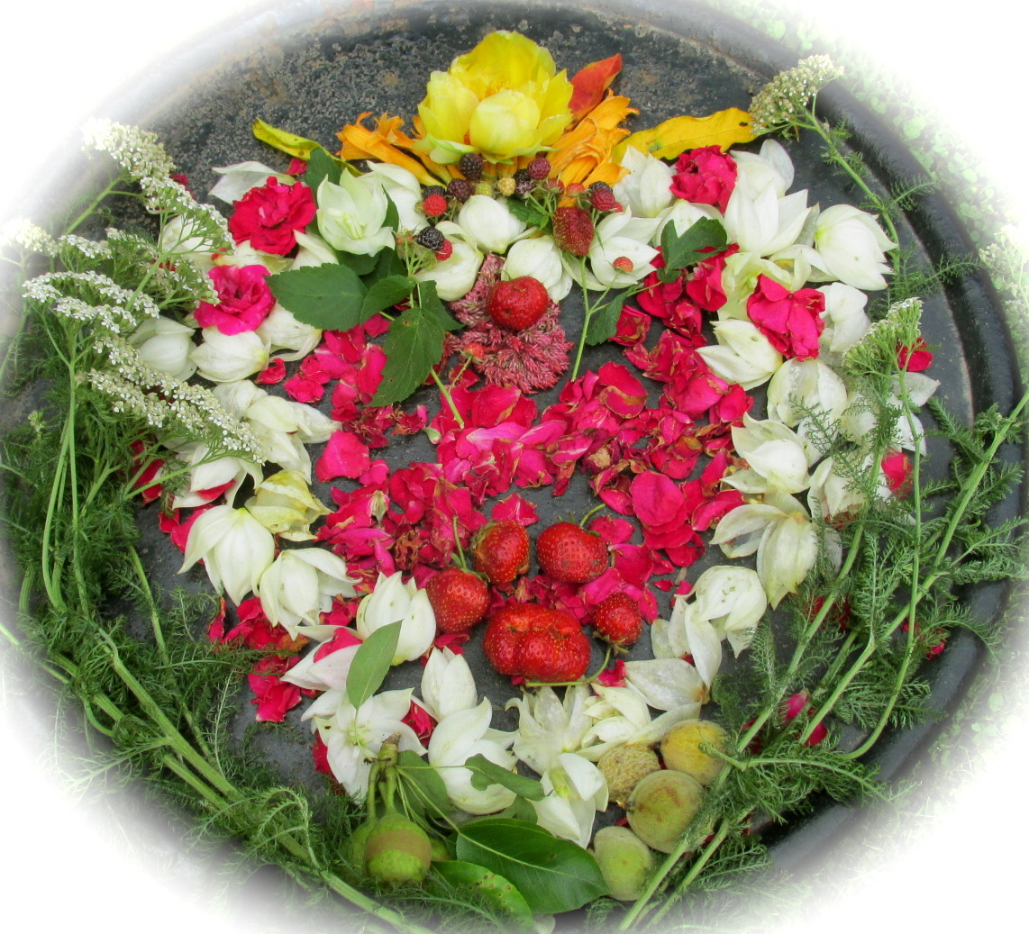
First Unitarian Universalist Society of Marietta
Sunday Service ~ December 19, 2021
Fourth Sunday of Advent ~ Love

Gathering Music All You Need is Love -Beatles

Welcome Rev. Kathryn Hawbaker

Welcome Song by Hal Walker - Kent, OH
Whoever you are, we welcome you
Wherever you come from, we welcome you
Whomever you love, we welcome you.

Prelude Hymn #131 Love Will Guide Us - Sally Rogers
Singing the Living Tradition

Acknowledging Native Lands Remember
based on the words of the first Native American US poet laureate Joy Harjo,
a member of the Muscogee Creek Nation.

Chalice Lighting We Remember

Story for All Ages The Real Gift
from Wonderful Welcome
* (Participate at home- Gather up a box, canister, or other container with a lid)

Offering
Offertory Little Drummer Boy -Bing Crosby & David Bowie

Sermon All You Need is Love -Rev. Kathryn Hawbaker

Closing Song There is More Love Somewhere

Joys & Sorrows

Postlude Little Drummer Boy Alex Boye’ w/ Genesis Choir

Thanks to all who help with our Sunday Services.
Tech Production Crew: Mike Bailey, Al Tuttle & Elaine Barr.

TODAY (12:30) Green Sanctuary Meeting on Zoom

FUUSM Announcements
Limited Office Hours in December: Mon.-Wed.-Fri. 10am-12 Noon.
Rev. Hawbaker is available by appointment (937) 470-4151.
Volunteers are invited to take a turn helping in the office.

Wed. 12/22 Midday Meditation at Noon on Zoom
https://zoom.us/j/9062049940?pwd=TEtGeE90WCtJeHB0UmJsRElhTEJVdz09
Meeting ID: 906 204 9940 Passcode: OMWed12

~ Festivals of Light ~
Join us on Friday & Saturday evenings @ FUUSM (6:30-7:30pm)
to share our outdoor display and add your bow of ribbon to the fence.

Tues. Dec. 21, 2021 Winter Solstice Watch @ Sacra Via (4:15-5pm)
7pm Winter Solstice Spiral at FUUSM
This annual ceremony features walking a simple spiral in a reflective and meditative
ritual that honors the return of the light and the cycle of the seasons.
We will be outside if weather permits (unlikely). Masks are required.

UU Ministry for Earth
Wed. December 22 Winterlight - A Solstice Celebration, with Rev. E. Nguyen
on Zoom at 8pm ET. Please register in advance for this event.

Friday 12/24/2021 (7pm) FUUSM Family Christmas Eve for All Ages
A Candlelight Service (Live in the Sanctuary & available on Zoom).
Masks are required and safety precautions are in place.
The Nursery is available without staff, with audio for listening to the service.

Resources & References
Remember
"Remember the sky you were born under. Know each of the star's stories…"
This is a 3-minute visual poem short film from the Sun Valley Writers' Conference 2021.
Remember is based on the words of the first Native American US poet laureate Joy Harjo, a member of the Muscogee Creek Nation. It's directed by award-winning filmmaker Jessica Sanders, featuring Navajo contemporary artist Tony Abeyta, and Navajo friends Owee Rae and her son Kier, and Crickett Tiger and Santiago Romero. Sanders also included three generations of her own family, whose origins are from China, Turkey, Spain, & Germany.

Peace on Earth/Little Drummer Boy
Recorded Sept. 1977 for a television special, Bing Crosby's Merrie Olde Christmas. The pair exchanged dialogue about what they do for Christmas before singing "Little Drummer Boy" with a new counterpoint with original lyrics written for the special, "Peace on Earth". Crosby died just over a month after recording the special.

Little Drummer Boy Alex Boye’ w/ Genesis Choir (African Tribal Version)

