Reminder: Daylight Savings Time starts this weekend. Turn your clocks back 1 hour Saturday night.

https://zoom.us/j/94822183499?pwd=ZVhkMHZWSnR1bTI5czZWRk1zdFFmQT09
Meeting ID: 948 2218 3499 Passcode: fuusm2323
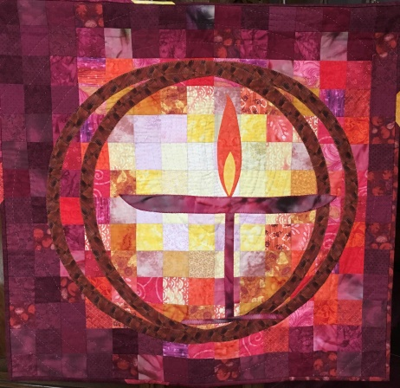
First Unitarian Universalist Society of Marietta
Order of Service ~ Sunday November 7, 2021

Navigating Uncertainties

Our mission is to nurture a diverse community
devoted to spiritual growth and freedom of thought
for the benefit of all.

Perfection is the enemy of the good.

Prelude Prelude in C-Major - Johann Sebastian Bach Randal Kidder, Pianist
Well Tempered Clavier Book I:

Welcome Chris Hoke, President of the Board of Trustees

Chalice Lighting Rev. Kathryn Hawbaker
Covenant of the Board

Story for All Ages The Rock Fell From the Sky -Jon Klassen
Katy McDaniel and Griffin Jeffery

Reading Breathe: A Letter to My Sons -Imani Perry Beth Lepore

Offertory No.3 in g-minor for the right hand - Stephen Beneking
Album for one Hand Alone No.III:

Message Alternatives and Opportunities Ted Goertzel
“One Never Knows, Do One” Andrew Clovis
FUUSM: Brainstorming Chris Hoke

Postlude Album for One Hand Alone No.III:
No.8 in A-Major for the right hand

Joys and Sorrows/Benediction Rev. Kat Hawbaker

Announcements Brainstorming Session (12:30-2:30pm) FH
Great Gratitude to our talented Tech Team - Mike Bailey & Ralph Olander
and Greeters Anita Newhart & Nancy Luthy.
Consider how you can share your gifts and join our teams in service.

You are welcome at FUUSM! Please use a Building Entry Log (bright red folder) in Office,
Sanctuary, & Social Hall to sign in & out when you’re in the buildings
~~~~~~~~~~~~~~~~~~~~~~~~~~~~~~~~~~~~~~~~~~~~~~~~~~~~~~~~~~~~~~~~~~~~~~
Next Week at FUUSM
Mon. 11/8 Board of Trustees (6:30pm) Parlor & FUUSM Main Zoom Link
Tues. 11/9 Office Closed
Wed. 11/10 Meditation (12-1pm) Zoom Mtg ID: 906 204 9940 Passcode: OMWed12
https://zoom.us/j/9062049940?pwd=TEtGeE90WCtJeHBOUmJsRE1hTEJVdz09

Wed. 11/10 Women’s Group – Hosted by Cynthia Ting
Thurs. 11/11 Office Closed – Veteran’s Day
Sat. 11/13 FUUSM Work Day (10am) Drum Class with Lawrence Green (3-5pm) FH

Sunday 11/14 Ethics of the Common Good Rob McManus, Marietta College
https://zoom.us/j/94822183499?pwd=ZVhkMHZWSnR1bTI5czZWRk1zdFFmQT09
Meeting ID: 948 2218 3499 Passcode: fuusm2323
- Today's Issues, 9:30 am in person in the Parlor. Contact Ted Goertzel for information.
- Choir Rehearsal, 9:30 am in the Sanctuary.
- Gathering and Greeting, 10:30 am in person and on Zoom.
Worship Service (11am) Live in the Sanctuary and on Zoom
(10:50-12:30) Society of Friends (Quakers) gathering in the Parlor.
~~~~~~~~~~~~~~~~~~~~~~~~~~~~~~~~~~~~~~~~~~~~~~~~~~~~~~~~~~~~~~~~~~~~~~~~~~~
For more information see the calendar at www.fuusm.org
Chris Keller, Office - fuusm@suddenlinkmail.com (740) 373-1238.
Rev. Hawbaker, - available by appointment - revkat@suddenlinkmail.com. (937) 470-4151
~~~~~~~~~~~~~~~~~~~~~~~~~~~~~~~~~~~~~~~~~~~~~~~~~~~~~~~~~~~~~~~~~~~~~~~
The Warming House on Front St. (beside the Congregational Church) is open If you can help on Thursdays, or if you can donate a side dish for the Thanksgiving meal, please contact Beth Lepore
@ shimplepore@suddenlink.net.

Norwood United Methodist Church is asking for help with a Community Thanksgiving Meal.
To volunteer, call (740) 374-5606; to contribute, make checks payable to Norwood UMC –
23 Colegate Drive, Mtta. OH. (Rev. Hawbaker has made a contribution on behalf of FUUSM.)

