
First U. U. Society of Marietta
Order of Service ~ Sunday October 17, 2021

Our mission is to nurture a diverse community
devoted to spiritual growth
and freedom of thought for the benefit of all.

Our FUUSM main zoom link:
Autumn Worship Services 2021
(open at 10:15am)
https://zoom.us/j/94822183499?pwd=ZVhkMHZWSnR1bTI5czZWRk1zdFFmQT09

Meeting ID: 948 2218 3499
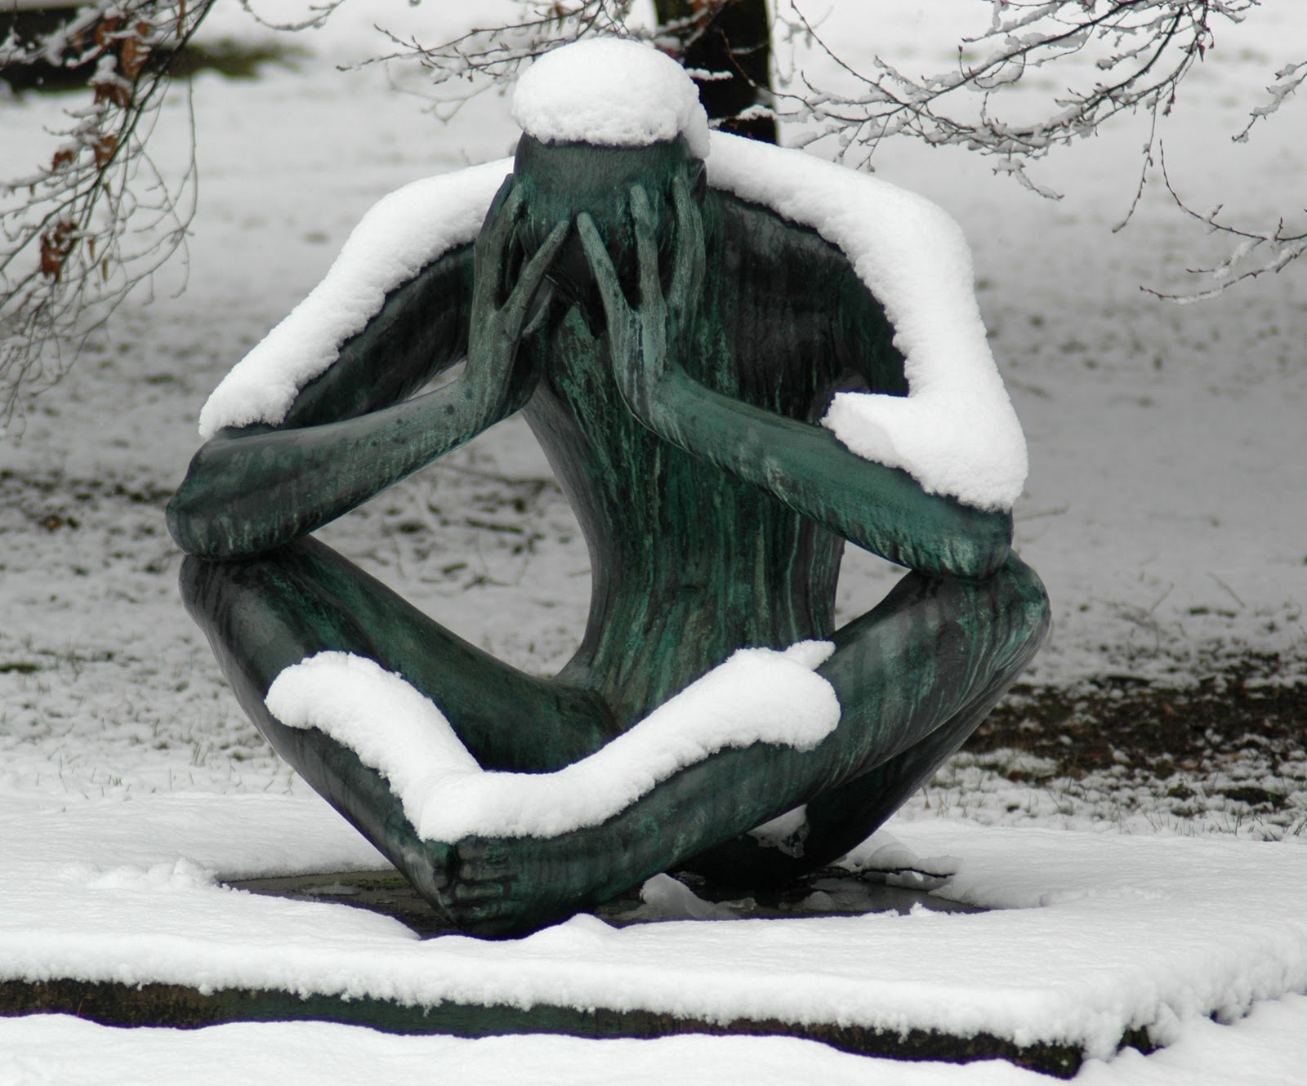
Passcode: fuusm2323

[ I Hate Winter by Prairie Father ]

Welcome
Welcome to the First Unitarian Universalist Society of Marietta (Mid-Ohio Valley).
Please enjoy a time of gathering and greeting one another via Zoom until the Welcome Slide appears.Please mute yourselves to establish a reverent space and pause for the beginning of the service.
At the end of the service there is a brief time to share Joys & Sorrows; Announcements and Zoom break out rooms for small group sharing and connection,
and another open time of sharing and socializing. The service is streamed live to FaceBook, but Joys & Sorrows will not be included in these public postings.
Welcome Rev. Kathryn Hawbaker
Whoever you are, we welcome you
Wherever you come from, we welcome you
Whomever you love, we welcome you. (Hal Walker)

Welcome
Welcome to the First Unitarian Universalist Society of Marietta (Mid-Ohio Valley).
Please enjoy a time of gathering and greeting one another via Zoom
until the Welcome Slide appears and the Prelude begins, denoting the start of the service.
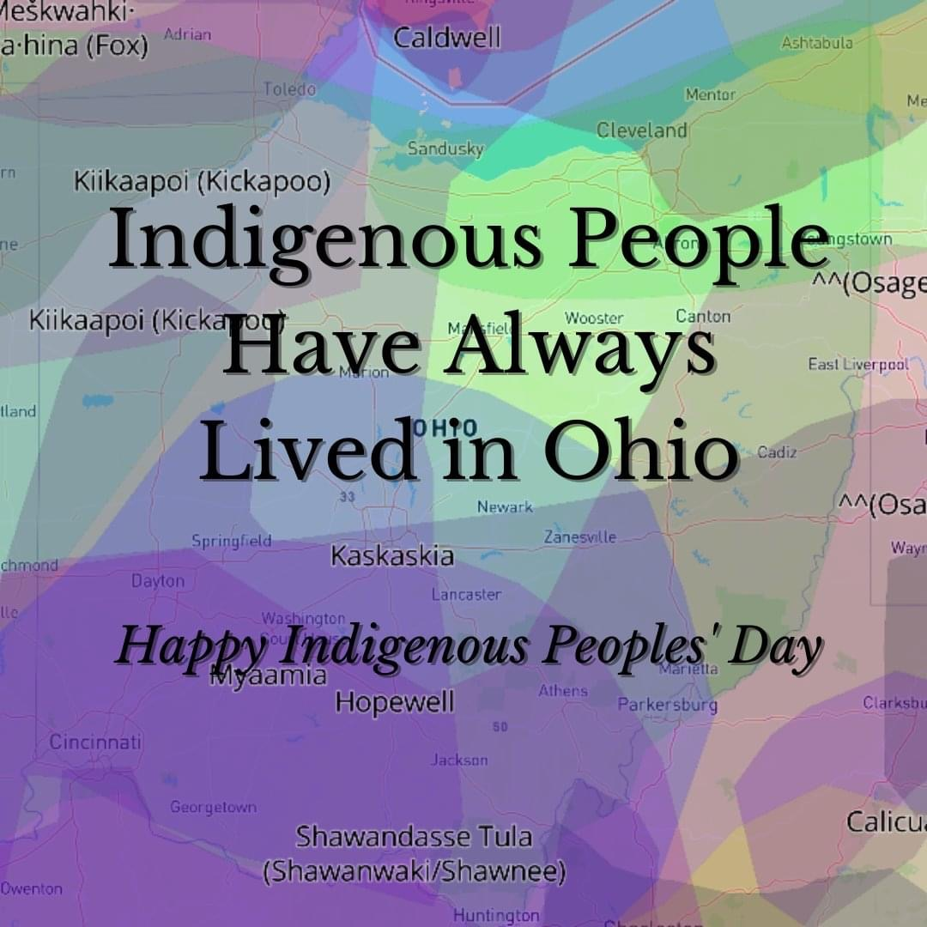
We ask that you mute yourselves (or we can help) to establish a reverent space and pause for the beginning of the service.

At the end of the service there are Announcements
& a brief time to share Joys & Sorrows;
Break-Out Rooms on Zoom, and an
open time of sharing and socializing.
Most of the service is streamed Live to FaceBook,
but Joys & Sorrows will not be included in public posts.

Acknowledging Native Lands
Marietta College -
Office of Diversity & Inclusion

Chalice Lighting Creating an Altar

FUUSM Affirmation
We, the members and friends of the First Unitarian Universalist Society of Marietta:
Support the free and disciplined search for truth as the center of religious community
and encourage an acceptance of pluralistic views;
Recognize our Judeo-Christian heritage, as well as other traditions,
and seek lasting values and new insights;
Affirm, defend and promote the equality, worth and dignity of every person;
Strive for a world community of love, justice, and peace;
Support the democratic process and mutual respect in all human relationships;
Cherish the universe and its resources and recognize the unity of all life

Time for All Ages from The Fall of Freddie the Leaf -Leo Buscalia

Meditation Feelings -Daily OM Taking the time to sit with your feelings
to acknowledge them, will save you much distress down the road.

Monk’s Morning Practice - Nick Keomahavong (Buddhist, Thailand)
Get centered and reflect on death; make your bed;
chanting & meditation; Do an act of generosity; Do chores.

Reading The Thing Is -Ellen Bass

Reflection A Deeper Recovery Martha McGovern

Offering Self-care is never a selfish act—it is simply good stewardship
of the only gift I have, the gift I was put on earth to offer to others. ~ Parker Palmer

Offertory There On Down the Road Ahead -folksong Randall Kidder, Pianist

Art slides: Pieta - by Michelangelo; Car Crash by LeeAnn Gallucci
Good Grief Charlie Brown by Charles Schultz

Reflection A Deeper Recovery Rev. Kathryn Hawbaker

Benediction
w/ Postlude On Golden Pond Randall Kidder, Pianist

Joys & Sorrows
Dylan (son of Cathy & Ron Rees) celebrated marriage with Ariela in a Jewish ceremony
in Upstate NY with family and friends last weekend.

Announcements
Zoom Break- Out Sessions will allow us to check-in with a small group of folks
on who we may be thinking about, and if we are grieving.

Video by Ralph Olander, AV Production by Mike Bailey
Greeters: Cathy & Ron Rees (Caring & Committee on Ministries)

You are welcome at FUUSM! Please use Building Entry Log (bright red folder)
in Office, Sanctuary, & Social Hall to sign in & out when you’re in the buildings.
*This assists with attendance data & contact tracing - if it becomes necessary.
Masks are required, especially as our area is at very high risk (Washington Co. OH)
and severe risk (Wood Co., WV) according to COVIDActNow.org

Announcements
Jim Grecni, Rebecca Phillips and team installed a drip irrigation system at the Fort Street pollinator habitat.
The Caring Committee is helping to organize our hospitality for a Celebration of Life to honor Jim Rapp on Sat. Oct. 30, 2021; Time with family at 2pm and service @ 3pm with special music and guests. Light refreshments in courtyard after the service.
In lieu of flowers, Jim requested that memorial contributions go to FUUSM for youth and young adult programs and outreach. This will also be supported by a future art auction.

Parkersburg Pride has a 4-part interview with Jim Rapp on their FB page

FUUSM Open Leadership Brainstorming Session - Sun. Nov. 7 (1-3pm)
The Board of Trustees is presenting the 11am service on Nov. 7 Navigating Uncertainties
and hosting an open session for brainstorming and priorities for the future of FUUSM.

FUUSM Annual Service Auction has been changed to March 19, 2022


Next Week at FUUSM
Tues. 10/19 Office Closed
Wed. 10/20 Meditation (12-1pm) Zoom Mtg ID: 906 204 9940
Passcode: OMWed12 https://zoom.us/j/9062049940?pwd=TEtGeE90WCtJeHBOUmJsRE1hTEJVdz09

Men’s Group (6:30) hosted by Chris Jacobs at the Marietta Boat Club,
713 Allen St, Marietta. Use the left door, near sliding glass doors.

Newsletter Deadline Your information makes the Confluence useful. What do you value in the newsletter? Email written & edited material to tedgoertzel@gmail.com

Please check the Calendar @ www.fuusm.org
Chris Keller, Office - fuusm@suddenlinkmail.com (740) 373-1238.
Rev. Hawbaker is attending a family gathering in AZ Oct. 21-26.

Resources
For area General Election (Nov. 2) Information- Early Voting is now available.
Washington County OH Board of Elections www.boe.ohio.gov/washington
Wood Co. WV GoVoteWV.org

LWV.org League of Women Voters
Local Issues and Initiatives: Township Trustees, Marietta School Board;
WV lost 1 US House seat in the 2020 Census and will elect 2 Representatives in 2022.

Defending Democracy -money in politics, pass the Freedom to Vote Act.
Redistricting voting maps, voting rights and access, etc.

