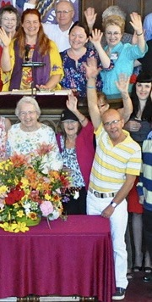
We laugh, we cry, we live, we die,
we dance, we sing our song….
And we believe in life,
and in the strength of love;…
And we believe that sharing is an answer.

We Laugh, We Cry - Shelley Jackson Denham

FUUSM Family and Friends,

With a heavy heart I announce the death
of Jim Rapp, a long-time and devoted member
of the congregation.
Jim was a talented and loyal friend and leader
who touched many lives here in Washington
County and beyond.
He served in every capacity at FUUSM.
He was a source of creativity, imagination,
vision and savvy, who knew that the work of
religious community is slow, but steady in the hands of people who care.

This past “Summer of Jim” was a time of sanctuary and connection, not just for Jim, but for all the people who stopped by the cabin in the woods. Jim showed us a way to face the medical crisis of cancer with determination and courage.
He was open and honest about what he wanted in life and in death, and he had the support of Dr. Cawley and so many other family and friends.

I will be forever grateful that Jim brought me to Marietta and found us the perfect home at the farm in Lowell, and for so much more…
There will be more to share and say, but for now we give thanks for his life.
For now we lament the loss of such a vibrant man, and we miss him.
May he rest in power. My his light ever shine.

A celebration of his life will be held later when the arrangements are made.
In faith, Rev. Kathryn Hawbaker

