
First Unitarian Universalist Society of Marietta
Order of Service ~ Sunday October 3, 2021

Our mission is to nurture a diverse community
devoted to spiritual growth and freedom of thought
for the benefit of all.

I think sometimes we need to take a step back
and just remember we have no greater right to be here
than any other animal. -David Attenborough

Slideshow Prelude FUUSM Blessing of the Animals -K.E.H.

Welcome Rev. Kathryn Hawbaker
Acknowledging Native Lands
An elder of Cherokee descent, Stan Rushworth
Instead of thinking that I am born with rights,
I choose to think that I am born with obligations…

Chalice Lighting
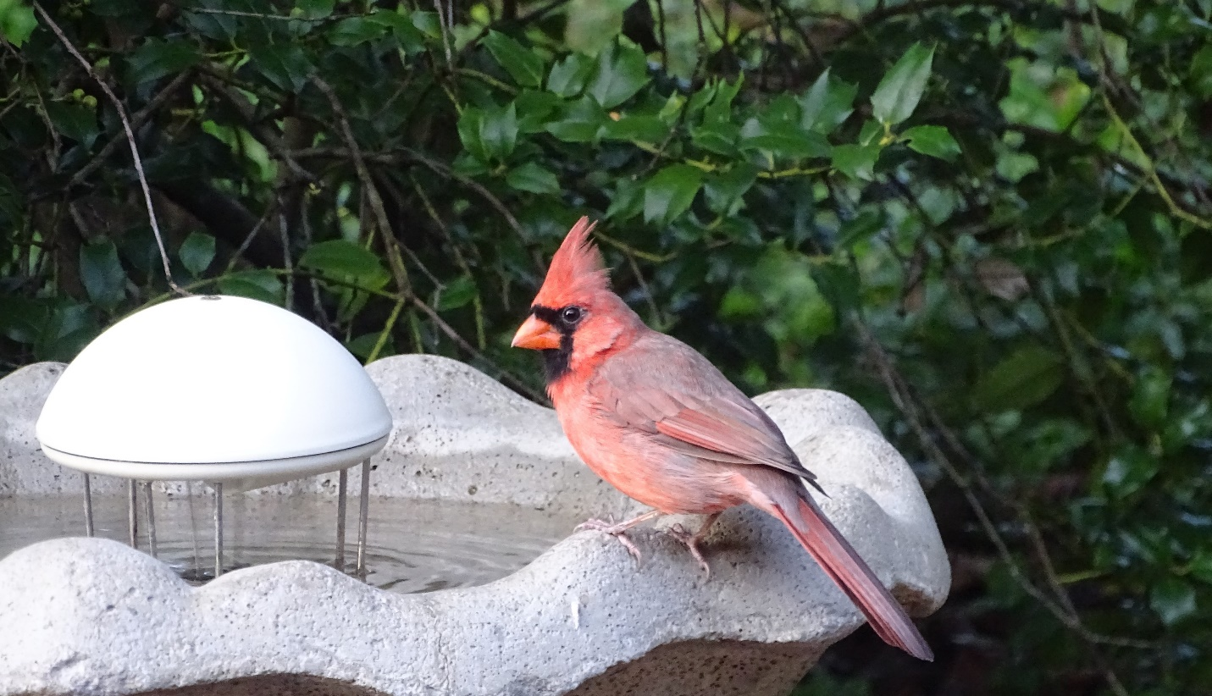
Cardinal at the chalice bird bath at the Banziger home.

Nature is cruel, but we don't have to be. -Temple Grandin


Meditation

Reading
from West With Giraffes -Lynda Rutledge

Presented by members of the UU+ Book Group

Offering

Offertory The Little White Donkey - Jasques Ibert Randall Kidder, Pianist

Sermon

Reverence for All Life

Rev. Kathryn Hawbaker

Benediction
Announcements
Postlude Blue Boat Home -Peter Mayer

Joys & Sorrows

“Until one has loved an animal, a part of one’s soul remains unawakened.”
-Anatole France, Nobel Laureate, 1921

Great Gratitude to our talented tech team and greeters.
Join us in the courtyard TODAY (12:30) for the Blessing of the Animals.
You are welcome at FUUSM! Please use a Building Entry Log (bright red folder) in Office, Sanctuary, & Social Hall to sign in & out when you’re in the buildings. *This assists with attendance data/contact tracing - if it becomes necessary.
Check the Weekly Update via the FUUSM-L email list for meetings (Zoom & in-person) and complete information for other events on the calendar.
Next Week at FUUSM
Mon. 10/4 Caring Committee (2pm) Zoom & Parlor Tues. 10/5 Office Closed
Wed. 10/6 Meditation (12-1pm) Parlor/Zoom Mtg ID: 906 204 9940 Passcode: OMWed12 https://zoom.us/j/9062049940?pwd=TEtGeE90WCtJeHB0UmJsRElhTEJVdz09
Wed. 10/6 Worship & Music (5pm) Zoom Mtg ID: 817 8372 4553 Passcode: worship https://us02web.zoom.us/j/81783724553?pwd=cDlEbTQzUGVaZ3NXVUtKdWJYYzNTdz09

Upcoming Events
Mon. Oct. 4 @ 8pm EST Meadville Lombard Community Vespers In Covenant with the Earth, led by Dr. Elias Ortega and Rev. abby mohaupt. She will invite us into a moment of reflection on the interdependent existence of our lives and the earth in a time of ecological crisis, and share a GreenFaith event, Faiths 4 Climate Justice: A Global Multi-Religious Action (Oct. 17-18).
Rev. Hawbaker can email you the link.
Saturday, October 9th, 2021 @ 9am - Armory Square, Marietta A Walk to Remember - Loved ones lost to suicide. For more info. call the Behavior Health Board (740) 374-6990
Sat. Oct. 9 Drum Class with Master Drummer Lawrence Greene (3-5pm) in FUUSM Social Hall. Suggested Donation $15-20.

Sun. October 10 What Does It Mean to be a Welcoming Congregation? Rev. K. Hawbaker National Coming Out Day (Oct. 11)
Learn about UPLIFT - the UUA Ministry and outreach for GLBTQIA+

Newsletter Deadline - Oct. 20, 2021. email written & edited material to tedgoertzel@gmail.com

Oct. 31 is the deadline for the Service Auction Catalog.
First items in, first served up at auction.
Sat. Nov. 13 FUUSM Annual Service Auction @ The Gathering Place.
Are you planning to attend with confidence in our safety protocols?

SMILE! Simply type First Unitarian Universalist Society of Marietta in the search bar at http://smile.amazon.com select it as the organization to support, then...shop thru Amazon Smile. This quarter we raised- $28.23.

Calendar @ www.fuusm.org Chris Keller, Office- fuusm@suddenlinkmail.com (740) 373-1238. Rev. Hawbaker is available by appointment (937) 470-4151.

