ANNOUNCEMENTS Sunday June 20, 2021

*Summer Solstice & Father’s Day*

**June 2021 Sunday Worship Services/Main Zoom Link**

<https://zoom.us/j/94822183499?pwd=ZVhkMHZWSnR1bTI5czZWRk1zdFFmQT09>

Meeting ID: 948 2218 3499 Passcode: fuusm2323

Dial in by phone from your regional location

By Phone 1-929 205 6099 (New York) 1-301 715 8592 (Germantown, PA)

Same Meeting ID (as above): 948 2218 3499 Different Passcode: 772050

**Sunday Schedule:**  (9:30am) Today’s Issues discussion group in the Parlor,

& Adult RE *Moving from Grief to Morning* in the Social Hall;

(10:30) Time of Gathering & Greeting on Zoom and in the Sanctuary, (11am) Service begins.

Nursery Open (10:30am-12:30) Attendants June 20: Deborah Lauer & Laura Cejka

Sunday Service***Living Waters*  -** Rev. Nancy McDonald Ladd

**11:00 a.m. on Zoom & Facebook, and "watch party" in the Sanctuary.**

**Meadville Lombard in the Pulpit:** This pre-recorded worship service is a gift from Meadville Lombard Theological School. Rev. Ladd, MDiv ‘04, Sr Minister of River Road UU Cong. in Bethesda, MD, will base her reflection on the Gospel of John 4:1-26, the story of the woman at the well.

A special musical guest is Mark Miller, faculty at Drew Theological School, and the Institute of Sacred Music at Yale University. A worship service not to be missed- for UU and liberal Christians as well.

**TODAY** Green Sanctuary Meeting 12:30pm on Zoom

[https://us02web.zoom.us/j/83615181647?pwd=SzBxcTliYWN1MjRRRXZweTNGZFB4QT09](https://webmail.suddenlink.net/do/redirect?url=https%252525253A%252525252F%252525252Fus02web.zoom.us%252525252Fj%252525252F83615181647%252525253Fpwd%252525253DSzBxcTliYWN1MjRRRXZweTNGZFB4QT09&hmac=cd3de3a4f548a141f1eb348bc4f1bc4f)

Meeting ID: 836 1518 1647 Passcode: green1

**Meadville Lombard Theological School** (Chicago) is where I earned my Masters of Divinity in preparation for UU ministry. I have followed their transformations over the years and welcome this opportunity to introduce you to this learning community and ask for your support -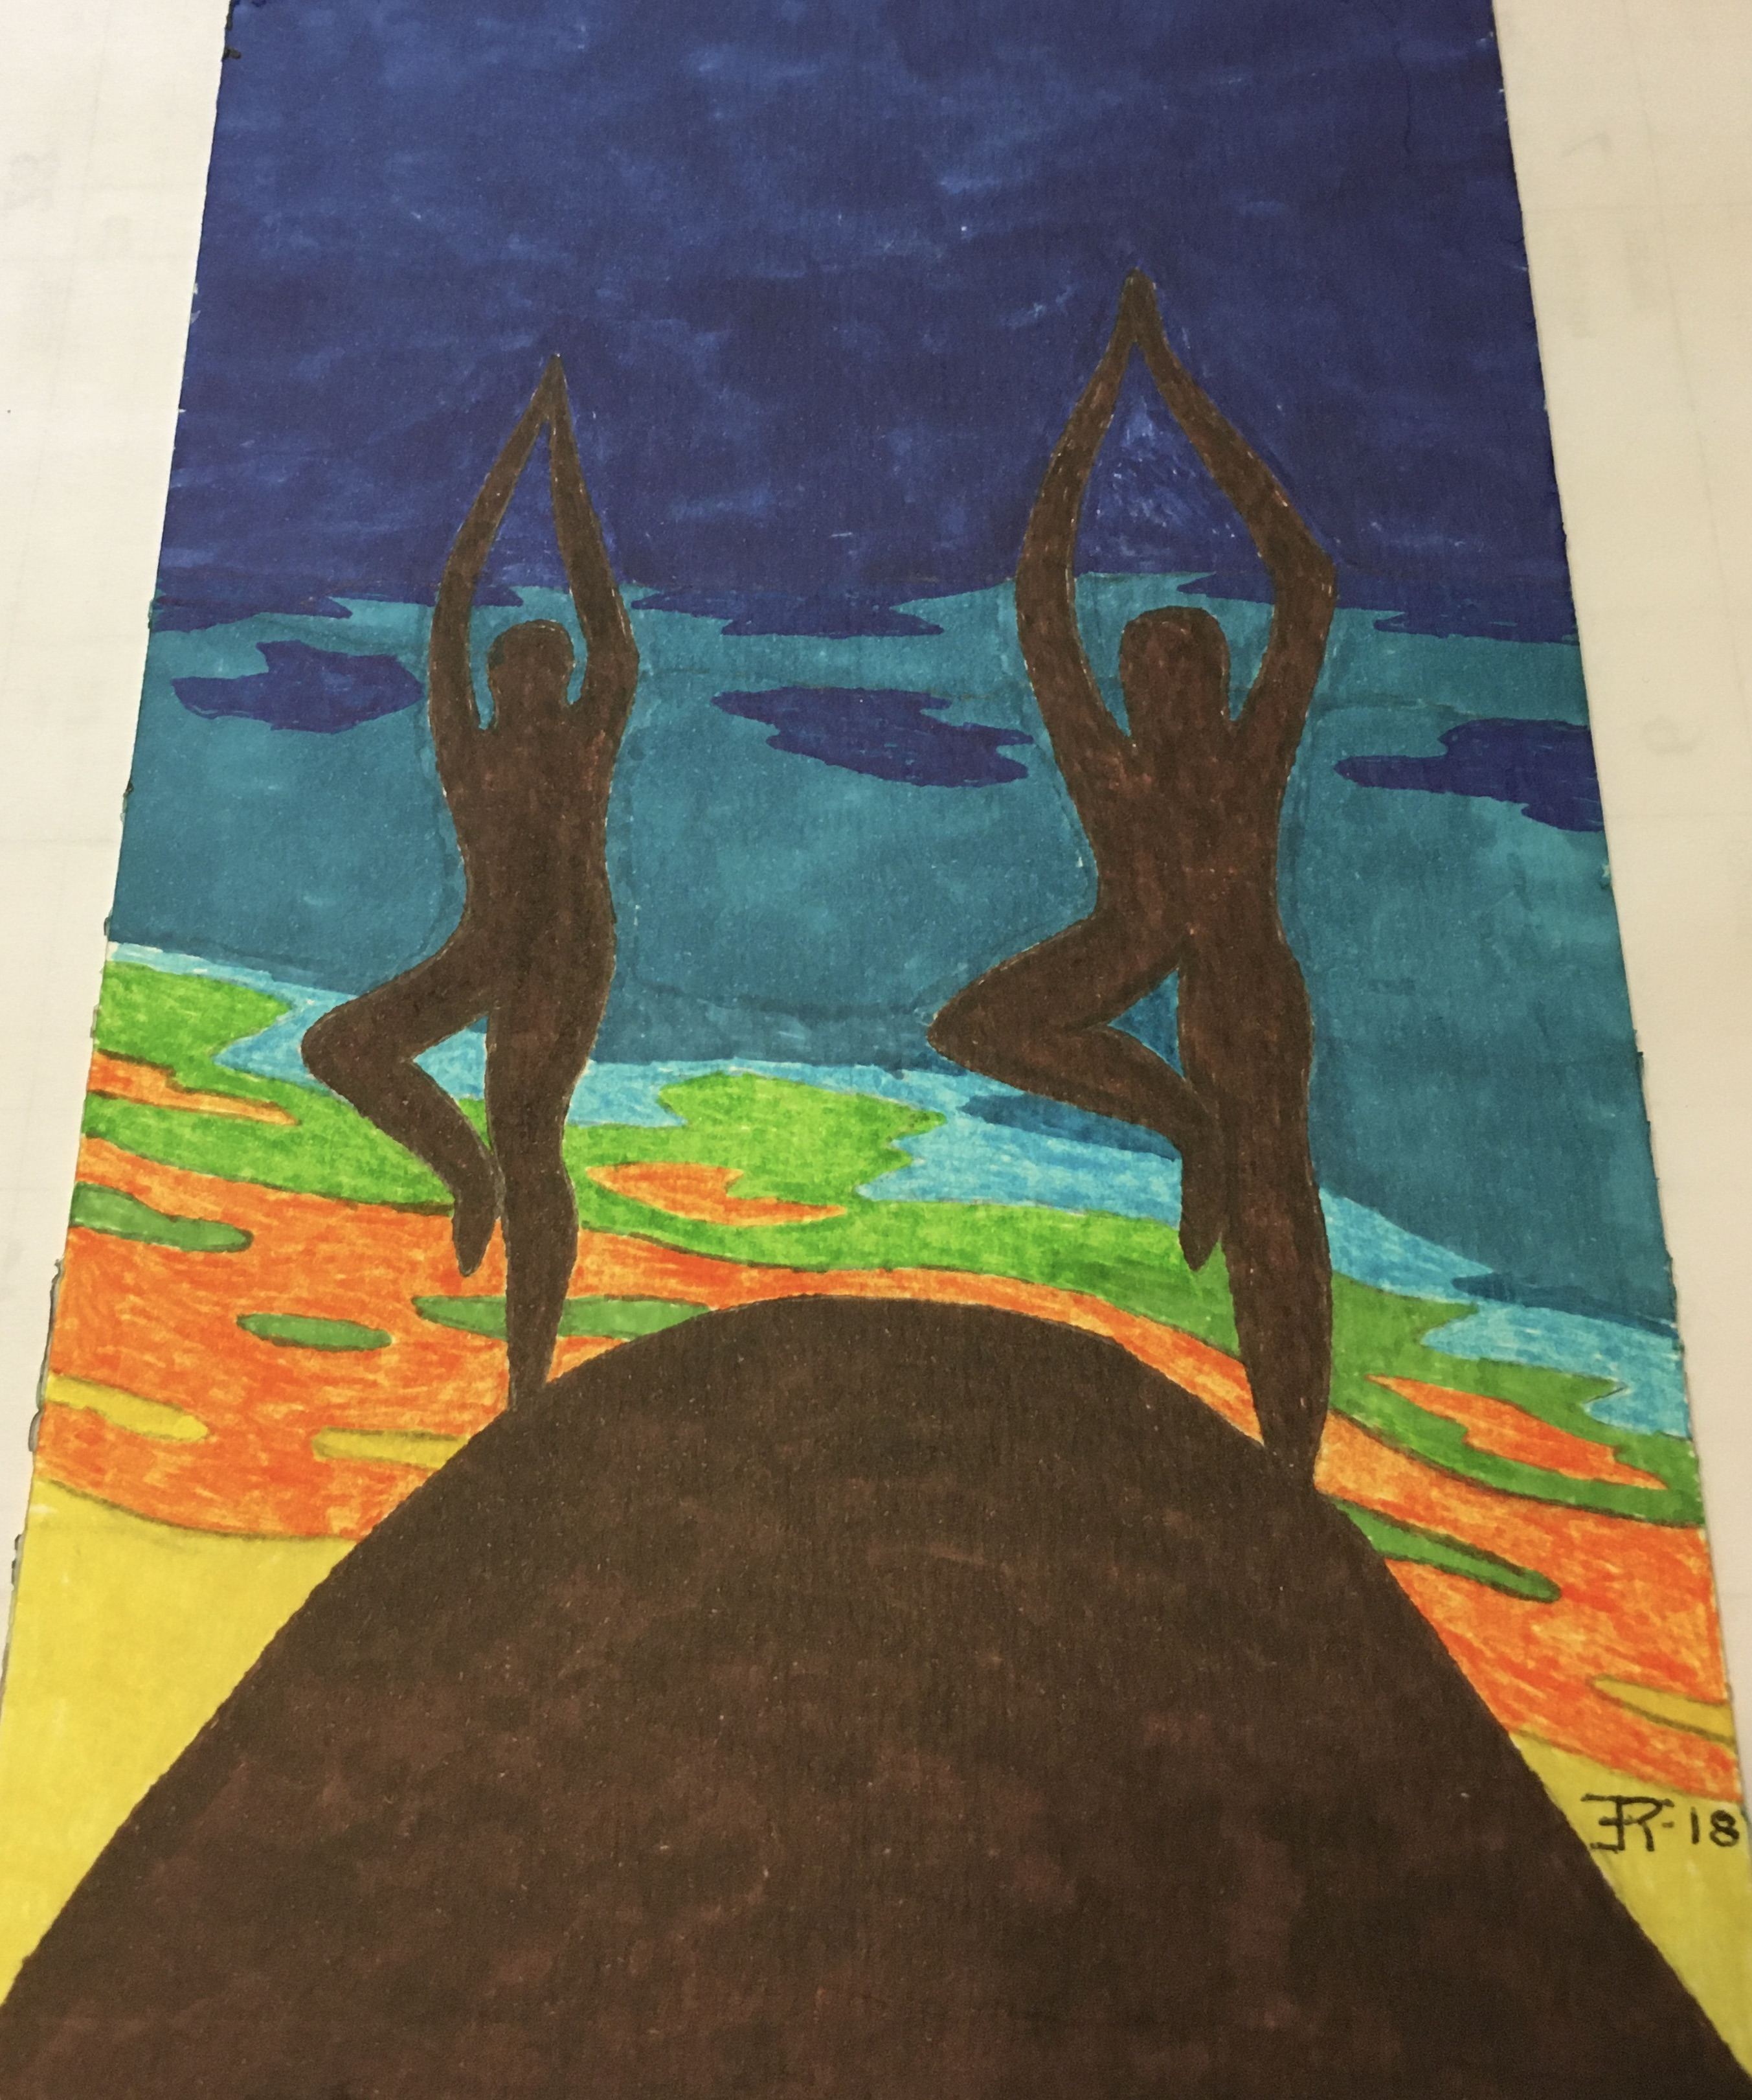

**Second Helping** is a reference to our special or second collection for groups and organizations that support our values and align with our mission. As we return to take up a monthly appeal, please continue your generosity as an expression of gratitude for the many resources M/L provides to our UU movement and in appreciation for the service today. I’ll give a second time, to round out our collective contribution.

*Yoga for the Summer Solstice* in Times Square, NY.

Mind Over Madness Yoga.

Come to the Courtyard after service for a simple observance of

International Yoga Day. Artwork by Ron Tepley-

If you have announcements for the Weekly Update please e-mail fuusm@suddenlinkmail.com

**Next Week at F.U.U.S.M.**

**Mon**. June 21 Guitar Camp – (6pm-8:30pm) FH Every Monday evening through August 9th.

**Tues.** June 22 Office Closed

**Wed. June 23-27**, 2021 **UUA General Assembly**

Mike & Adeline Bailey & Rev. Hawbaker are FUUSM delegates

**Wed. June 23** (12-1pm) Midweek Midday Meditation (Zoom) All are Welcome

https://zoom.us/j/9062049940?pwd=TEtGeE90WCtJeHB0UmJsRElhTEJVdz09

Meeting ID: 906 204 9940 Passcode: OMWed12

**Fri. June 25** Chris Keller – vacation day

**Poor People’s Campaign** Free buses to Washington D.C. for **Wed. June 23 Moral March**

June 21st starts 365 Days of Fighting Forward. *Forward together, not one step back!*

**Next Saturday - June 26, 2021** (11am-3pm)

Out-MOV sponsors - Pride in the Park @ City Park in Parkersburg, WV

LGBTQIA+ Community Celebration. Show your support.

**Next Sunday June 27 - General Assembly Morning Worship** -Unitarian Univ. Assoc.

**11:00 am on Zoom & Facebook, and "watch party" in the Sanctuary.**

Recognizing the importance of shared ministry and the many innovative approaches to worship created by congregations during the pandemic, UUA President, Rev. Dr. Susan Frederick Gray, selected the First Universalist Church of Minneapolis to serve as worship leaders for this year's GA Sunday Morning Service. Last year more than 10,000 screens tuned in to watch.

Please join us this year for the largest annual gathering of Unitarian Universalists in worship.

**Current FUUSM Guidelines for Building Use** (June 2021)

*If attendee is not feeling well, they should not attend

*All attendees sign in and provide information requested.

*Maintain 6 ft. distance, “take turns” entering, exiting, & taking seats to allow spacing.

(Sanctuary capacity 25-50; Fellowship Hall capacity - 15).

*Use face masks that cover nose and mouth. We have some if you forget to bring your own.

*Wash hands/use hand sanitizer upon entering building.

*No food or beverages in the building– you can’t eat/drink with a face mask on.

*One person in a bathroom at a time.

*****************************************************

First Unitarian Universalist Society of Marietta 232 Third Street, Marietta, Ohio 45750

Summer Office Hours are flexible: Mon., Wed., Thur., & Fri. (10am -1pm). Office closed Tues. Phone 740) 373-1238 [fuusm@suddenlinkmail.com](mailto:fuusm@suddenlinkmail.com) www.fuusm.org

**Minister**: Rev. Kathryn E. Hawbaker; **Office Administrator**: Chris Keller;

**Pianist**: Randall Kidder; **Choir Director**: Martha Webster.

**2020-2021 Board of Trustees**: Cory Sampson, President; Beth Lepore, Vice President;

Nancy Luthy, Secretary; Ted Goertzel, Treas.; Chris Hoke, Katy McDaniel, & Andrew Clovis.