First Unitarian Universalist Society of Marietta
Sunday January 31, 2021 Charter Sunday
Zoom - Our main FUUSM Zoom Link is the one we use for Sunday Services
(and other meetings & gatherings).
https://zoom.us/j/94822183499?pwd=ZVhkMHZWSnR1bTI5czZWRk1zdFFmQT09
Meeting ID: 948 2218 3499 Passcode: fuusm2323
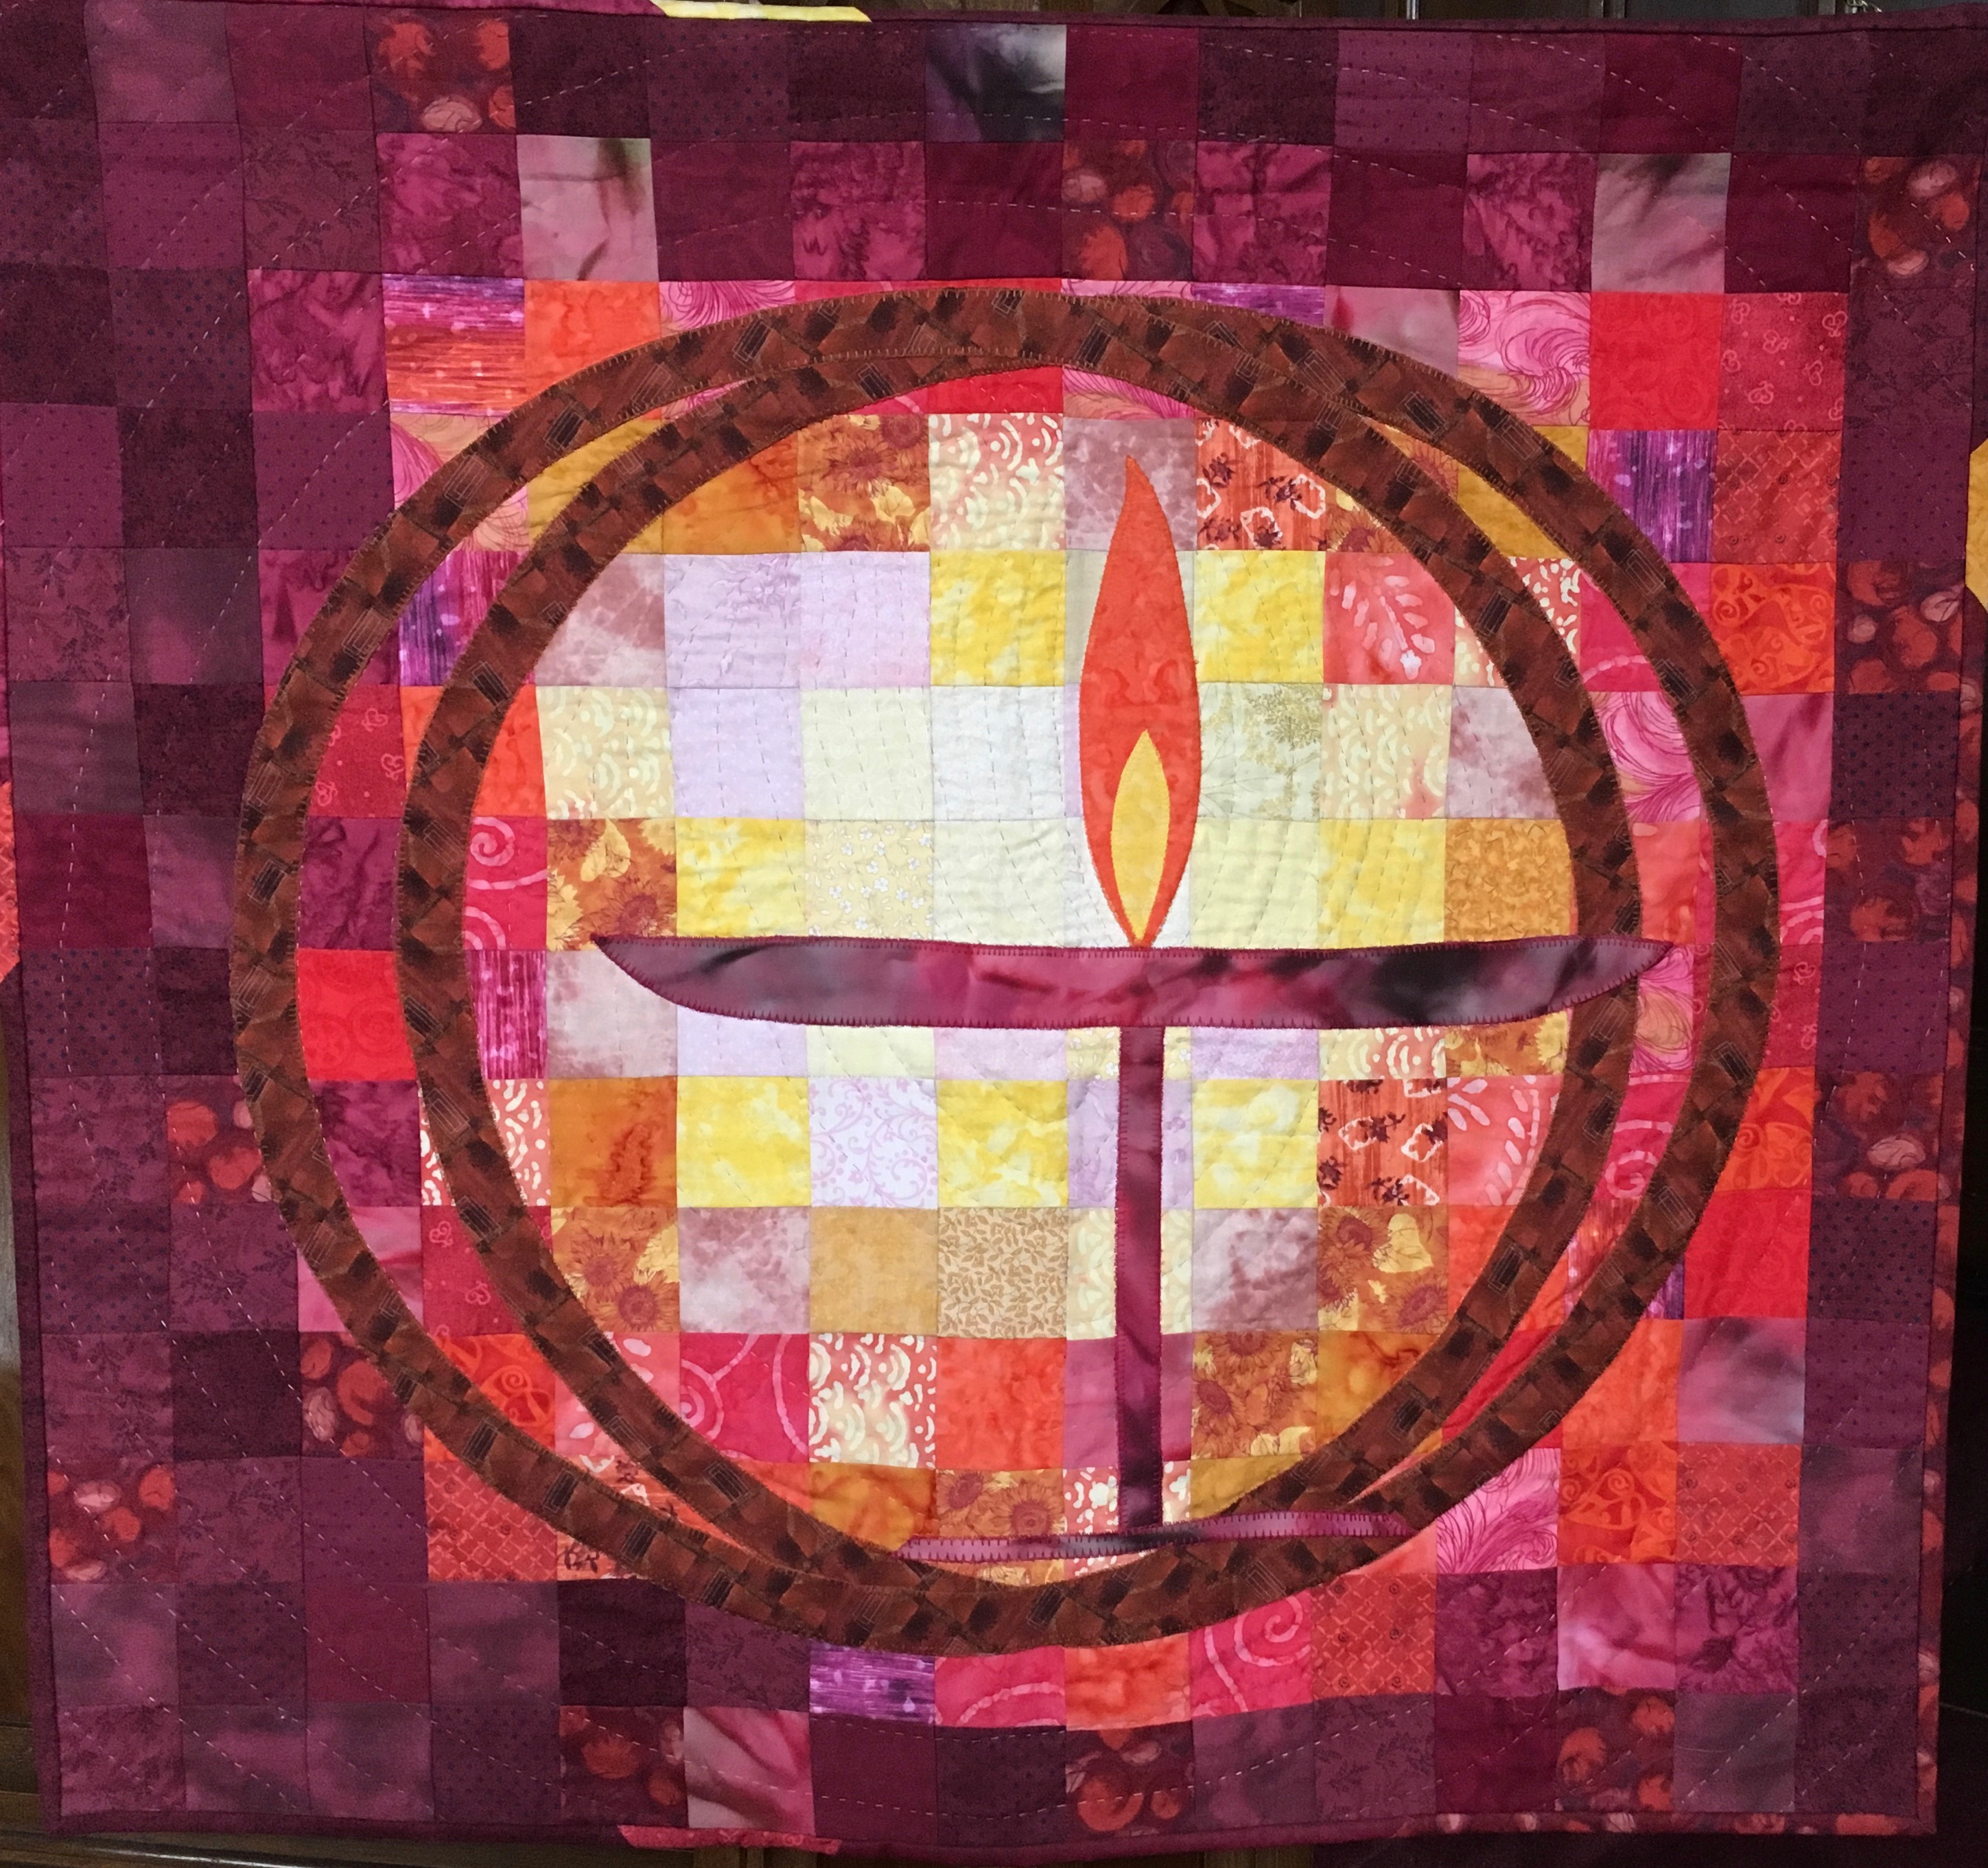
The Sunday Service is also streamed live to Facebook, and you can find it there later as a video

This Sunday Jan. 31, 2021 Charter Sunday
FUUSM founded Feb. 1855.
Celebrate FUUSM’s Birthday! There is room for you
in the Sanctuary on Sunday Mornings. Following all of our safety protocols, if you are not participating in Zoom or Facebook,
and are comfortable coming into the Sanctuary for Sunday Service, you are welcome.

Sunday we begin a once a month feature carefully moving forward with live in-person events, with a lively sharing activity at Noon for those who attend in person. The Zoom Service will be available on screen in the Sanctuary at 11am. A time of Gathering/Greeting begins at 10:30am.
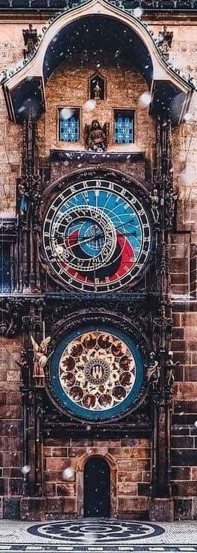
Check our website www.fuusm.org for a video of the Reenactment.

(11am) Budgeting Our Time and Treasure
- Rev. Kathryn Hawbaker
It was with the Poor Peoples Campaign
that I really began to see and understand how
a budget is a moral document. This perspective
can help create conversations between leaders
and the people they serve. A mission or values-based
budget shares information in ways that focus our
attention and resources on what is most important.
It’s a way of understanding how a congregation uses
its assets and resources to serve its mission
that makes sense to the members who care about
how the congregation is serving its mission.

Our Mission- Orloj in Prague, Czechia -installed 1410 CE
To nurture a diverse community, Oldest working astronomical clock
devoted to spiritual growth
and freedom of thought for the benefit of all.

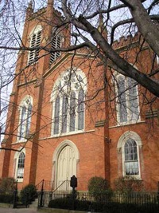
Order of Service ~ Charter Sunday Jan. 31, 2021

Prelude Dreamgift Spencer Brewer Randall Kidder, Pianist

Welcome Rev. Kathryn Hawbaker
Recognition of Native Lands
Serpent Mound. (300 BCE -1120 CE)

Chalice Lighting A Birthday Big Idea Josie Jeffery

Story for All Ages Kamala & Maya’s Big Idea -Meena Harris
(niece of Kamala Harris, US Vice President)

Musical Meditation The Song that Nature Sings - Ruth E. Schram Performed by Martha Webster

Reading from Big Ideas for Small Congregations J. Dwinell & E. Germann-Melosh

Hymn #1017 Building A New Way -Martha Sandefer, 1952- arr. Jim Scott
Singing the Journey
-Led by Amanda Thomas, Music Director -Second Unitarian Church Chicago

Reflection Big Ideas and Budgeting Time & Treasure
Rev. Kathryn Hawbaker

Wheel of Life ~ Joys & Sorrows

Benediction A Blessing FUUSM Virtual Choir
Traditional Irish Blessing, music by Jay Althouse Martha Webster, Choir Director

Social Time via Zoom

12 Noon Live in-person Birthday Party with balloons & Big Ideas in the Sanctuary.

READINGS & RESOURCES
Nahum Ward (1785-1860) a Unitarian since his boyhood in New England, placed a notice in the January 30, 1855 edition of the Marietta Intelligencer.
He asked all friends of liberal Christianity to assemble at the Court House for the purpose
of establishing a Unitarian Society in the community. Incorporation was signed on Feb. 4 1855.
Construction of their new church began in July of the same year. It was completed two years later and dedicated on June 4, 1857. The total cost of the building was $25,000 and was assumed by Mr. Ward himself. He then sold it to the congregation for the sum of one dollar.

Mission & Purpose in the Charter
Our Mission- To nurture a diverse community,
devoted to spiritual growth and freedom of thought for the benefit of all.

Purpose
Believing that religion is summed up in love of god and love of humanity,
our purpose is to advance liberal religious ideas,
to encourage expression and fellowship,
to provide an atmosphere of freedom for the quest of truth,
and to work for the peaceful progression of all people.

FUUSM AFFIRMATION
We, the members & friends of the First Unitarian Universalist Society of Marietta:
  - Support the free and disciplined search for truth as the center of religious community and encourage an acceptance of pluralistic views;
  - Recognize our Judeo-Christian heritage as well as other traditions and seek lasting values and new insights;
- Affirm, defend, and promote the equality, worth, and dignity of every person; - Strive for a world community of love, justice, and peace;
- Support the democratic process and mutual respect in all human relationships;
- Cherish the universe and its resources and recognize the unity of all life.

SONG LYRICS

The Song that Nature Sings by Ruth E. Schram

In everything, there is beauty A hint of love a form of grace,
Though it may be hard to see, Even harder to believe
Everything in nature has its place.
And in everything, There is wonder, A mystery to be undone,
New discoveries to find; simple pleasures re-designed,
All things old and new beneath the sun.
Have you ever chased the wind?
Can you tell where it will go or where it's been?
If you could see the earth through it's eyes,
Do you think that it would come as a suprise.
That in everything there is music? A melody, a bit of song.
Though it may not meet your ear, if you tune your heart to hear.
You will recognize and sing along, The song that nature sings,
You will recognize and sing along. The song that nature sings...

Hymn #1017 Building A New Way -Martha Sandefer, 1952- arr. Jim Scott
Singing the Journey

We are building a new way. We are building a new way.
We are building a new way, feeling stronger ev’ry day,
We are building a new way.

We are working to be free. We are working to be free.
We are working to be free, of hate and greed and jealousy.
We are working to be free.

We can feed our every need. We can feed our every need.
We can feed our every need, start with love, that is the seed.
We can feed our every need.

Peace and freedom is our cry. Peace and freedom is our cry.
Peace and freedom is our cry, without these this world will die.
Peace and freedom is our cry.

A Blessing Traditional Irish Blessing, music by Jay Althouse
May love and laughter light your days and warm your heart and home
May good and faithful friends be yours wherever you may roam.
May peace and plenty bless your world. May all your days be bright.
May angels always be nearby to help you through the night.
May all the things you’re wishing for and all your dreams come true.
May every gentle wind that blows bring peace, & joy, & happiness to you

