November 2020 Sunday Worship Services Zoom Link
https://zoom.us/j/94822183499?pwd=ZVhkMHZWSnR1bTI5czZWRk1zdFFmQT09
Meeting ID: 948 2218 3499 Passcode: fuusm2323
Dial in by phone from your regional location
By Phone 1-929 205 6099 US (New York) 1-301 715 8592 US (Germantown)
Same Meeting ID (as above): 948 2218 3499 Different Passcode: 772050
(10:30) Gathering & Greeting (11am) Welcome Slide

Please respond to the polls on Zoom at the end of the Sunday Service (11/29)
to select your choice in the song bracket for Giving Thanks.
The Ribbon Ceremony will offer a time to share a ribbon or bow on Zoom,
and tell us what it represents for you in this time of preparation.

Sunday November 29, 2020
Advent begins ~ Making Each Day Count

When I rise up let me rise up joyful like a bird
When I fall let me fall without regret like a leaf.
-Wendell Berry (farmer poet of Kentucky)

Order of Service

Welcome Slide
Prelude Ribbon in the Sky - Stevie Wonder Randall Kidder, Pianist

Welcome Rev. Kathryn Hawbaker

If You’re Planning to Attend FUUSM Elsie Cejka
Advent Wreath 1st Sunday of Advent - Hope

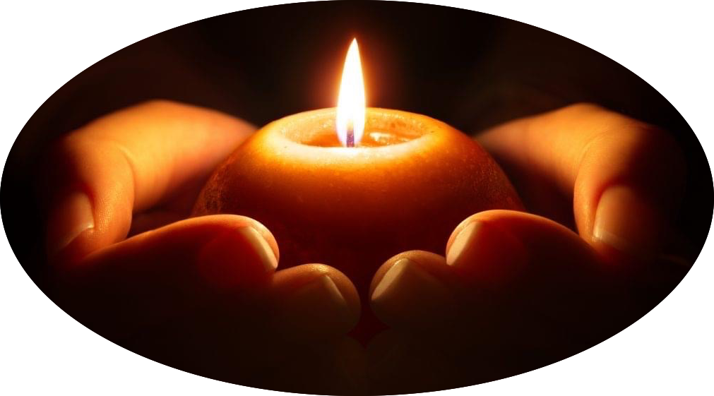
Response: Give Light - Hal Walker
Give light, and people will find a way (3x)
People will find a way
I do believe.

Chalice Lighting #419 Look to This Day!
Sanskrit Salutation to the Dawn -attributed to Kalidasa
Look to this day! For it is life, the very life of life.
In its brief course lie all the verities and realities of our existence:
The bliss of growth, the glory of action, the splendour of beauty;
For yesterday is but a dream and tomorrow is only a vision;
But today well spent makes every yesterday a dream of happiness
and every tomorrow a vision of hope.
Look well, therefore, to this day.

Story for All Ages The Sneeches -by Dr. Seuss

Hymn #318 We Would Be One (Church of the Larger Fellowship)
Singing the Living Tradition

FUUSM Affirmation
We, the members & friends of the First Unitarian Universalist Society of Marietta:
- Support the free and disciplined search for truth as the center of religious
community and encourage an acceptance of pluralistic views;
- Recognize our Judeo-Christian heritage as well as other traditions
and seek lasting values and new insights;
- Affirm, defend, and promote the equality, worth, and dignity of every person;
- Strive for a world community of love, justice, and peace;
- Support the democratic process and mutual respect in all human relationships;
- Cherish the universe and its resources and recognize the unity of all life.

Offering We give thanks for the generous ways you
the members and friends have supported the congregation and ministry with your pledges and financial contributions, and many gifts.

Meditation
(YouTube video) George

Ribbon Ceremony
A time to show a ribbon or bow on Zoom, and tell us what it represents for you.

Postlude What Can One Little Person Do? -Sally Rogers
(YouTube video) Verses with examples from our US history
"When Barack was a young man In Chicago’s streets he planned
To help the least of us to find the meaning of hope.
From Hawaii to DC, he’s now made history
And we know that he has justice on his side."

Zoom Poll
Joys & Sorrows

Announcements
*Announcements through Zoom, and see Announcements below.
Time of Social Sharing

* Food Pantry items are still being collected @ FUUSM at door to the Social Hall.
ANNOUNCEMENTS

CARD PROJECT - Reaching out to the community…
Please return holiday cards for area nursing homes.
to FUUSM by Dec. 10th

Songs of Giving Thanks - Blessings (Nov. 29) words below
1) O’ Give Thanks for Unknown Blessings OR Give Thanks
2) # How Could Anyone OR Ancient Mother
3) May Your Eyes See Only Beauty OR Now I Walk in Beauty
4) The Earth is Our Mother OR Mother I Feel You Under My Feet

Words for the Songs of Giving Thanks ~ Choose one of each pair

1) O’ give thanks for unknown blessings already on the way. (repeat)
OR Give thanks, give thanks, and so we say give thanks (repeat)

2) How could anyone ever tell you- you were anything less than beautiful?
How could anyone ever tell you- you were less than whole?
How could anyone fail to notice that your loving is a miracle?
How deeply you’re connected to my soul.
OR Ancient Mother
Ancient Mother, I hear you calling. Ancient Mother, I hear your song.
Ancient Mother, I hear your laughter. Ancient Mother, I taste your tears.

3) May your eyes see only beauty, your ears be filled with sweet song
Your hands hold only gladness, your feet be dancing on the ground.
As you turn into the morning, loving as you go-
May your hearts burst into flower, your love be ever true.

OR Now I walk in beauty, beauty is before me
Beauty is behind me, above and below me.

4) The Earth is our mother, we must take care of her, (2x)
hey yunga ho yunga hey yung yung. (repeat)
Her sacred ground we walk upon with every step we take. (2x)
OR
Mother I feel you under my feet, Mother I hear your heart beat (2x)
He-ya he-ya he-ya he-ya he-ya he-yo, (repeat)

