**October 2020 Sunday Worship Services Zoom Link**

<https://zoom.us/j/94822183499?pwd=ZVhkMHZWSnR1bTI5czZWRk1zdFFmQT09>

Meeting ID: 948 2218 3499 Passcode: fuusm2323

Dial in by phone from your regional location

By Phone 1-929 205 6099 US (New York) 1-301 715 8592 US (Germantown)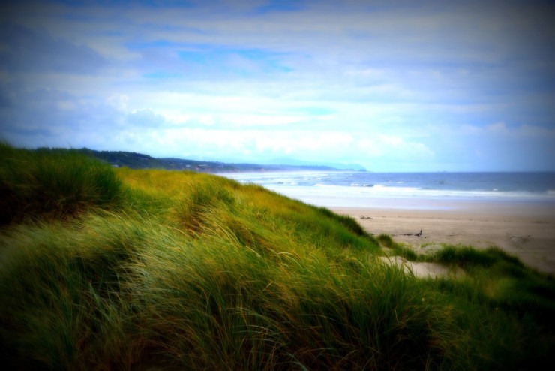

Same Meeting ID (as above): 948 2218 3499 Different Passcode: 772050

(10:30) Gathering & Greeting (11am) Welcome Slide

(Use the Zoom Poll to respond) True or False ? -

1. The Doctrine of Discovery originated in a papal bull in **1455**

2. **1792**- President Thomas Jefferson claimed

the Doctrine of Discovery was international law.

3. **1820s**- D.o Discovery engraved in law by US Supreme Court under John Marshall in decision regarding ___________ Nation.

First Unitarian Universalist Society of Marietta

Order of Service Sunday October 11, 2020

Indigenous Peoples Day

Our mission is to nurture a diverse community,

devoted to spiritual growth and freedom of thought for the benefit of all.

Prelude *Impressions of the Wa-Wan Ceremony Op.21,*

*No.2 Nearing the Village* -Arthur Falwell Randall Kidder, Pianist

Welcome Rev. Kathryn Hawbaker, Minister

Welcome to the First Unitarian Universalist Society of Marietta (Mid-Ohio Valley).

Please enjoy a time of gathering and greeting one another beginning at 10:30 via Zoom

until a Welcome Slide appears and the Prelude begins, denoting the start of the service.

We ask that you then mute yourselves to establish a reverent space and pause for the beginning of the service.

At the end of the service are Announcements & a brief time to share Joys & Sorrows;

and then an additional open time of sharing and socializing.

Please be mindful that the service is also streamed Live to FaceBook,

and because of this, the time of Joys & Sorrows will not be included in public postings.

Chalice Lighting Poem by Dawna Markova

I will not die an unlived life.

I will not live in fear of **falling** or catching fire.

I choose to inhabit my days, to allow my living to open me,

to make me less afraid, more accessible:

to loosen my heart until it becomes a **wing,**

a torch, a **promise.**

I choose to risk my significance,

to live so that which came to me as **seed**

goes to the next as blossom

and that which came to me as blossom,

goes on as fruit.

Story for All Ages *SkyWoman Falling - Robin Wall Kimmerer*

*from Braiding Sweetgrass*

SOURCE: Questions for a Resilient Future: Robin Wall Kimmerer

[https://n .youtube.com/watch?v=y4nUobJEEWQ](https://www.youtube.com/watch?v=y4nUobJEEWQ)

Hymn *We’ll Build a Land* FUUSM Virtual Choir, Directed by Martha Webster

Singing the Living Tradition #121

Words: Barbara Zanotti (based on Isaiah/Amos) Music: Carolyn McDade, arr. by Betsy Jo Angebranndt

Reflection*Indigenous Peoples Day* Rev. Kathryn Hawbaker

*Let us mourn, not celebrate, the 400-year anniversary*

*of the Mayflower’s arrival in 1620.* Roxanne Dunbar-Ortiz

Music K’Nikastosia from **Matriarch** by Joanne Shenandoah

Closing Words by L. R. Knost

*Do not be dismayed by the brokenness of the world.*

*All things break. And all things can be mended.*

*Not with time, as they say, but with intention.*

***So go.***  *Love intentionally, extravagantly, unconditionally.*

*The broken world waits in darkness for the light that is you.*

Postlude *Impressions of the Wa-Wan Ceremony Op.21,*

*No.7 Song of Peace* -Arthur Falwell Randall Kidder, Pianist

*See Note Below

Great Gratitude to those who contributed to this service with research - Jane Tumas-Serna, and music, Randall Kidder, & Martha Webster & the Virtual Choir and help with technical support: Michelle Wilson & Mike Bailey. Laura Cejka was in the Nursery today.

Musical Note

**Arthur Falwell** (1872-1952). After earning a degree in electrical engineering at the Massachusetts Institute of Technology he decided what he really wanted was a career in music.  He then studied for six more years in Boston, Berlin, and Paris. At the turn of the century German and European influences dominated American music. It was Farwell who made the first declaration of American musical independence from Europe. He wanted it to break away from European tradition and become as recognizably "American" as French, Russian, or Spanish music. In 1901 he founded the Wa-Wan Press at Newton Center, Massachusetts to mainly publish American composers whose works were based on American folk material; ragtime, African-American, Cowboy songs, Native-American music, regional folk music. By 1912 he had published music of 37 men and women composers.

Farwell became interested In the music and folklore of Native Americans and collected music of the Southwest and folk songs of southern California and incorporated melodies and rhythms into his compositions (much as Bela Bartok collected folk songs of his native Hungary and wrote music based on them). His best known works are based on themes taken from Omaha tribal dances and songs. -Randall Kidder

Today Oct. 11 is National Coming Out Day!

GLBTQ+ RESOURCES & ORGANIZATIONS

**Fairness West Virginia**

405 Capitol St., STE 405 Charleston, WV 25301

**Human Rights Campaign**

The **Human Rights Campaign** (**HRC**) is the largest [LGBTQ](https://en.wikipedia.org/wiki/LGBTQ) [advocacy group](https://en.wikipedia.org/wiki/Advocacy_group) and political [lobbying](https://en.wikipedia.org/wiki/Lobbying) organization in the [United States](https://en.wikipedia.org/wiki/United_States).[2] The organization focuses on

protecting and expanding [rights for LGBTQ individuals](https://en.wikipedia.org/wiki/LGBT_rights_in_the_United_States), notably advocating for [marriage equality](https://en.wikipedia.org/wiki/Same-sex_marriage), anti-discrimination and [hate crimes](https://en.wikipedia.org/wiki/Hate_crime) legislation, and [HIV/AIDS](https://en.wikipedia.org/wiki/HIV/AIDS) advocacy.

**Fairness Parkersburg & Parkersburg Pride ~ See Facebook pages**