September 2020 Worship Services Zoom Link
https://zoom.us/j/94822183499?pwd=ZVhkMHZWSnR1bTI5czZWRk1zdFFmQT09
Meeting ID: 948 2218 3499 Passcode: fuusm2323
Dial in by phone from your regional location
+1 929 205 6099 US (New York) +1 301 715 8592 US (Germantown)
Same Meeting ID (as above): 948 2218 3499 Different Passcode: 772050

Welcome
Welcome to the First Unitarian Universalist Society of Marietta (in the Mid-Ohio Valley).
Please enjoy a time of gathering and greeting one another via Zoom
until the Welcome Slide appears and the Prelude begins, denoting the start of the service.
We ask that you mute yourselves (or we can help) to establish a reverent space and pause for the beginning of the service.

At the end of the service there is a brief time to share Joys & Sorrows,
followed by announcements; and additional open time of sharing and socializing.
Please be mindful that the service is also streamed Live to FaceBook,
and because of this, the time of Joys & Sorrows will not be included in public postings.

TODAY Sunday Sept. 20 Ingathering Water Ceremony
In the Courtyard (9:30am & 10:15am & on Zoom (11am).

You may bring water to the courtyard beginning @ 9:30am to pour your water from a sacred place into a common vessel. Family friendly activities are also available there.
If you are participating via zoom, you may choose to show the pouring of water, or just describe the source of water that is significant to you.

This Water Ceremony marks our Ingathering -the beginning of the FUUSM Program Year (like the school year). It is the time of the Autumnal Equinox, and the Jewish Holy Day of Rosh Hashana - made especially significant as we mourn the death of Supreme Court Justice Ruth Bader Ginsberg.

(12:30pm EST) FUUSM Green Sanctuary Meeting
Join Zoom Meeting https://us02web.zoom.us/j/86321736030
Meeting ID: 863 2173 6030
Dial by your location +1 301 715 8592 US (Germantown)
1-312 626 6799 US (Chicago) +1 646 558 8656 US (NY)

First Unitarian Universalist Society of Marietta
232 Third Street, Marietta, OH 45750 (Third & Putnam Sts.)
Order of Service ~ Sunday September 20, 2020
Ingathering Water Ceremony
Our mission is to nurture a diverse community,
devoted to spiritual growth and freedom of thought for the benefit of all.

(10:30) Gathering & Greeting (11am) Welcome Slide
Prelude Between the Devil & the Deep Blue Sea -Ted Koehler & Harold Arlen
Randall Kidder, Pianist

Welcome Rev. Kathryn Hawbaker, Minister
Listen, People, Listen… Listen to the waters, calling us like rivers, running to the sea

Chalice Lighting Widen the Family Circle the Barnett-Sheaves Family

Opening There’s a River Running Through My Soul Martha Webster, Choir Director
Opening Words A Time of Ingathering Rev. Susan Frederick-Gray

Story for All Ages Tale of the Journeying Stream a Sufi Parable

Offering Thank-you for your donations and pledge payments.
We eat from trees we did not plant, and drink from wells we did not dig…

Special Music Bring Me Little Water, Silvy - Huddie Ledbetter (Leadbelly)
for First U.U. Church of Brooklyn Water Communion Ceremony shared by Suzyn Mills

Water Ceremony Sharing the Waters
Slideshow music: Dancing Waters - Michael Jones (piano & rainstick) Randall Kidder & Kat Hawbaker

Benediction
~Invitation to Share Joys & Sorrows~
Postlude Valley in the Clouds -David Arkenstone Randall Kidder, Pianist
*Following Joys & Sorrows, and the musical selection (Postlude),
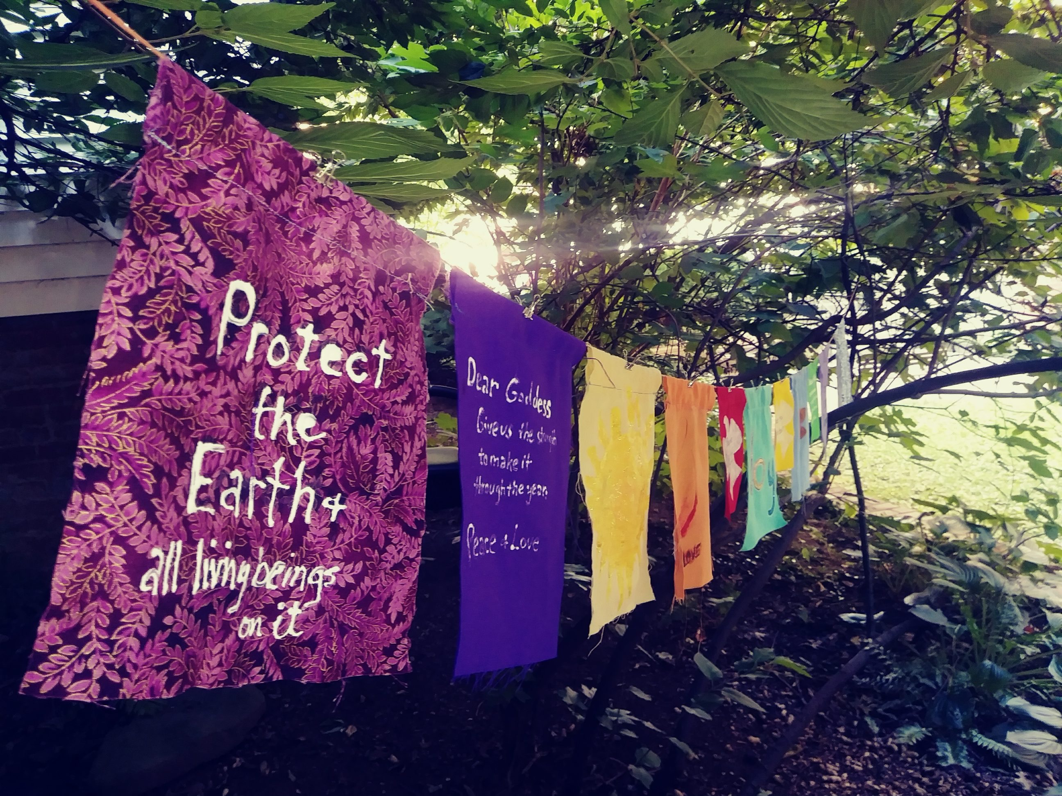
the Zoom room will remain open for a time of socializing and connection.

Great Gratitude to those who contributed to our services and provided technical support:
Ralph Olander, Michelle Wilson, Mike Bailey,
Al Tuttle & Rev. Kat Hawbaker.

You are invited to create prayer flags
to hang in the courtyard.
Materials are available there.
The winds carry the prayers into the world.

Next Sunday
Sun. Sept. 27 (11am) Fall Congregational Meeting (Zoom & Live in Sanctuary)
Your input and vote is important to address future plans and the proposed budget.
The Proposed Budget has been shared by email, and the agenda is available.
Treasurer & Board Member, Ted Goertzel has shared the results of the survey.
Thanks to all who offered their feedback -it helps with our planning.

FUUSM Affirmation
We, the members & friends of the First Unitarian Universalist Society of Marietta:
- Support the free and disciplined search for truth as the center of religious
community and encourage an acceptance of pluralistic views;
- Recognize our Judeo-Christian heritage as well as other traditions
and seek lasting values and new insights;
- Affirm, defend, and promote the equality, worth, and dignity of every person;
- Strive for a world community of love, justice, and peace;
- Support the democratic process and mutual respect in all human relationships;
- Cherish the universe and its resources and recognize the unity of all life.



ANNOUNCEMENTS
Black Lives Matter (MOV) gathers Saturdays (12 Noon to 3pm) @ the Putnam St. Bridge.
Let’s show up for racial justice and keep learning together.

This Week at FUUSM
Wed. Sept. 23 Midweek Midday Meditation (12-1pm) (Zoom & Parlor)
https://zoom.us/j/98570571823?pwd=VklkWWUrSjZCclJ2dElZS3ZVVHFhdz09
Meeting ID: 985 7057 1823 Passcode: OMWed12
Dial in by your location +1 301 715 8592 US (Germantown +1 312 626 6799 US (Chicago)
Same Meeting ID: 985 7057 1823 Different Passcode: 528033

Wed. Sept. 23 (7pm) UU the Vote - link below

Fri. Sept. 25 Shoe Strike for Climate Justice (10am-3pm) Muskingum Park, Marietta.

Sat. Sept. 26 (12 -3pm) Black Lives Matter (MOV) @ Putnam St. Bridge

FUUSM UU the Vote
Topic: UU the Vote Time: Wed. Sep 23, 2020 7pm (w/ Ted Goertzel)
Join Zoom Meeting
https://us02web.zoom.us/j/88626163372?pwd=OHdmUDE3WEhEWnl6MHp2VEJkc09WZz09
Meeting ID: 886 2616 3372 Passcode: UUAvote
Dial in by phone from your nearby location +1 929 205 6099 US (New York)
+1 301 715 8592 US (Germantown) +1 312 626 6799 US (Chicago)
Same Meeting ID: 886 2616 3372 Different Passcode: 6764166

UU the Vote
UUs in Ohio and UU Justice Ohio (UUJO—our state action network) have been partnering with the Ohio Organizing Collaborative (OOC) https://www.ohorganizing.org/ - a coalition of front line community organizations working for justice and electoral justice here in our communities. Help folks connect to voter registration page at OHVOTES.ORG

OFFICE HOURS
Use the FUUSM Building Entry Log (in a bright red folder) in the Office, Sanctuary and Fellowship Hall. Please sign in and out each time you enter any of the buildings. Thank you.
*Complete Guidelines are at the end of this bulletin.

Check the Weekly Update via the FUUSM-L email list for hybrid meetings (Zoom & in-person)
and other events on the calendar. Access to the FUUSM Office is limited at this time for safety purposes.
Please call or text Chris Keller before you come in. Masks are required.
Regular Hours: Mon. Wed. Thurs. & Fri. (10:30-2:30pm).
Please check the FUUSM website www.fuusm.org and use email or phone
to contact Chris Keller in the Office fuusm@suddenlinkmail.com (740) 373-1238;
or Rev. Kathryn Hawbaker (937) 470-4151. Rev. Hawbaker is available by appointment,
but not on Tuesdays (Day Off) or Thursdays, (Sermon, study & community service).
FUUSM Guidelines for Building Use
Safety Committee Taskforce on COVID-19
Main Requirements for the Social Hall (Fellowship Hall) and generally for all spaces:

1. Maintain 6-foot distancing and “take turns” entering, exiting, and taking seats to allow spacing with a maximum of 15 people.

2. Use facemasks that cover nose and mouth and prevent respiratory droplets and aerosols from escaping.

3. No Food or Beverages in the building– you can’t eat/drink with a facemask on.
Please bring your own water bottles and take them with you when you leave.

5. All attendees sign in and provide information requested (For confidentiality, the group leader/facilitator can hold the attendance list.)

6. If attendee is not feeling well, they will not be allowed to enter the building.

7. One person in a bathroom at a time.

8. At the end of the meeting, clean and sanitize table surfaces, bathroom fixtures/handles, door knobs/handles, railing and other “touchable surfaces”. People/groups using the facility will provide their own cleaning and sanitizing materials.

9. Empty waste cans (including bathrooms) and place waste bags in trash bins next to the RE/Office building.

10. Maximum length of meeting – 3 hours

