**Current FUUSM Standard Sunday Service Format**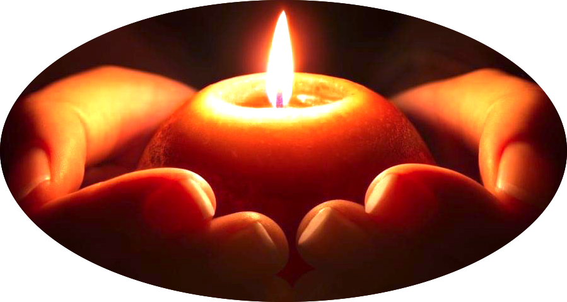

Time of Gathering & Greeting

(Open Zoom Room ~10:30-10:55)

Musical Prelude & (Welcome Slide)

11AM Service begins

Joys & Sorrows at the end (w/o FB)

**Zoom Link**

Topic: August Sunday Services

Aug 23, 2020 11:00 AM Eastern Time (US & Canada)

Join Zoom Meeting

<https://zoom.us/j/94822183499?pwd=ZVhkMHZWSnR1bTI5czZWRk1zdFFmQT09>

Meeting ID: 948 2218 3499 Passcode: fuusm2323

Dial in by phone from your location

+1 929 205 6099 US (New York) +1 301 715 8592 US (Germantown)

Same Meeting ID (as above): 948 2218 3499 Different Passcode: 772050

Welcome to the First Unitarian Universalist Society of Marietta (Mid-Ohio Valley).

Please enjoy a time of gathering and greeting one another via Zoom

until the Welcome Slide appears and the Prelude begins, denoting the start of the service.

We ask that you mute yourselves (or we can help) to establish a reverent space and pause for the beginning of the service.

At the end of the service there is a brief time to share Joys & Sorrows,

and then an additional open time of sharing and socializing.

Please be mindful that the service via Zoom is also streamed Live to FaceBook,

and because of this the time of Joys & Sorrows will not be included in public postings.

Covenant #471 -arranged by L. Griswold Williams

Love is the doctrine of this church,

The quest of truth is its sacrament, and service is its prayer.

To dwell together in peace, to seek knowledge in freedom,

To serve human need, to the end that all souls shall grow into harmony with the Divine-

Thus do we covenant with each other and with God.

Traditionally, there are four types of prayers – prayer of petition, of praise,

of thanks, of forgiveness. When we take this new approach toward prayer,

these traditional forms break open and become channels that lead to insight.

**First Unitarian Universalist Society of Marietta**

Order of Service Sunday August 23, 2020

***Our mission is to nurture a diverse community,***

***devoted to spiritual growth and freedom of thought for the benefit of all.***

(10:30) **Gathering & Greeting** (11am) **Welcome Slide**

Prelude  ***Make Channels for the Streams of Love*** Randall Kidder, Pianist American folk melody, arr. by Annabel M. Buchanan (1889-1983); Words by Richard Chenevix Trench (1807-1886)

WelcomeMartha McGovern, Worship Leader

Opening Chant  ***Listen People Listen*** Rev. Kathryn Hawbaker, Minister

*Listen, people, listen, listen to the waters*

*calling us like rivers, running to the sea.*

Chalice Lighting    **Beginnings of a Poem…** -Mereth DunnEstry (1985)

Offering – Thank you for your donations and pledge payments.

Reflection:  Prayer & Poetry

Prayer of Petition Prayer Song *From You I Receive*

Prayer of PraisePrayer Song *Earth My Body*

Prayer of ThanksgivingPrayer Song *Give Thanks*

Prayer of Forgiveness Prayer Song *We Begin Again in Love*

Prayer of Loving Gaze

Poem ***The Summer Day*** -Mary Oliver

Poem ***What I Know*** -The old man at Underbrow Cottage (Ron Tepley)

in response to Mary Oliver’s poem *In Blackwater Woods*

Benediction ***Sanctuaries of Silence*** -Gordon Hempton

*When I listen, I have to be quiet.  I become very peaceful*

*and I think what I enjoy most about listening is that I disappear, I disappear.*

Invitation to Share Joys & Sorrows

*Following the video and Joys & Sorrows, the Zoom room will remain open for a time of socializing.

Great Gratitude to those who contributed to this service and provided technical support:

Martha McGovern, Ralph Olander, Randall Kidder, & Mike Bailey.

*\* * * * * * * * * * * * * * * \**

*Drink from the well of your self and begin again* ~Charles Bukowski

*Let the beauty we love be what we do.*

*There are hundreds of ways to kneel and kiss the ground;*

*There are hundreds of ways to go home again.* ― Rumi

*******************

View photos of flags in the courtyard on Instagram via Jane Tumas-Serna

<https://www.instagram.com/p/CENU4RsBWSc/?igshid=1oux1xxj7i115>

You are invited to create prayer flags to hang in the courtyard.

Materials are available there. The winds carry the prayers out into the world.

JOY

Crystal Barnett Sheaves & Justin Sheaves have a special joy in announcing their intention to adopt and bring into their family another child -a sibling to Axelton.

Please visit their FaceBook page if you haven’t already supported them.

ANNOUNCEMENTS

**Mondays -** Black Lives Matter (12-3pm) The vigil gathers at the fountain next to the Lafayette Hotel.

**Sunday Mornings (9:30am)** in the Parlor

The **Today’s Issues** group meets Sunday mornings (9:30am) in the Office/RE building next to the church following social distancing guidelines. Each Sunday the group will discuss essays from the NY Review of Books.

**Mon. Aug. 24** Personnel Committee (5:30pm) Hybrid- Parlor & Zoom

**Mon. Aug. 24**  (6:30-8pm)  Cakes for the Queen of Heaven  (Zoom)

<https://zoom.us/j/95134658909?pwd=ZFdIUGZhQkorWkdLNklLNVBXbFROdz09>

Meeting ID: 951 3465 8909               Passcode: Cakes

Dial by phone from your location        +1 301 715 8592 US (Germantown)

Same Meeting ID: 951 3465 8909     Different (Numerical) Passcode: 736019

**Wed. Aug. 26**  **Midweek Midday Meditation** (12-1pm)**(**Zoom & Parlor)

<https://zoom.us/j/98570571823?pwd=VklkWWUrSjZCclJ2dElZS3ZVVHFhdz09>

Meeting ID: 985 7057 1823 Passcode: OMWed12

Dial in by your location +1 301 715 8592 US (Germantown) +1 312 626 6799 US (Chicago)

Same Meeting ID: 985 7057 1823 Different Passcode: 528033

**Sat. Aug. 29** MOVCA Shoe Strike (9am-2pm) Williamstown, WV

The Shoe Strike is to remind people that the Climate Crises has not been a victim of the pandemic.

It is growing stronger every day! The shoes stand in the places where all the past, current and future victims of Climate Chaos cannot stand for themselves. This is a way for you to participate in the most extreme form of socially responsible protest we can think of. And a way to get rid of your old shoes.

Drop shoes in or near the container on the wall next to the rear basement door of the church office/parlor building starting now and lasting through the last week of September. There are bags in the container. Our plan, after all of our shoes are finished marching, is to give them all to the current Cobbler John, who is collecting shoes to repair if needed and send them all to needy areas of the world.

**Next Sunday Aug. 30** Live Presentation with Felix Burrows  ***Speak for Yourself***

for a limited number of congregants (15) in the Sanctuary.

For more information, contact Rev. Hawbaker.

**All Services will continue to be available on Zoom & Facebook.**

Looking Ahead

**Sun. Sept. 20** *Water Ceremony* **~** In Courtyard (9:30am) & on Zoom (11am).

**Sun. Sept. 27** (11am)  *Fall Congregational Meeting* **- Your input and vote is important.**

To address future plans and the proposed budget.

**The FUUSM Office**  is not open to the general public, but we are checking messages and making plans.  Please check the FUUSM website, and use email or phone to contact Chris Keller in the Office  [fuusm@suddenlinkmail.com](mailto:fuusm@suddenlinkmail.com)  (740) 373-1238, or Rev. Kathryn Hawbaker.

Check the Weekly Update through the FUUSM-L email list for news of hybrid meetings (Zoom & in-person) and other events on the calendar.

SERVICE NOTES & POEMS

Hymn #299 ***Make Channels for the Streams of Love***

1) Make channels for the streams of love where they may broadly run;

and love has over-flowing streams to fill them every one.

2) But if at any time we cease such channels to provide,

the very founts of love for us will soon be parched and dry.

3) For we must share, if we would keep this gift all else above;

we cease to give, we cease to have- such is the law of love.

**Beginnings of a Poem…** -Mereth DunnEstry (1985)

**(**\*)

*I cup a word in my*

*hands,*

*nuzzle it,*

*inhale its sounds,*

*taste its variations,*

*tease it into attention.*

A poem by Li-Young Lee suggests the opening to awe and the embrace of spirit:

***From Blossoms***

From blossoms comes

this brown paper bag of peaches

we bought from the boy

at the bend in the road where we turned toward

signs painted *Peaches*.

From laden boughs, from hands,

from sweet fellowship in the bins,

comes nectar at the roadside, succulent

peaches we devour, dusty skin and all,

comes the familiar dust of summer, dust we eat.

O, to take what we love inside,

to carry within us an orchard, to eat

not only the skin, but the shade,

not only the sugar, but the days, to hold

the fruit in our hands, adore it, then bite into

the round jubilance of peach.

There are days we live

as if death were nowhere

in the background; from joy

to joy to joy, from wing to wing,

from blossom to blossom to

impossible blossom, to sweet impossible blossom.

***The Summer Day***  -Mary Oliver

Who made the world?

Who made the swan, and the black bear?

Who made the grasshopper?

This grasshopper, I mean –

the one who has flung herself out of the grass,

the one who is eating sugar out of my hand,

who is moving her jaws back and forth instead of up and down –

who is gazing around with her enormous and complicated eyes.

Now she lifts her pale forearms and thoroughly washes her face.

Now she snaps her wings open, and floats away.

I don’t know exactly what a prayer is.

I do know how to pay attention, how to fall down

into the grass, how to kneel down in the grass,

how to be idle and blessed, how to stroll through the fields,

which is what I have been doing all day.

Tell me, what else should I have done?

Doesn’t everything die at last, and too soon?

Tell me, what is it you plan to do

With your one wild and precious life?

***What I Know*** -Ron Tepley

-The old man at Underbrow Cottage

in response to Mary Oliver’s poem

*In Blackwater Woods*

What I know is

that the past is the past

And the present is what

my life is

and we my friends

are capable of choosing

what that will be.

We must give our voices

to the World

And live our lives

with love

with happiness

with tolerance

or

become an ugle image

of hate and injustice.

***In Blackwater Woods***

Look, the trees

are turning

their own bodies

into pillars

of light,

are giving off the rich

fragrance of cinnamon

and fulfillment,

the long tapers

of cattails

are bursting and floating away over

the blue shoulders

of the ponds,

and every pond,

no matter what its

name is, is

nameless now.

Every year

everything

I have ever learned

in my lifetime

leads back to this: the fires

and the black river of loss

whose other side

is salvation,

whose meaning

none of us will ever know.

To live in this world

you must be able

to do three things:

to love what is mortal;

to hold it

against your bones knowing

your own life depends on it;

and, when the time comes to let it go,

to let it go.

“In Blackwater Woods” by Mary Oliver,

from *[American Primitive](http://www.amazon.com/American-Primitive-Mary-Oliver/dp/0316650048)*. © Back Bay Books, 1983.