**Current FUUSM Standard Sunday Service Format (8/2020)**

**Time of Gathering & Greeting**  (Open Zoom Room ~10:30-10:55)

**Musical Prelude & (Welcome Slide) 11AM Service begins**

**Joys & Sorrows at the end** (w/o FB)

Welcome to the First Unitarian Universalist Society of Marietta (Mid-Ohio Valley).

Please enjoy a time of gathering and greeting one another via Zoom until the Welcome Slide

appears and the Prelude begins, denoting the start of the service.

We ask that you mute yourselves (or we can help) to establish a reverent space and pause

for the beginning of the service.

We acknowledge that there are a variety of needs and interests and appreciate your help

in choosing what is nurturing to you, as we reach the widest circles of FUUSM communities.

At the end of the service there is a brief time to share Joys & Sorrows, and then an additional open time of sharing and socializing.

Please be mindful that the service via Zoom is also streamed Live to FaceBook, and because of this the time of Joys & Sorrows will not be included in public postings.

Please limit spoken announcements to essential facts and utilize the Office Weekly Update or reach people via the email list (FUUSM-L@fuusm.org). It’s a good habit to include Chris Keller in the

FUUSM Office [fuusm@suddenlinkmail.com](mailto:fuusm@suddenlinkmail.com) for all calendar items and programs.

We want to connect and share information, but please be mindful when you reply to the whole list,

as that creates many more emails than necessary.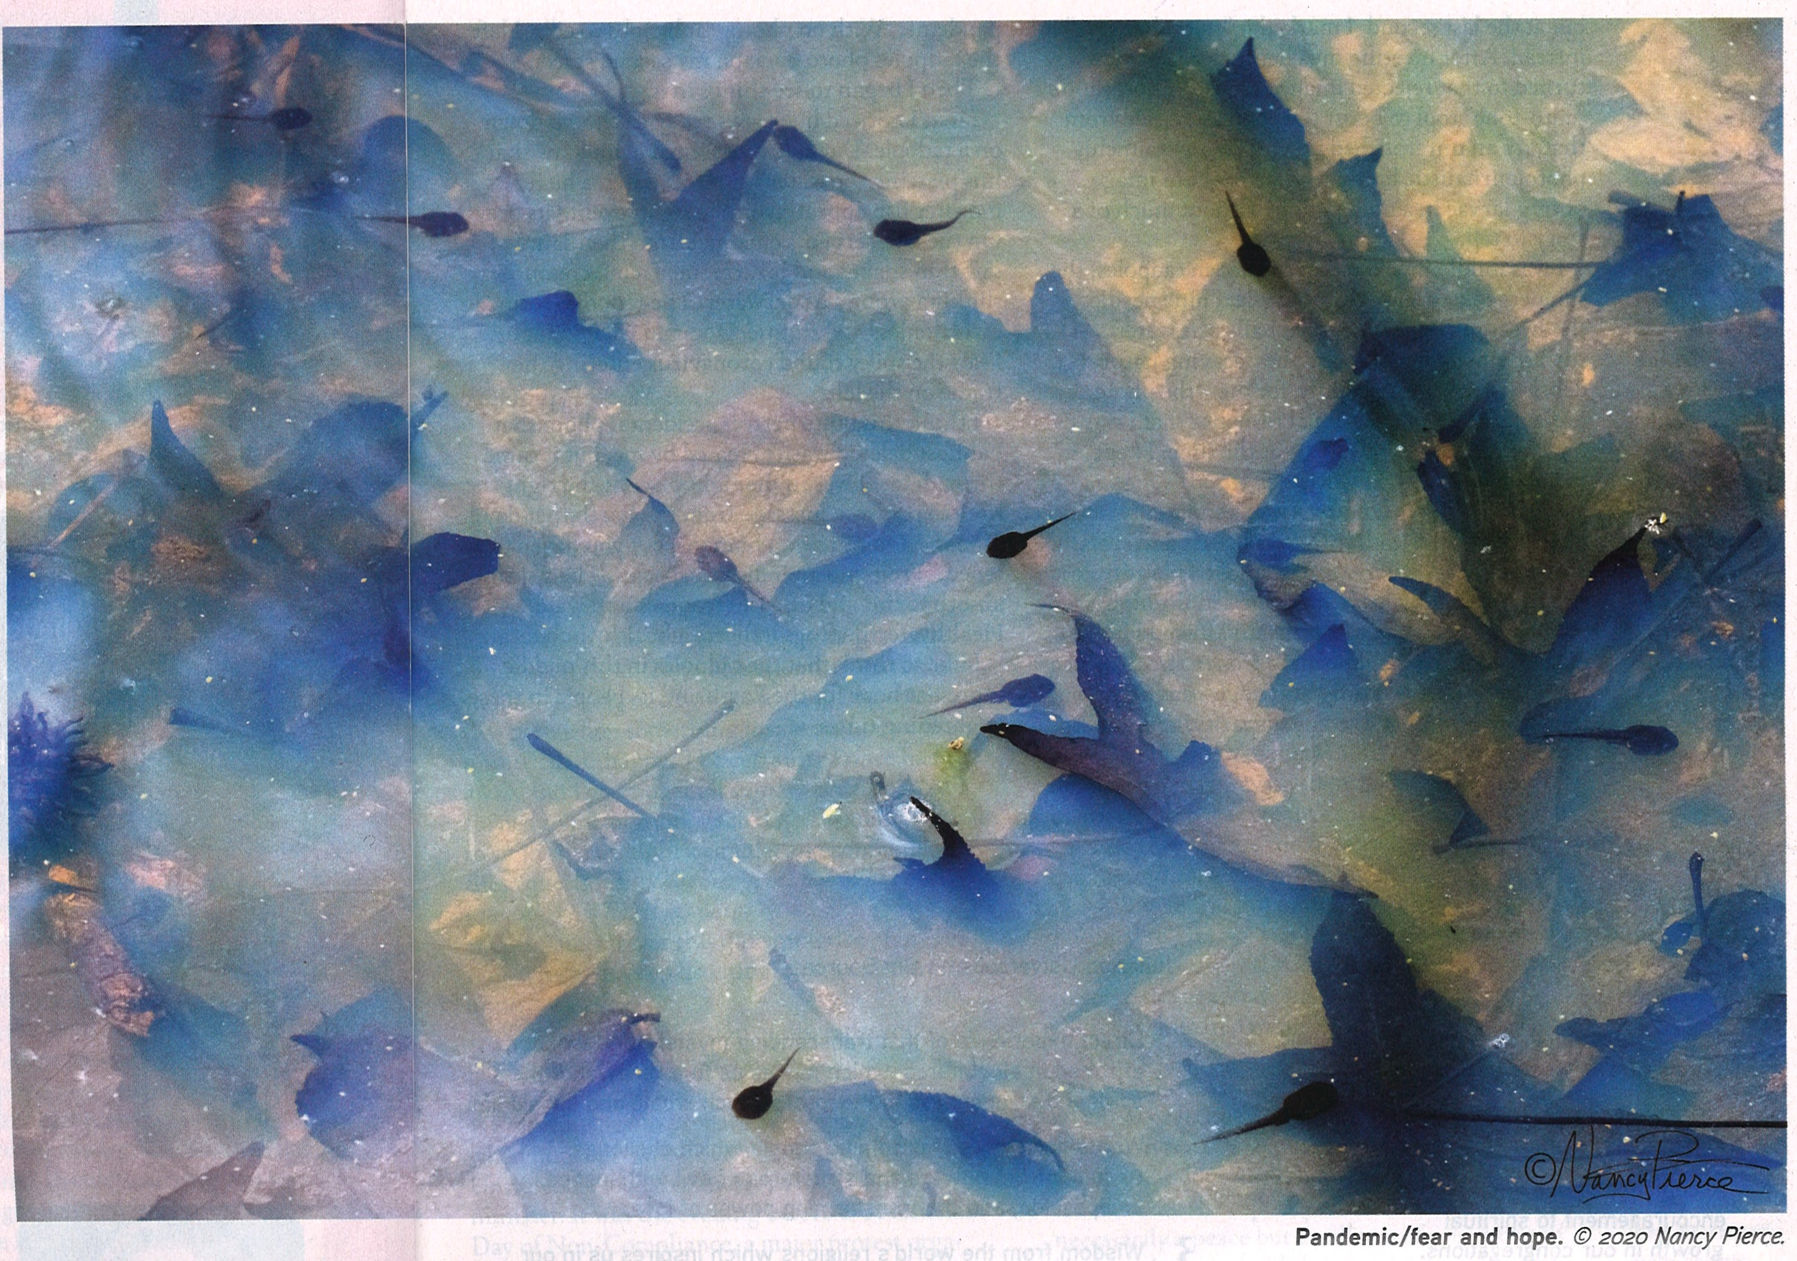

**First Unitarian Universalist Society of Marietta**

**Order of Service August 16, 2020**

Our mission is to nurture a diverse community,

devoted to spiritual growth and freedom of thought for the benefit of all.

(10:30) **Gathering & Greeting**

(11am) **Welcome Slide**

**Prelude *Prelude*** and ***Fugue Op.16, No.2*** Clara Wieck Schumann Randall Kidder, Pianist

**Welcome** Rev. Kathryn Hawbaker

**Chalice Lighting**

**Time for All Ages *The Great Realisation*** -Tomfoolery (Tomos Roberts)

**Opening Lesson *Teaching Conspiracy Theories*** Peg Clifford, Professor, WVU-Parkersburg

**Meditation *Uncertainty*** Rev. Kathryn Hawbaker

**Visual Reflection *Pandemic/ Fear & Hope*** *-*Nancy Pierce (2020)

**Hymn *Fuente de Amor Spirit of Life*** by Carolyn McDade

Singing the Living Tradition #123

The Spanish version is number **31** in [Las voces del camino](http://www.uua.org/worship/music/hymnals/voces/index.shtml), © 1999 [Ervin Barrios](http://ebls.webs.com/) (Mexican, b. 1954).

Performed by All Souls Church Unitarian in Washington, DC. directed by Jen Hayman

1) **Spanish** 2) English

**Fuente de Amor, ven hacia mí.** Spirit of Life, come unto me.

**Y al corazón, cántale tu compasión.** Sing in my heart all the stirrings of compassion.

**Sopla al volar, sube en la mar,** Blow in the wind, rise in the sea;

**hasta moldear la justicia de la vida.** Move in the hand, giving life the shape of justice.

**Arráigame, libérame,** Roots hold me close; wings set me free;

**Fuente de Amor, ven a mí, ven a mí.** Spirit of Life, come to me, come to me.

**Reflection *The Social Psychology of a Pandemic:***

*Conspiracy Theories, Social Anxiety, and Why Some People Won’t Wear a Mask*

Guest Speaker: Mark Sibicky, Ph.D.

Mark Sibicky is McCoy & Plankey Research Professor at Marietta College. A social psychologist,  Dr. Sibicky will explore uncertainty and our reactions to it as a component of the pandemic experience.

**Closing Hymn *We Laugh, We Cry***  Randall Kidder, Pianist

(2 verses, words below) Singing the Living Tradition #354 words & music by Shelley Jackson Denham

**Sharing Joys & Sorrows**

**Postlude *Now's the Time*** -Charlie Parker Randall Kidder, Pianist

*Following the postlude, the Zoom room will remain open for a time of socializing.

Great Gratitude to those who contributed to this service and provided technical support.

To quote the wise Rabbi Tarfon,

*“You are not required to finish the task, but neither are you free to desist from it.”*

The work of repairing the world will not be complete today, tomorrow or even within our lifetimes —

but each one of us has the power to be part of the healing.**-**American Jewish World Service

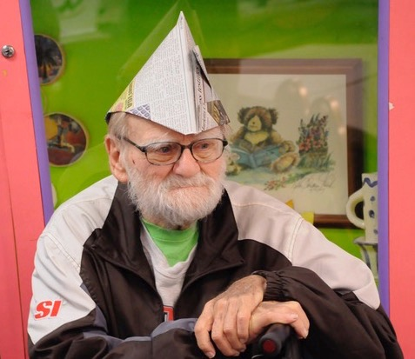

***Happy Birthday Ron Tepley!!***

FUUSM Folks are all invited to Shari & Dave

Ballantyne’s home 841 Greene St. in Newport

on Sun. Aug.16 (5:30-7:30pm)

for ice cream & cake under canopies, with social

distancing in the front lawn area.

If you need directions call  740-568-8200.

If there’s not enough parking, we are allowed to use the parking lot of the church across the street from us.

However; the green in me says share a ride if you can.

Please join us in this celebration by wearing a mask.

- Shari and Dave Ballantyne

**Hymn of Community** *We Laugh, We Cry* Randall Kidder, Pianist

**#354** Singing the Living Tradition

1) We laugh, we cry, we live, we die; we dance, we sing our song.

We need to feel there’s something here to which we can belong.

We need to feel the freedom just to have some time alone.

But most of all we need close friends we can call our very own.

**Chorus: And we believe in life, and in the strength of love, and we have found a need to be together.** We have our hearts to give, we have our thoughts to receive, and we believe that sharing is an answer.

2) A child is born among us and we feel a special glow.

We see time’s endless journey as we watch the baby grow.

We thrill to hear imagination freely running wild.

We dedicate our minds and hearts to the spirit of each child.

**Chorus: And we believe in life, and in the strength of love, and we have found a time to be together.** And with the grace of age, we share the wonder of youth, and we believe that growing is an answer.

 ANNOUNCEMENTS

The monthly newsletter deadline is Tues. Aug. 18. Please share news and information

with our newsletter editor Adeline Bailey at [adesign@suddenlink.net](mailto:adesign@suddenlink.net)

**Monthly Meetings**

**Mondays** Black Lives Matter (12-3pm) The vigil gathers at the fountain next to the Lafayette Hotel.

Mon. Aug. 17 (6:30-8pm) Cakes for the Queen of Heaven (Zoom)

<https://zoom.us/j/95134658909?pwd=ZFdIUGZhQkorWkdLNklLNVBXbFROdz09>

Meeting ID: 951 3465 8909 Passcode: Cakes

Dial by phone from your location +1 301 715 8592 US (Germantown)

Same Meeting ID: 951 3465 8909 Different (Numerical) Passcode: 736019

**Wed. Aug. 19** **(12-1pm) Midweek Midday Meditation**

Zoom & Parlor <https://zoom.us/j/9062049940?pwd=TEtGeE90WCtJeHB0UmJsRElhTEJVdz09>  
Meeting ID: 906 204 9940 Password: OMWed12

Mon. Aug. 24 (5:30pm) Personnel Comm. (Parlor & Zoom)

(6:30-8pm) Cakes for the Queen of Heaven (Zoom) See Link above.

Mon. Aug. 31 (2-3pm) Caring Circle

**Looking Ahead**

**Next Sunday Aug. 23 *Prayer & Poetry*** Rev. K. Hawbaker & Martha McGovern

#471 *Love is the doctrine of this church,*

*The quest of truth is its sacrament, and service is its prayer.* arr. L. Griswold Williams

**Sun. Aug. 30** Live Presentation with Felix Burrows ***Speak for Yourself***

for a limited number of congregants (15) in the Sanctuary.For more information, contact Rev. Hawbaker.

**Services will continue to be available on Zoom & Facebook.**

**Sun. Sept. 20 *Water Ceremony* ~** In Courtyard (9:30am) & on Zoom (11am).

**Sun. Sept. 27 (11am) Fall Congregational Meeting**

To address future plans and the proposed budget.

**The FUUSM Office**  is not open to the general public, but we are checking messages and making plans.  Please check the FUUSM website, and use email or phone to contact Chris Keller in the Office [fuusm@suddenlinkmail.com](mailto:fuusm@suddenlinkmail.com) (740) 373-1238, or Rev. Hawbaker.

Check the Weekly Update through the FUUSM-L email list for news of hybrid meetings (Zoom & in-person) and other events on the calendar.