Sunday Services Link for July 2020 Zoom Meeting 11AM
https://zoom.us/j/94822183499?pwd=ZVhkMHZWSnR1bTI5czZWRk1zdFFmQT09
Meeting ID: 948 2218 3499 Password: fuusm2323
Dial in by phone +1 312 626 6799 US (Chicago) +1 929 205 6099 US (New York)
Same Meeting ID: 948 2218 3499 Different from above -Password: 772050

Sunday June 28, 2020 (11am)
Order of Service

Worship Team: Rev. Kathryn Hawbaker, & Martha McGovern,
Randall Kidder, Pianist, and Lucy Filipow, RE Teacher
Mike Bailey & Ralph Olander, Technical Services,
Michelle Wilson, Social Media Consultant.
}!{

We see how the past conspired the particularity of our present,
examining our history can help us understand the depth and scale
of the challenges at hand.

“Trying to struggle with real history has been a way to learn something
about who we are less personally — less who I am than who we are as a nation. What are we doing here? How is it that we have managed to persist
in the blindnesses that we started out with? …
How are we able to lie to ourselves like that?
-Marilyn Nelson

Prelude Lift Every Voice and Sing -Rene Marie
Voice of My Beautiful Country


Welcome
Martha McGovern, Worship Associate

Testament
Text of The Testament of Freedom,
“I Shall Not Die without a Hope”
by Randall Thompson
performed by the Turtle Creek Chorale
with the Dallas Wind Symphony

“I shall not die without a hope
that light and liberty are on steady advance . . .
And even should the cloud of barbarism and despotism again obscure the science and liberties of Europe, this country remains to preserve and restore light and liberty to them . . . The flames kindled on the 4th of July, 1776, have spread over too much of the globe to be to be extinguished by the feeble engines of despotism; on the contrary, they will consume these engines and all who work them.”
(Thomas Jefferson in a letter to John Adams, 1821)

Chalice Lighting May we restore light and liberty-
first to ourselves, and then in sharing with others.
Reach out to learn more and consider new possibilities.
May we lift up the light of truth, & affirm the divine spark in everyone.

Give Light -Hal Walker
Give light and people will find a way, (3x)
People will find a way I do believe

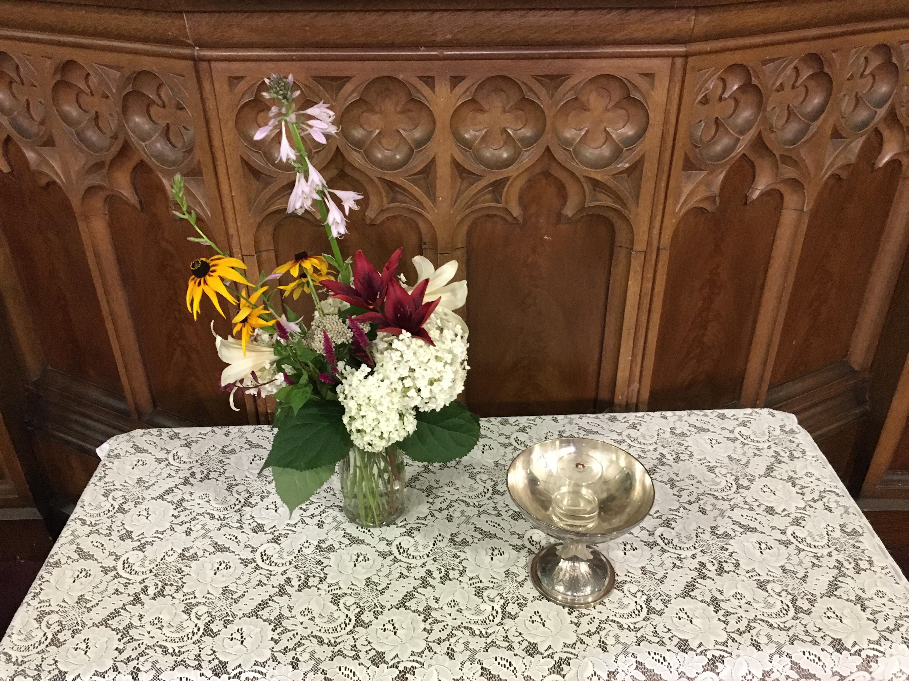

FUUSM Affirmation We the members and friends
of the First Unitarian Universalist Society of Marietta:

- Support the free and disciplined search for truth as the center of religious community and encourage an acceptance of pluralistic views;
- Recognize our Judeo-Christian heritage as well as other traditions and seek lasting values and new insights;
• Affirm, defend, and promote the equality, worth, and dignity of every person;
• Strive for a world community of love, justice, and peace;
• Support the democratic process and mutual respect in all human relationships;
• Cherish the universe and its resources and recognize the unity of all life."

Hymn of Community We Laugh, We Cry Randall Kidder, Pianist
#354 Singing the Living Tradition

1) We laugh, we cry, we live, we die; we dance, we sing our song.
We need to feel there’s something here to which we can belong.
We need to feel the freedom just to have some time alone.
But most of all we need close friends we can call our very own.

C) And we believe in life, and in the strength of love,
and we have found a (need/time/place/joy) to be together.
We have our hearts to give, we have our thoughts to receive,
and we belive that sharing is an answer.

2) A child is born among us and we feel a special glow.
We see time’s endless journey as we watch the baby grow.
We thrill to hear imagination freely running wild.
We dedicate our minds and hearts to the spirit of each child.

C) time And with the grace of age, we share the wonder of youth,
and we belive that growing is an answer.

3) Our lives are full of wonder and our time is very brief.
The death of one among us fills us all with pain and grief
But as we live, so shall we die, and when our live are done.
the memories we shared with friends, they will linger on and on.

C) place We have the right to grow, we have the gift to believe
that peace within our living is an answer.

4) We seek elusive answers to the questions of this life.
We seek to put an end to all the waste of human strife.
We search for truth, equality, and blessed peace of mind.
And then we come together here, to make sense of what we find.

C) joy And in our search for peace, maybe we’ll finally see
even to question truly is an answer.
Story for All Ages The Opportunity
by Joel Ackerman, illustrated by Ania Tomicka

Reading from ON BEING with Krista Tippett -Martha McGovern
This History Is Long: This History Is Deep
updated January 11, 2018; original Air Date November 17, 2016
The Warmth of Other Suns by Isabel Wilkerson

Anthem Lift Every Voice and Sing
#149 Singing the Living Tradition Women of the Calabash- The Kwanzaa Album
words by James Weldon Johnson (1871-1938); Music: J. Rosamond Johnson

Lift every voice & sing, til earth ‘n heaven ring, ring with the harmonies of liberty; let our rejoicing rise, high as the listening skies, let it resound loud as the rolling sea. Sing a song full of the faith that the dark past has taught us;
sing a song full of the hope that the present has brought us;
facing the rising sun of our new day begun, let us march on till victory is won.

Stony the road we trod, bitter the chastening rod, felt in the days when hope unborn had died; yet with a steady beat, have not our weary feet come to the place for which our fathers sighed?
We have come over a way that with tears has been watered; we have come, treading our path thru the blood of the slaughtered, out from the gloomy past, till now we stand at last where the white gleam of our bright star is cast.

God of our weary years, God of our silent tears, thou who hast brought us thus far on the way; thou who hast by thy might led us into the light, keep us forever in the path, we pray. Lest our feet stray from the places, our God, where we met thee; lest our hearts drunk with the wine of the world, we forget thee; shadowed beneath thy hand, may we forever stand, true to our God, true to our native land.

Offertory Stay Alive from Hamilton -Lin Manuel Miranda

Reflection Interdependence - A Journey Toward Wholeness
A Paradox of WE - Now and in the Future Rev. Kathryn Hawbaker

Call & Response I’m On My Way - (We’re on our way).
We’re on our way We’re on our way - to the freedom land to the freedom land.
(unison) We’re on our way - Great God - We’re on our way We’re on our way.

Closing Words My Tribe Through Darkness Comes Shining
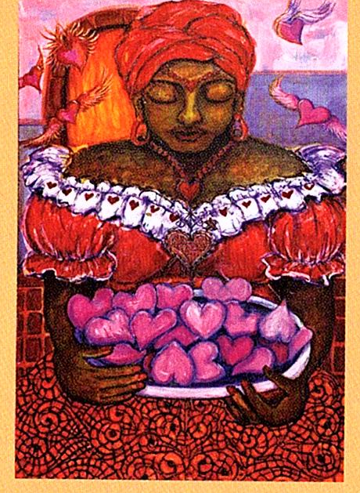
Carol Bridges 2008

Cola Smith 2008

Closing Song Freedom is Coming Vida

Benediction Reach Out -Susan Frederick-Gray

WE are not in this alone and we don’t have to figure it out on our own.
Reach out to congregations near you, reach out to your colleagues across congregations,
reach out to your UUA Regional staff.

It matters that we support the uprisings whose goal is the liberation of Black people and
communities who for too long have been crushed by white supremacy, militarism, and
capitalism. We must find the sources within ourselves to give us courage in this moment.
To resist. To risk. To sacrifice for this movement that needs all of us to succeed.
To be midwives for a new era in which all of us will be free.
-Rev. Susan Frederick-Gray, UUA President

Extinquish the Chalice
(Song) Reach out and people will find a way, (3x)
People will find a way I do believe

Social Check-In Join us for Joys & Sorrows
and then an optional Time of Sharing in Breakout Rooms on Zoo

Do you have an example of experiencing segregation in your life?
How did you feel?


Postlude Wider Circles - Rising Appalachia
Announcements

U.U. the Vote and the Ohio Poor Peoples Campaign
What an appropriate way to spend this Sunday afternoon (7/5/20),
you're invited to attend a watch party at 4PM for Good Trouble-

Using interviews and rare archival footage, JOHN LEWIS: GOOD TROUBLE chronicles Lewis’ 60-plus years of social activism and legislative action on civil rights, voting rights, gun control, health-care reform and immigration. Using present-day interviews with Lewis, now 80 years old, Porter explores his childhood experiences, his inspiring family and his fateful meeting with Dr. Martin Luther King Jr. in 1957. In addition to her interviews with Lewis and his family, Porter’s primarily cinéma verité film also includes interviews with political leaders, Congressional colleagues, and other people who figure prominently in his life.
Click here to RSVP for the film

Mon. 7/6 Caring Committee (2pm)
Personnel Committee (6:30pm)

Wed. 7/8 Meditation on Zoom (12-1pm)
Board of Trustees (6:30pm)

Adult Religious Exploration
Mondays July 13, 20, 27 & August 3, 10, 17 (6:30-8pm).
Cakes for the Queen of Heaven - Unit 2 On the Threshold -
New people are invited to join as this is a new series that also has 6 sessions in feminist theology for adults and older young people.
Join Zoom Meeting
https://zoom.us/j/9062049940?pwd=TEtGeE90WCtJeHB0UmJs-RElhTEJVdz09

Meeting ID: 906 204 9940 Password: OMWed12
Dial in by your location +1 929 205 6099 US (New York) +1 301 715 8592 US (Germantown)
PHONE: Same Meeting ID: 906 204 9940 Different Password: 340057

Unitarian Universalist Association of Congregations

Business Resolution Affirmed
Embodying Human Rights in Our Investment Decisions
This resolution was submitted by petition - signed by not fewer than 250 members of UUA
certified (in 2019) congregations, with no more than 10 members from one congregation.

Actions of Immediate Witness (AIW) affirmed by the UUA Gen. Assembly 2020
Title: Address 400 Hundred Years of White Supremacist Colonialism
Description: This AIW describes the reasons why Unitarian Universalists must remember and address the European invasion of this continent, the genocide of the original peoples and the ongoing destruction of our earth. It offers priority actions which Unitarian Universalists can take in solidarity with Indigenous-led movements and struggles.

Title: Amen to Uprising: A Commitment and Call to Action
Description: This AIW is a call to action for Unitarian Universalists to engage in the larger movement to end anti-Blackness and defund the police. This current global political moment is presenting us with unique and urgent possibility. With specific attention to our universalist theology, we imagine the possibility of a world free from policing. This AIW affirms our renewed commitment to creating authentic justice rather than relying on state violence.

U.U. the Vote and the Ohio Poor Peoples Campaign
What an appropriate way to spend this Sunday afternoon (7/5/20),
you're invited to attend a watch party at 4PM for Good Trouble-

Using interviews and rare archival footage, JOHN LEWIS: GOOD TROUBLE chronicles Lewis’ 60-plus years of social activism and legislative action on civil rights, voting rights, gun control, health-care reform and immigration. Using present-day interviews with Lewis, now 80 years old, Porter explores his childhood experiences, his inspiring family and his fateful meeting with Dr. Martin Luther King Jr. in 1957. In addition to her interviews with Lewis and his family, Porter’s primarily cinéma verité film also includes interviews with political leaders, Congressional colleagues, and other people who figure prominently in his life.

Click here to RSVP for the film

