Memorial Announcement

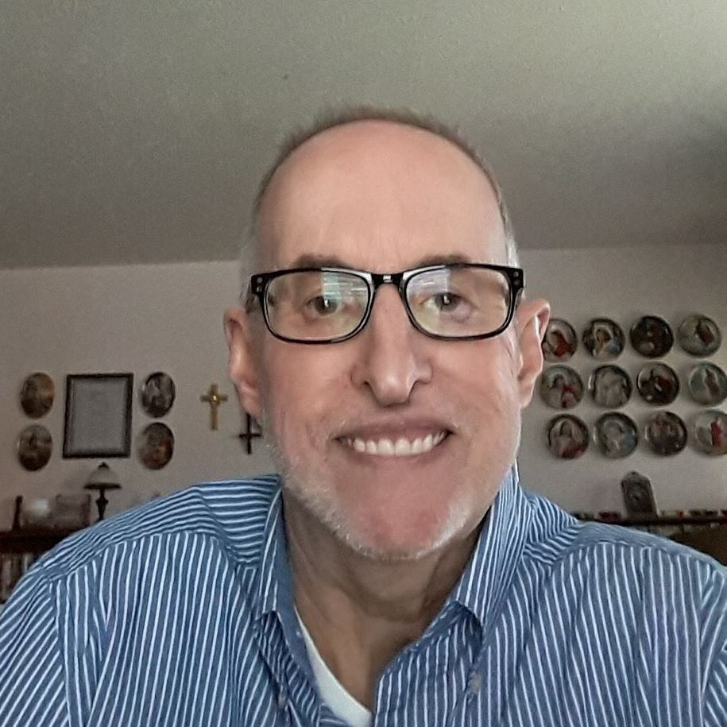
GARY BUCLEY
Our FUUSM friend and member of the Caring Committee, Gary Buckley has died today, Jan. 1, 2019 under Hospice Care @ MMH. Diagnosed with cancer over a week ago, Gary was resigned and passed peacefully.

We will miss his friendship and conversation, his contagious smile and strong opinions about fairness and justice. Gary suffered physical limitations for many years, but they didn’t stop him from taking an active interest in our congregation and the world. We knew the power of a warm welcome, and he cared very much for all of us. He was very appreciative and he was easy to talk to, even though he was often shy to get started.

His wisdom and compassion was born of principle and many experiences working for the benefit of others. I regret that I didn’t take more time to get to know him better. What I remember well, I now will treasure.

All Blessings, Rev. Kathryn Hawbaker

Gary Buckley
b. April is from Vienna, Parkersburg, Wv and has lived in Marietta for several years. (2013)
He retired from Washington County Board of Developmental Disabilities (WCBDD).
Two hip replacements made it hard fro him to get in and out of his car, but he had a handle on it- (on his side)- It was the General Lee maneuver for the passenger.

He enjoyed Words With Friends in more ways than just the game.

FB Posts:

Good things come to those who Believe,
Better things come to those who Wait,
and the best things come to those who Don’t Give Up
(Wisdom Corner)

Family isn’t always blood.
It’s the people in your life who want you in theirs;
the ones who accept you for who you are.
The ones who would do anything to see you smile
and who love you no matter what.

(Words To Inspire the Soul)

I can’t make people LIKE me.
All I can do is show them who I am, how I FEEL and what I BELIEVE.
It’s up to them to understand my worth!

