Anna Prince (born March 18 - died just after Mother’s Day-May 2017)

The wind breaths ripples
The river flows in both ways
Reflecting the sky.

So many of us here at First UU Society of Marietta deeply loved Anna & Alberto Prince (married 64 years). We are deeply grateful for their lives and the memories we hold dear. Alberto died Dec. 3, 2016, and the service was in St. Petersburg- the congregation we shared them with. Bright and beautiful Anna- her creative artistry and positive spirit was such a blessing to so many of us. We offer our sincere sympathy and heartfelt condolences to the whole family.

They were long time members and active supporters who left a legacy of good ideas, humanist principles and loyal commitments to our congregation and community. Anna was born in Danbury, Connecticut and graduated from George Washington University and studied psychology at Marietta College. She loved spending time with her sisters and family.

I treasure the quick sketches Anna drew and the way she made art and creativity a spiritual practice. I remember the first and every visit -such a beautiful garden and art gallery at their home in Marietta. Her Garden Party and painting classes were always popular at the annual Service Auction. Anna knew how to live in the moment and savor each breath.

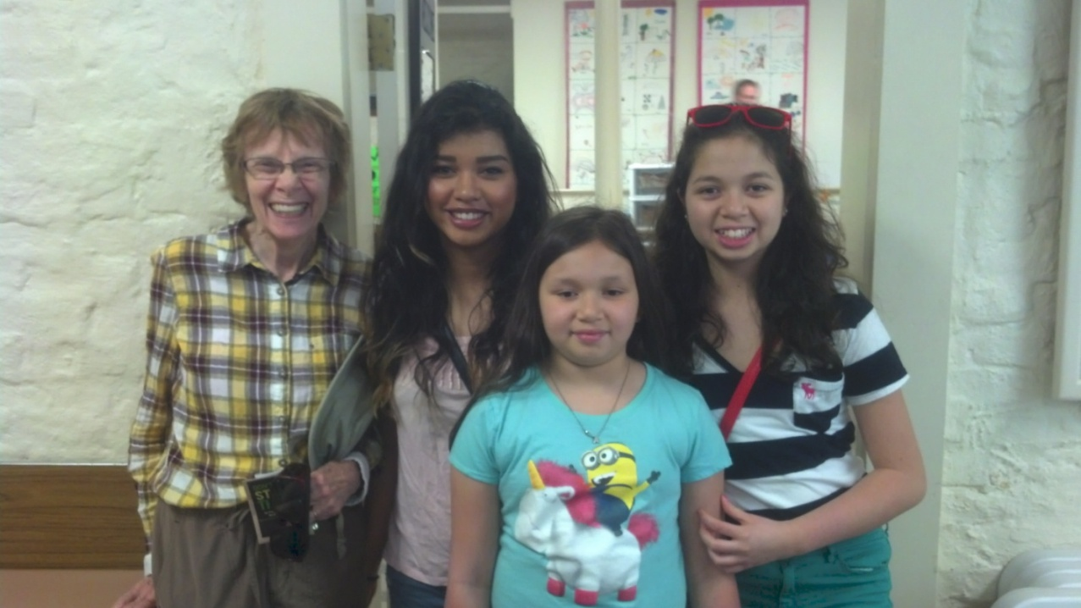
I got to know the girls (her granddaughters) at the OMD-UU Summer Institute, a week-long summer camp for all ages, and the oldest “Kat” was in the youth program where I was serving as Chaplain. (This photo was taken in June 2014).

Anna knew the arts of hospitality and the depths of the human soul. Like the labyrinths she loved, she made her way with courage and strength amid the twists and turns that life gave her.

Alberto and Anna Prince contributed so much to the life and legacy of our congregation.
We are so grateful for their generosity, as we remember them.
All Blessings, Rev. Kathryn E. Hawbaker and the F.U.U.S.M. Family

