How They Wrestled with the New
Thomas Nagel
SEPTEMBER 29, 2016 ISSUE

The Dream of Enlightenment: The Rise of Modern Philosophy
by Anthony Gottlieb
Liveright, 293 pp., $28.95
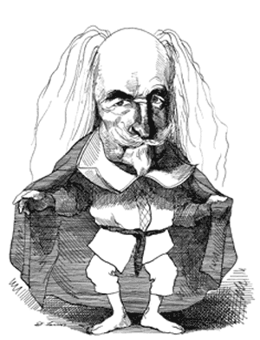Thomas Hobbes; drawing by David Levine
It is fascinating to learn about the concrete historical circumstances under which great philosophical works—works that have become timeless classics—were produced, and about the relation to their own times of the extraordinary individuals who produced them. For those with limited firsthand knowledge of the works this biographical approach can serve as an accessible introduction or reintroduction to the thought of some of the most important creators of our intellectual world. Anthony Gottlieb, a former executive editor of The Economist who is not a philosopher but a philosophical fellow traveler, is writing just such a history of the entire course of Western philosophy. The first volume, The Dream of Reason (2000),* took the story from ancient Greece to the Renaissance. The second volume, The Dream of Enlightenment, ends in the eighteenth century; a third volume will take us from Kant to the present day.
Gottlieb concentrates most of his discussion on six philosophers of the seventeenth and eighteenth centuries whose stature and influence are especially great—Descartes, Hobbes, Spinoza, Locke, Leibniz, and Hume—along with shorter treatments of Bayle, Voltaire, and Rousseau, and brief comments on many other figures. Here is what he says at the outset:
It is because they still have something to say to us that we can easily get these philosophers wrong. It is tempting to think that they speak our language and live in our world. But to understand them properly, we must step back into their shoes. That is what this book tries to do.
Gottlieb exaggerates the intellectual distance of these figures from us: it isn’t that they speak our language, but that we speak their language, because our world has been significantly formed by them. And he does not always succeed in stepping back into their shoes, which in the case of a great philosopher means understanding his thoughts from the inside, as well as in relation to his historical milieu. Nevertheless Gottlieb’s biographical narrative is vivid and often illuminating. Most important, he emphasizes throughout that these men lived in a historical period dominated by dramatic developments and conflicts in three areas—science, religion, and politics—and that their thoughts and writings were dominated by the need to respond to those developments, and to understand the relations among them.
First, there was the scientific revolution, which introduced a new way of understanding the physical world through universal laws, mathematically formulated, that govern everything that happens in space and time. Although knowledge of those laws is based on observation and experiment, the reality they describe is not directly available to human perception, but can be known only by theoretical inference. Two of Gottlieb’s thinkers, Descartes and Leibniz, were major contributors to the mathematical sciences—Descartes through the creation of analytic geometry (hence the term “Cartesian coordinates”) and Leibniz through the invention of the calculus (which was created independently by Newton). Descartes also produced theories of mechanics, optics, and physiology, Leibniz made significant contributions to dynamics, and Spinoza worked in optics and conducted experiments in hydrodynamics and metallurgy. But all six grappled with the question of how the austere physical reality revealed by the new science is related to the familiar world that we perceive—and to our minds, in which both perception and scientific reasoning take place.
Second, after the Reformation and the terrible wars of religion it had become clear that the plurality of religious beliefs in Christendom was not going to disappear. This posed questions both about the grounds for religious belief and about how governments should choose between imposing a single orthodoxy and tolerating diversity. In addition, each of these philosophers had to be concerned about the relation of his own work to the religious orthodoxy of his community, and about the dangers of ostracism, repression, or persecution. Descartes was deterred by the condemnation of Galileo from publishing his cosmological theories, and Spinoza was excommunicated by the Jewish community of Amsterdam.
Third, the basis of legitimate political authority was coming seriously into question, with skepticism about the divine right of kings and support for the right of subjects to overthrow a ruler who abused his power. This was not just theoretical: it took concrete form in the English civil war that culminated with the execution of Charles I in 1649 and the Glorious Revolution that replaced James II with William of Orange in 1688. Hobbes, Spinoza, Locke, Hume, and Rousseau all produced theories of political authority starting from the subject’s rather than the ruler’s point of view.
The metaphysical and epistemological problems that arose out of the scientific revolution are particularly difficult and abstract, and the responses of these thinkers are among the most formidable structures that philosophy has produced. They were concerned, as philosophers have always been, to understand the nature of reality in the broadest sense: what kinds of things and facts ultimately constitute everything there is. They were also concerned with whether we humans have the capacity to discover the answers to those questions, and if not, what limits to our knowledge are imposed by our finite human faculties. The advances of the scientific revolution gave these problems a new form.
Given how much he has to cover, Gottlieb does a pretty good job of summarizing the complex speculative responses of his philosophers. They are contributions to a collective intellectual inquiry that has continued ever since, and their value lies in working out some of the main alternative possibilities for making the most general sense of reality. Others can then explore, refine, and elaborate those proposals, and attempt to refute or defend them, or at least to evaluate their relative plausibility. I will confine myself—with apologies for the capsule presentation—to one metaphysical example, the mind–body problem, which grew directly out of the scientific revolution and is very much still with us.
The problem arose because the new mathematical conception of physical reality dehumanized it. Among other things, that conception left out all the rich qualitative aspects, such as color, smell, taste, and sound, with which the world appears to our senses. These so-called “secondary” qualities were interpreted as effects on our minds, as opposed to the geometrically describable so-called “primary” qualities like shape, size, and motion, which are features of the physical world as it is in itself, independent of our minds.
The question was: How complete an account of the nature of reality could the new physical science in principle provide? Do our minds necessarily escape its reach, even if our bodies are part of the physical world? Hobbes gave the most radically materialist answer to this question, holding not only that we, with all our thoughts and perceptions, are nothing but matter in motion, but that even God is a physical being. A scientifically updated version of this view—with mechanics replaced by quantum theory, molecular biology, and neuroscience, and God eliminated from the picture—is the dominant form of contemporary naturalism. It holds that physics can aspire to be the theory of everything.
But in different ways, the others took mind to be an aspect of reality not captured by physical theory. Descartes, famously, was a dualist who believed there were two fundamental types of things: matter, which was extended in space, and mind, which was nonspatial and capable of thought and perception, but also in the case of human beings intimately linked during life to a material body. Spinoza, in contrast, believed that there was only one type of thing, but that it had different aspects. Gottlieb explains:
For example, if we want to describe some piece of human behavior, we may focus either on the psychological state of the person concerned—i.e., on what he thinks, feels and desires—or else on his physical state—i.e., on what is happening inside his brain and other parts of his body. According to Spinoza, these are merely alternative ways of describing the same chain of events; they are explanations of one thing from two different perspectives.
And while Descartes believed God, the divine mind, was separate from the physical world, Spinoza believed that God and Nature were not two distinct things but two aspects of one thing, and that this entity—God or Nature—was in fact the only independently existing reality, of which we and everything else were merely dependent features.
Leibniz, the polar opposite of Hobbes, believed that mind, not matter, was fundamental, and that reality consisted of an infinite number of beings he called monads—with different perceptual perspectives, each of which represents the entire universe with more or less clarity. Matter exists within these perspectives, but not independently of them. God, the supreme monad, created our world out of all the logically possible worlds by creating the perspectives of a coordinated but noninteracting set of monads—including ourselves—in whose perceptions the history of this world is reflected.
The view that mind is the basis of all reality is known as idealism, and though it was dominant in the nineteenth and early twentieth centuries, it is not now a common view among philosophers. Materialism is for the moment in the ascendant. However, there is increasingly significant support for dualism, not in the form proposed by Descartes, with a separable soul, but as the view that mental phenomena involve additional nonphysical events associated with the neural states of animal organisms—and also for dual-aspect theories of the type Spinoza favored, according to which the mental and the physical are distinct but inseparable aspects of a single more basic reality.
Commenting on Leibniz’s belief that only monads have absolute reality, Gottlieb says, “Nowadays, philosophers do not have much use for talk of what is absolutely real. Something either exists or it doesn’t, and there are no halfway houses.” This is completely wrong. The term “absolute” may not be in vogue, but a great deal of philosophy nowadays is occupied with what is fundamental—i.e., not analyzable in terms of anything else—and what by contrast is dependent on and grounded in something more fundamental. Whether mind has an independent reality that is irreducible to the physical, and whether ethics, logic, probability, necessity, and causality are real in themselves or are mind-dependent, as Leibniz thought matter was, are central questions of contemporary philosophical debate.
In contrast with these four bold metaphysicians Gottlieb finds Locke refreshingly agnostic on the relation of mind and matter:
While Descartes, and indeed most other thinkers, maintained—at least in public—that it was impossible for mere matter to think, Locke could see no reason why God could not create purely physical beings who had the power of thought. We simply don’t know enough to decide whether or not such a thing is possible.
This brings out an important difference between Locke (and Hume) on the one hand, and Descartes, Spinoza, and Leibniz on the other: a difference in their views of the grounds of our knowledge of reality and how far that knowledge can penetrate into the hidden nature of things.
It is a weakness of Gottlieb’s account that he does not understand and therefore dismisses the importance of this difference, now standardly denoted as the opposition between rationalism and empiricism. “The distinction is a vague and confusing one, anyway,” he says.
Several of the so-called rationalists of the seventeenth century took a greater interest in the empirical sciences than their “empiricist” counterparts; Leibniz and Descartes knew far more about these sciences than Locke or Hume ever did.
This is a surprisingly superficial remark. The difference between rationalists and empiricists was not over the validity of empirical science, but over how much could be known on the basis of a priori reasoning, rather than observation. Observations alone do not create scientific theories: they have to be created by reasoners, who construct possible laws of nature and calculate their observable consequences for the purpose of experimental confirmation or disconfirmation.
Even where the empiricists admitted nonempirical certainties, as in mathematics, they interpreted them as apprehensions of the relations among our ideas, and that leaves it unclear how far such knowledge reaches beyond our own minds. The modern logical positivist view that necessary truths are tautologies that depend on the rules of our language is a direct descendent of this empiricist conception of a priori knowledge. The rationalists, by contrast, believed that reason could give us direct knowledge of necessary truths about a reality independent of our minds—logical, mathematical, and metaphysical truths—and this has important consequences for the interpretation of the empirical sciences.
Gottlieb shows his sympathy for empiricism in his attitude toward Descartes, who he says “tried to work out too much in his head.” Most people would agree with Gottlieb that Descartes relied on flimsy arguments for the existence of a nondeceiving God to defend his trust in his own reasoning and perception. But there is no consensus that anyone else, however ingenious the attempts in the centuries since, has come up with a satisfactory answer to radical skepticism.
In spite of this, most of us, whether we are engaged in ordinary life or in the pursuit of science, rely on both experiential evidence and a priori reasoning to acquire what we regard as knowledge of a mind-independent reality. And in reasoning, we take ourselves to be justified by what seems plainly self-evident—what Descartes called the “natural light” of reason. If we do not take this as a method of learning about reality, whether in mathematics or in science, it is difficult to avoid retreating to an empiricism that makes most of human knowledge an exploration of the insides of our own minds, and of how things appear to us.
Religion was a major concern of all these thinkers, and in some cases a source of trouble in their relation to society. The casual unbelief so common among today’s intellectuals would have seemed very foreign to them. Both Hobbes and Spinoza were widely condemned as atheists, though Gottlieb argues persuasively that Hobbes, in spite of his materialism, was not one; and of Spinoza he says charmingly:
Spinoza’s God is admittedly so different from anyone else’s that a case can be made for saying that he was an atheist without realizing it; but it does appear that he believed that he believed in God.
Descartes, Locke, and Leibniz were sincere Christians, though Descartes’s works were condemned by the Catholic Church as incompatible with orthodoxy. But Hume, though he veiled it in his publications, was clearly a religious skeptic, and produced a devastating argument against miracles, based on the maxim: “No testimony is sufficient to establish a miracle unless the testimony be of such a kind that its falsehood would be more miraculous than the fact which it endeavours to establish.”
In the relation of God to the world there was one problem of particular difficulty: the so-called Problem of Evil. If God is omniscient, omnipotent, and infinitely good, why does he not prevent all the evils that we see in the world around us—all the suffering and wickedness? Spinoza’s response was that our concepts of good and evil are relative to our parochial human interests, but, as Gottlieb puts it, “nothing is either good or bad from God’s perspective, which is to say from the point of view of nature or the universe as a whole.”
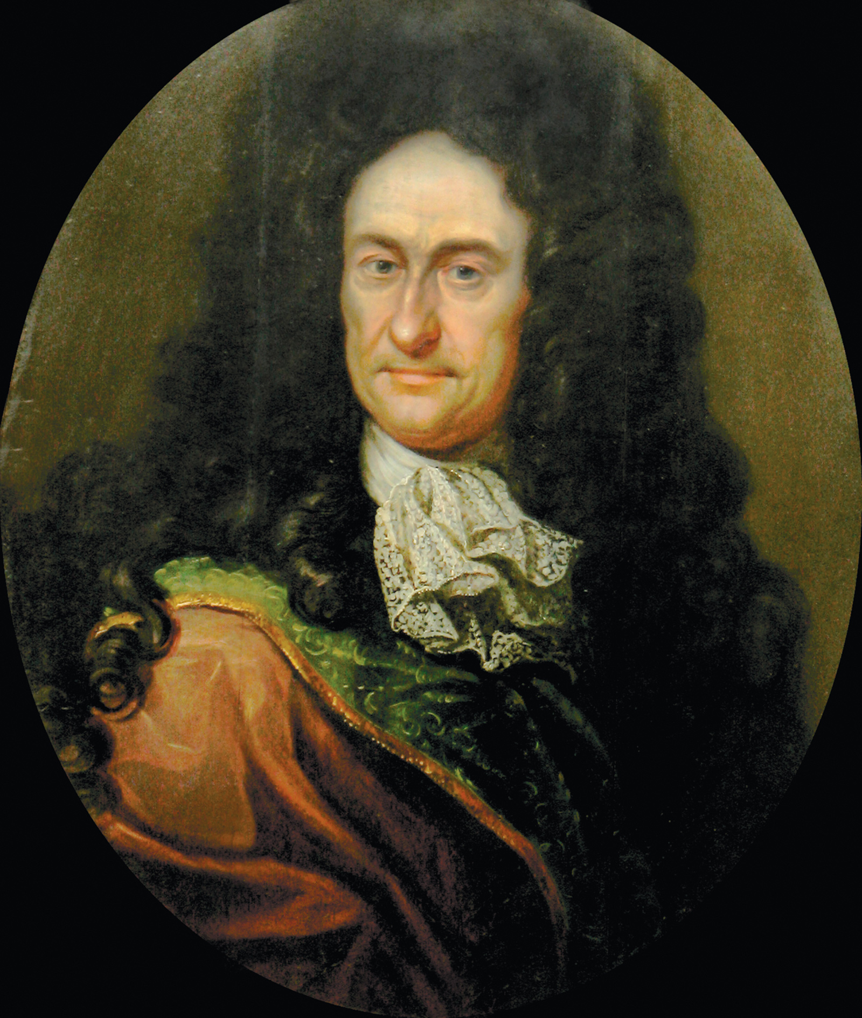Private Collection/Prismatic Pictures/Bridgeman Images
Gottfried Wilhelm Leibniz, circa 1700
Leibniz, however, did not avoid the problem in this way, but embraced a solution that is probably his most famous claim, and the one that has made him a figure of popular ridicule ever since (unforgettably caricatured as Dr. Pangloss in Voltaire’s Candide): namely that this is the best of all possible worlds, even though from our limited perspective that may not be obvious. Leibniz’s hypothesis about how this could be so was that, of the infinity of possible universes that God could have created, this one achieves the best possible balance between simple laws and desirable effects. That requires assigning great value to the simplicity of the laws of nature.
It also depends on a fundamental tenet of Leibniz’s thought: the Principle of Sufficient Reason, according to which nothing happens without a reason. God had to choose, from among all the logical possibilities, which world to make actual, and his reason could only be that it was better than the alternatives. Theists continue to explore solutions to the problem of evil, but secularists typically regard its insolubility as one of the strongest arguments for atheism, and for the view that there is no reason why this universe exists rather than another.
There is a remarkable parallel between Hobbes’s project in moral and political theory and Descartes’s project in the theory of knowledge. Each of them attempted to dismantle and then reconstruct a complex edifice of thought and practice that is usually supported by tradition, custom, and authority on a new foundation that depended solely on what could be found in the point of view of a single individual. In this they were the creators of an individualistic method of justification that has marked the modern world ever since, even though it has also provoked resistance.
As Descartes attempted to ground all knowledge starting with nothing but the capacities of his own mind or that of any other person, Hobbes attempted to ground morality and political authority in the motives and reasoning of any person subject to them: the justification for abiding by the rules had to work for each individual separately, in virtue of the human nature we all share. Hobbes appealed in this justification to a minimal foundation, the rational motive of self-interest, and in particular the dominant motive of self-preservation, together with facts about the human condition that made morality and government the indispensable means to serve those interests. Objective requirements were constructed starting from the subjective point of view.
Gottlieb doesn’t understand Hobbes, and it will take a bit of space to explain why. What was distinctive about Hobbes’s theory, and what led to his being attacked as a moral nihilist, was his refusal to appeal to any concern for the good of others or the collective good as a basis for moral motivation. He demonstrated that the familiar rules of morality, which he called the laws of nature, are principles of conduct such that if everyone follows them, everyone will be better off. But the fact that everyone will be better off if everyone follows them gives no individual a reason to follow them himself. He can have a reason to follow them only if that will make him individually better off. And there is no natural guarantee that individual self-interest and the collective interest will coincide in this way.
Hobbes concluded that although we all have a reason to want to live in a community governed by the moral rules, we cannot achieve this unless we bring it about that it is in each person’s individual interest to abide by those rules. And the method of doing that is to agree with one another to support a powerful sovereign with a monopoly on the use of force, who will use it to punish violators. Only then can each individual be confident that if he obeys the rules, he will not be laying himself open to assault and dispossession by others. Without the trust engendered by the knowledge that violators will be punished, civilization is impossible and individual self-interest—the same rational motive that supports morality—leads to perpetual conflict and constant insecurity. This is the famous Hobbesian state of nature, and Hobbes was most notorious for saying that in this condition, we are almost never obligated to obey the moral rules, because it is not safe to do so.
Gottlieb, failing to grasp the subtle and rigorous relation of self-interest, morality, and law in Hobbes’s theory, says:
He wrote that “all men are permitted to have and to do all things in the state of nature,” which was taken to mean that there was nothing really wrong with murder, theft, or anything else. In fact he was stating the tautology that nothing would be illegal if there were not yet any laws.
Whereas Hobbes was stating not a tautology but the substantive moral thesis that law is necessary to remove a condition of insecurity that would otherwise excuse us from the practical force of moral requirements:
The laws of nature oblige in foro interno; that is to say, they bind to a desire they should take place: but in foro externo; that is, to putting them in act, not always. For he that should be modest, and tractable, and perform all he promises, in such a time, and place, where no man else should do so, should but make himself a prey to others, and procure his own certain ruin, contrary to the ground of all laws of nature, which tend to nature’s preservation.
Gottlieb is misled by Hobbes’s statement that the laws of nature can be summed up in the Golden Rule. But for Hobbes, this is just a summary of the rules for peaceful coexistence that serve all our interests and that we are obligated to follow when it is safe to do so—not, as Gottlieb says, an “unselfish” principle that somehow supersedes their self-interested foundation.
Appalled by the disorders of the English civil war, Hobbes did not believe in the possibility of limited government: he thought sovereign power had to be absolute and undivided, and that it extended to prescribing the forms of religious worship, since religious conflict was a major source of civil instability. Hobbes held that we were released from our obligation to obey the sovereign only when he lost the ability to protect us. Spinoza, though his political theory followed Hobbes in being grounded in self-interest, defended more liberal and democratic institutions, with protections for freedom of speech and religion. But the most influential theorist of individual liberty and toleration as a condition of legitimate government was Locke.
For Locke the foundation of morality was not collective self-interest but the natural rights of each individual, given by God—rights to life, liberty, and property that men have reason to respect even in the absence of law. The state of nature, according to Locke, is therefore governed by morality in a way that it is not according to Hobbes:
The state of nature has a law of nature to govern it, which obliges every one: and reason, which is that law, teaches all mankind, who will but consult it, that, being all equal and independent, no one ought to harm another in his life, health, liberty, or possessions.
Yet there is still a need to punish violators, and if this is left in the hands of individuals, the results are likely to be too unreliable and chaotic, so it is necessary to confer a monopoly of the enforcement power on a single authority, by a social contract that will ensure the protection of our natural rights.
Locke eventually concluded that this foundation for legitimate government entailed a right of resistance and even rebellion against a sovereign who grossly abused his power. Gottlieb explains the connection of Locke’s theories with the efforts to prevent the accession of Charles II’s Roman Catholic brother James to the English throne, and his eventual overthrow. But he adds that although Locke’s name was invoked in support of the American Revolution, he would have been “aghast to discover that ideas from his book were later used against the British colonial regime, in which he himself played an enthusiastic part.”
Hume did not believe in natural rights or in the social contract. He was a philosophical prodigy whose greatest work, A Treatise of Human Nature, written when he was in his twenties, offered an analysis of every form of thought, knowledge, and value through a comprehensive theory of the operations of the human mind. One of his most famous theses was that causal judgments express only habitual mental associations due to observed correlations, and do not identify necessary connections between events.
In ethics and political theory, also, his analysis took the form of a psychological account of our moral judgments—an account that explained both their nature and their content. Like Hobbes, he offered a secular account of morality and political obligation, but it was not grounded solely in self-interest. Hume held that there is a distinctive motive that he called the moral sentiment, which is based on the human affective capacity for sympathy with the happiness and unhappiness of others, together with the human intellectual capacity to take up a general and detached standpoint toward the world that abstracts from our own particular perspective and our own particular interests.
This standpoint, when infused with sympathy for everyone, enables us to judge acts or character traits or institutions or policies to be good or bad not for ourselves or for any other particular person, but impersonally. Such judgments are simply expressions of the moral sentiment, in which sympathy is mixed with detachment. They do not describe the world, either truly or falsely, but express a feeling or attitude, favorable or unfavorable; yet the feeling is of a kind that allows people to agree in their moral judgments, since it does not depend on their particular interests.
The details of Hume’s moral theory are very sophisticated. It was an early form of utilitarianism, but it included a theory of property rights, contract, promises, and political obligation that explained them as the product of human conventions whose strict rules serve the collective interest, even though in many individual cases they require actions that are contrary to the general welfare. (It is no defense against eviction that you need the rent money more than your landlord does.)
Hume, like all of Gottlieb’s thinkers, was interested in practically everything, and I have barely sampled their creative achievements. Gottlieb offers a compact but fairly comprehensive survey, along with much historical detail. Except for Spinoza, these men did not live in an ivory tower; they were worldly, connected with royalty and the aristocracy, in some cases active as diplomats or in government service. In spite of some shortcomings, Gottlieb’s highly readable book can be recommended as an engaging personal introduction to some of our most brilliant moral and intellectual ancestors. If it opens a path to the works themselves, so much the better.

