**Invitation to 2016 Committee Recharge Event**

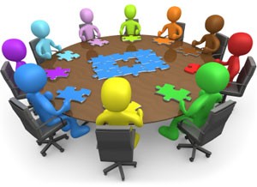

You are cordially invited to our annual Committee Recharge event to be held in the Fellowship Hall on Saturday, September 24, from 9 a.m. till noon.

Board members will provide refreshments in the form of an enhanced continental breakfast available at 8:30 a.m.

**Committee Chairs: if you are unable to attend, please arrange for a representative of your committee to participate**. **It will be very helpful to come prepared with at least one goal your committee wants to achieve over the next year**.

AGENDA

Welcome, invocation

Team-building exercise (Diana Bonnell)

Celebration of past accomplishments & how these lead to this year's goals & objectives

Goals & objectives of each committee for 2016-2017 –starting with Board (we realize that some committees may not have developed their specific goals for the year yet, but we would ask for some general statements along this line from each committee)

Break

-Discussion: What brings all the committees together as a cohesive whole serving FUUSM's mission?

- Marketing to and recruitment of committee members (the Board has discussed the idea of a "Committee Fair" to be held some time in the near future (like a job fair) so that members & friends can match personal preferences with committees. What is the mission of each committee and how is that mission best promoted (Diana Bonnell)?

-Review of “best practices” of committee management

-Adjournment

The purposes of the Committee Recharge are to: promote and demonstrate inter-committee collaboration and communication, (based on the committee report presented at the Annual Meeting this spring) celebrate past accomplishments of the committee and how that leads into this year's goals & objectives, share committee goals and objectives for the upcoming year, (in recognition of the fact that this meeting does not represent just a disparate collection of independently operating committees) what brings all these committee activities together as a cohesive FUUSM entity? Plan recruitment of members & friends to committees, discuss how the Board can support committee goals & objectives, and review good practices of committee management.

Please come prepared for a morning of sharing, collaboration and fun!

Thank you for your participation

FUUSM Board of Trustees