 Unitarian Universalist Mental Health Network
Online Worship Service
May 28, 2023
4pm PDT, 5pm MDT, 6pm CDT, 7pm EDT
Zoom link: https://us02web.zoom.us/j/88699701792
HELD – Showing Up for Each Other’s Mental Health
In this first worship service produced by the UU Mental Health Network Speaker’s Bureau, the Rev. Barbara F. Meyers will talk about her book HELD which tells a lot of stories from her ministry focused on mental health issues - both how-to stories and how-not-to stories and gives guidance for congregants in the pews who want to help make a difference. It has a built-in study guide. We hope that the book will be used by many congregations and help to make the denomination a friendlier place to people with mental health problems and their families.
Participants in the service:
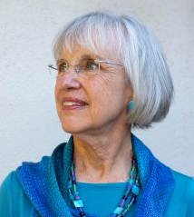 | Rev. Barbara F. Meyers is a Unitarian Universalist community minister with a mental health ministry based in Fremont, California. She is a peer support specialist and assistant director of the Life Reaching Across to Life peer support center, the author of a mental health curriculum for congregations, and the book “Held – Showing Up for each Other’s Mental Health” published by Skinner House Books in 2020. She is the President of the Board of the UU Mental Health Network.
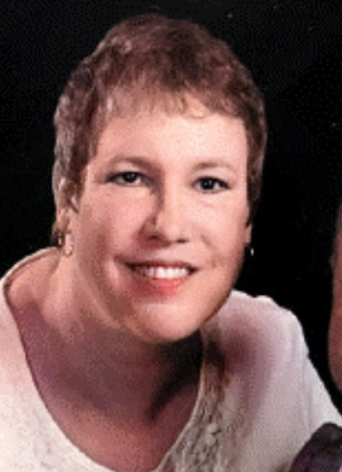 | Sheri Thomas, a worship assistant and board member at Channing Memorial Church, Unitarian Universalist, in Ellicott City, MD, was born with cerebral palsy and diagnosed with bipolar disorder in her fifties. She breaks down barriers and promotes full accessibility as part of various disability commissions and committees in Maryland. Her book, "IMBALANCED: A Memoir," traces Sheri’s remarkable journey from a front-page headline in 1962 to her current role as an advocate fighting to remove the stigmas surrounding physical disabilities and mental health. For a free digital copy of her book, email her at imbalanced.book@gmail.com.
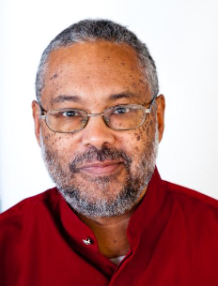 | Rev. Dr. Mark Morrison-Reed served as minister to congregations in Rochester, New York and Toronto, Canada with his wife and co-minister the Rev. Donna Morrison-Reed before becoming an Affiliated Faculty at Meadville Lombard Theological School and Coordinator of its Sankofa Collection. Morrison-Reed is primarily recognized as a historian of the African-American experience within Unitarian Universalism. He has written or edited seven books and three curricula. He received the award for Distinguished Service to the Cause of Unitarian Universalism in 2019.
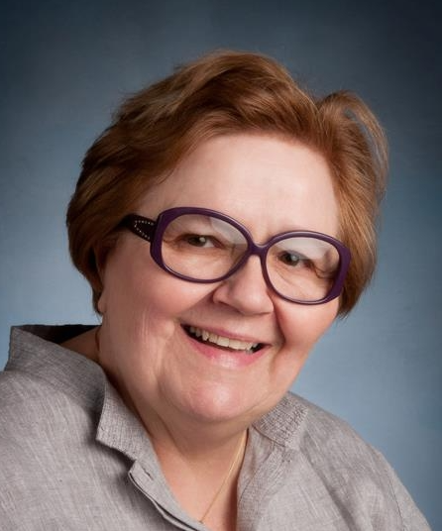 | Carol McGough is a long-time member of the Unitarian Universalist Congregation at Montclair, NJ. She has served in every capacity from office manager while our professional manager was on maternity leave to board secretary. Currently, she facilitates the covenant group, Our Positive Place, which supports people affected by mental illness.
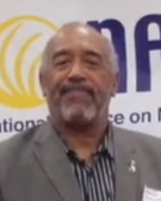 | Mark Williams works as President at NAMI New Jersey. He was successful in getting the North Plainfield Borough Council to establish a Stigma-Free Zone initiative ‘to reduce the stigmas typically associated with mental health problems through education, open conversation and advocacy.’ He is a member of First Unitarian New Jersey in Fanwood, New Jersey.
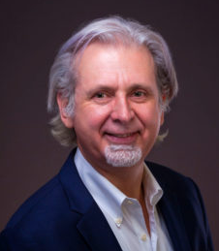 | Markus Grae-Hauck is a conductor, pianist, and vocal coach based in the New York City area. He has been a UU musician since 2005 and is currently serving as the Director of Music Ministries at UU Congregation of Montclair, New Jersey. He has conducted and/or accompanied big bands, various vocal ensembles, and over 70 musical theater productions. He has also lived in Germany, France, and Spain, figured out the meaning of life, played keyboards in a rock group while dressed in a neon pink jumpsuit, co-founded an opera company, and released two CDs of his own piano compositions; his music has been featured on nationally syndicated German network radio.

